**FPT ACADEMY INTERNATIONAL**



## FPT – APTECH COMPUTER EDUCATION

**QUICK CALLIGRAPHY**

|  |  |  |  |  |  |
| --- | --- | --- | --- | --- | --- |
| **Center Name** | | FPT – Aptech – HCM2  Address: 590 Cach Mang Thang Tam, District 3, Ho Chi Minh City | | | |
| **Instructor** |  | | Ms. Le Mong Thuy | |  | |
| **Class** |  | | T1.2303.M0 | |  | |
| **Group** |  | | 1 | |  | |
| **Group members** | | **Name** | | **Student ID** | |
|  |  | | Vu Minh Tuan | | Student1459120 | |
|  |  | | Bui Thi Nhung | | Student1459130 | |
|  |  | | Chu Quoc Huy | | Student1459125 | |
| **Duration** | Start date | | 19th June 2023 | |  | |
| End date | | 26th July 2023 | |  | |

**This is to certify that**

**Mr. and Ms.:**

Vu Minh Tuan

Bui Thi Nhung

Chu Quoc Huy

**has successfully designed & developed**

eProject: Quick Calligraphy website

**Submitted by:**

Vu Minh Tuan

**Date of issue:**

**Authorized Signature:**

# TABLE OF CONTENT

FPT – APTECH COMPUTER EDUCATION 1

TABLE OF CONTENT 2

ACKNOWLEGMENT 3

SYNOSIS 3

PROBLEM DEFINITION 3

CUSTOMER'S REQUIREMENTS SPECIFICATIONS (CRS) 4

**Business/Project Objective: 4**

**Hardware/ Software Requirements: 5**

SCOPE OF THE WORK (IN BRIEF) 6

ARCHITECTURE AND DESIGN OF THE SYSTEM 7

DIAGRAM OF THE WEBSITE 8

TASK SHEET REVIEW 1 9

SITE MAP 10

MOCK OF THE WEB SITE 11

1. Home 11

2. Calligraphy 13

3. Categories (Western, Arabic, East Asian, Indic, and Greek) 15

4. Learn 17

5. Gallery 24

6. Contact 25

7. About 27

8. Feedback 28

TASK SHEET REVIEW 2 29

WEBSITE DESCRIPTION 30

RESPONSIVE 70

JAVASCRIPT DESCRIPTION 71

TASK SHEET REVIEW 3 76

# ACKNOWLEGMENT

On behalf of team members. I would like to thank everyone who supported my team to successfully complete this eProject report. Especially, our teacher, she has supported us a lot since we started studying at FPT Aptech. With this eProject, she guided us very meticulously, enthusiastically and strictly. With her guidance, we were able to successfully complete this project. Besides, I also want to thank all the team members, each of whom worked hard to complete the eProject in earnest during the month of working together. Finally, our group would like to say thank you to my classmates and family for sharing and creating for the group the best environment to focus on the project, motivating the members to achieve their goals.

# SYNOSIS

# The goal of the eProject is that we need to create a website that meets all the requirements of the client, Quick Calligraphy. Quick Calligraphy is an energy company specializing in the supply of various electrical products. They always satisfy customers with professional staff with many years of experience. The main goal of this website is to reach customers who need the best quality electrical products for their home or company. In addition, the products have discounts and promotions for customers, especially the company also supports the direct installation of their products. Customer satisfaction is always the top goal of Quick Calligraphy.

# PROBLEM DEFINITION

The Web site is to be created based on the following requirements.

1) The home page must describe the keywords or highlight the calligraphy designs with all navigation links defined.

2) The site should provide the brief information about calligraphy as from where it originated etc.

3) There should be a well-designed menu with necessary sub menu options.

4) There should be various categories (forms and styles) like easy for kids, complex for elders and so on

5) There should also be categories of designs as Arabic, Indic, Greek etc (more categories can be added)

6) Proper description of the letters and fonts must be added in the website.

7) Contact us page: contact us details with location should be displayed using Geo Location API (eg. Google Maps).

8) About Us

9) Feedback form

10) Gallery section should be added.

11) Color combination must be uniform throughout the project.

12) Navigation must be smooth.

# CUSTOMER'S REQUIREMENTS SPECIFICATIONS (CRS)

**Client: Quick Calligraphy**

### Business/Project Objective:

Calligraphy is the art of forming beautiful symbols by hand and arranging them well.

It’s a set of skills and techniques for positioning and inscribing words so they show integrity, harmony, some sort of ancestry, rhythm and creative fire.

Calligraphy can be taken to expert heights. Calligraphy skills are used in many areas of art and graphics, from greetings card design to tattoo artistry. But you don’t have to be a pro to express your creative self and have a pleasant effect on the viewer or recipient of your efforts.

Essentially, there are three main types of calligraphy: Western, Arabic, and Oriental. Within each style, there may be several lettering sub-styles or hands. Seeing examples of these styles can help you perfect your art and get inspired to create something amazing.

Here we are aiming to design a website “Quick Calligraphy” which will provide an easy way to learn calligraphy and provide the basic other details about the art.

**Input to the system:**

- Searching calligraphy images based on type and name.

- User’s view and rating on calligraphy images.

- Images slider based on user’s interact.

- Pop up information based on user’s interact.

- User’s information in contact form.

- User’s location.

- Feedback about the quality of website and rating scale.

- Links to user’s social networking sites.

**Output from the system:**

- Searching results based on: name, and type of calligraphy.

- Image information by view, and rating.

- Images on slider.

- User’s location.

- The site should be able to provide a brief introduction/history about the calligraphy under the Calligraphy and Categories page.

- The location of the foundations on the Contact page.

- Displays Terms of Service and allows users to email directly to the foundations.

**Process**:

- Display pop up information based on user’s interact.

- Display image in slider based on user’s interact.

- Filter calligraphy images based on name searching, and type of calligraphy.

- Display image information by view, and rating.

- Validate data input from user.

- Display user’s location.

**Expected delivery date:** 26-July-2023.

**List of deliverables:**

- Document Word, PDF.

- User Guide.

- Source code.

### Hardware/ Software Requirements:

* **For developer**

**Hardware**

* A minimum computer system that will help you access all the tools in the courses is a Pentium 166 or better.
* 64 Megabytes of RAM or better.

**Software [Either or Combination as per Course/Sem]**

* Notepad/HTML editor/CoffeeCup
* Angular / Angular JS / React / BootStrap
* Dreamweaver / Figma
* MS IE / Chrome / FireFox / Netscape /MS Edge
* **For web users**

**Hardware**

* A minimum computer system that will help you access all the tools in the courses is a Pentium 166 or better.
* 64 Megabytes of RAM or better.

**Software [Either or Combination as per Course/Sem]**

* Notepad/HTML editor/CoffeeCup
* Angular / Angular JS / React / BootStrap
* Dreamweaver / Figma
* MS IE / Chrome / FireFox / Netscape /MS Edge

# SCOPE OF THE WORK (IN BRIEF)

After a long and detailed discussion, our group has decided to create a website contain the following webpages:

1. ***Homepage:*** Displays the summary information about calligraphy and the types of its go with illustrations.
2. ***Calligraphy:*** Display detailed information about the definition, history, and some types of calligraphy and artwork.
3. ***Categories:*** Display detailed information about the definition, and history of Western, Arabic, East Asian, Indian, and Greek calligraphy and their illustrations.
4. ***Learn:*** Display calligraphy writing instruction from basic to advanced.
5. ***Gallery:*** Displays all calligraphy images based on the Category (Western, Arabic, east Asian, Indian, and Greek). In the above categories, images can be filtered by name and type.
6. ***Contact:*** Display the address of foundations in Google map, and allow customers to message any information they want to Quick Calligraphy.
7. ***About:*** Display the information of foundations.
8. ***Feedback:*** Feedback about the quality of website and rating scale.

# 

## ARCHITECTURE AND DESIGN OF THE SYSTEM

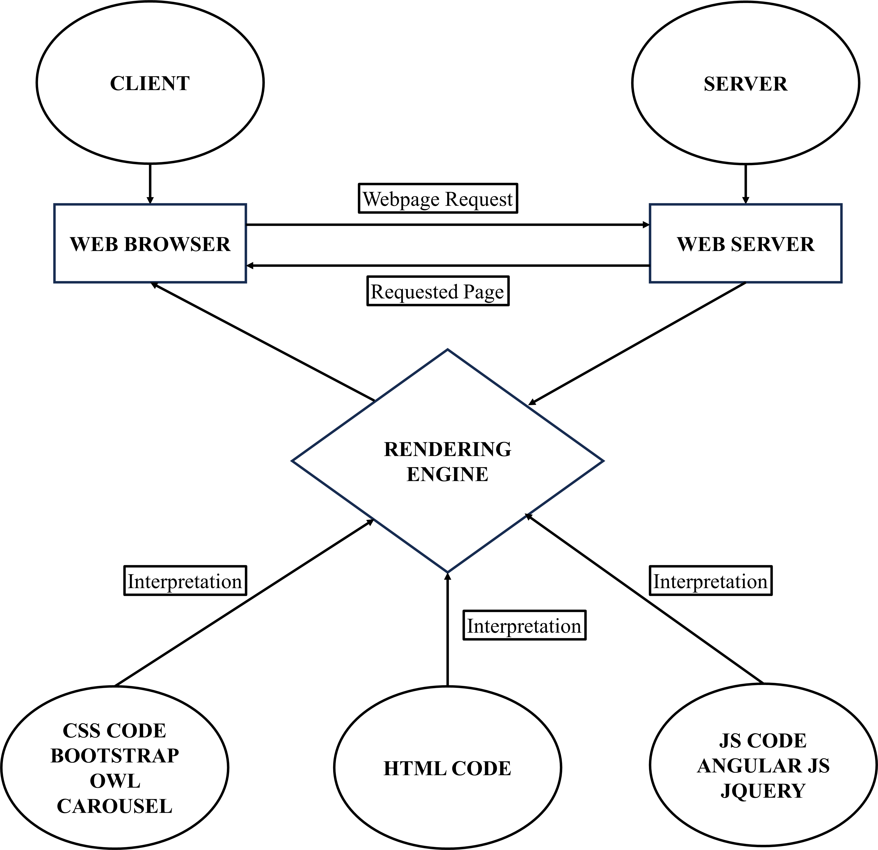

# 

## DIAGRAM OF THE WEBSITE

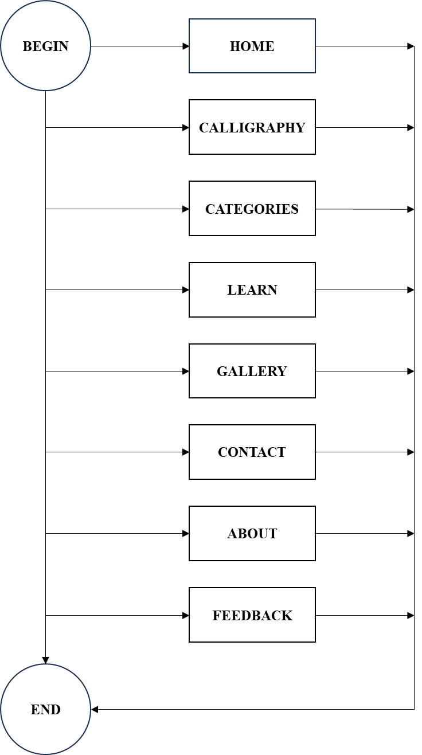



# TASK SHEET REVIEW 1

|  |  |  |  |  |  |  |  |
| --- | --- | --- | --- | --- | --- | --- | --- |
| **Project Ref. No.:**  **eP/Advertisement Portal Management**  **System/01** | | **Project Title:** | **Activity Plan Prepared By:** | **Date of Preparation of Activity Plan:** | | | |
| **Sr.**  **No.** | **Task** | **Actual**  **Start**  **Date** | **Actual Days** | **Team**  **Mate Names** | **Status** |
| 1 | Problem Statement | Quick Calligraphy | Tuan | 19-June-23 | 1 | Nhung | Completed |
| 2 | Analysis of Quick Calligraphy requirements about the website | 19-June-23 | 1 | Nhung | Completed |
| 3 | The scope of the work (in brief) | 19-June-23 | 1 | Tuan | Completed |
| 4 | Architecture and design of the system | 19-June-23 | 1 | Tuan | Completed |
| 5 | Diagram of the website | 19-June-23 | 1 | Huy | Completed |
| 6 | Task Sheet | 19-June-23 | 1 | Huy | Completed |

|  |  |
| --- | --- |
| **Date:** | |
| Signature of Instructor:  **Ms. Le Mong Thuy** | Signature of Team Leader:  **Vu Minh Tuan** |

# SITE MAP



# MOCK OF THE WEB SITE

## Home

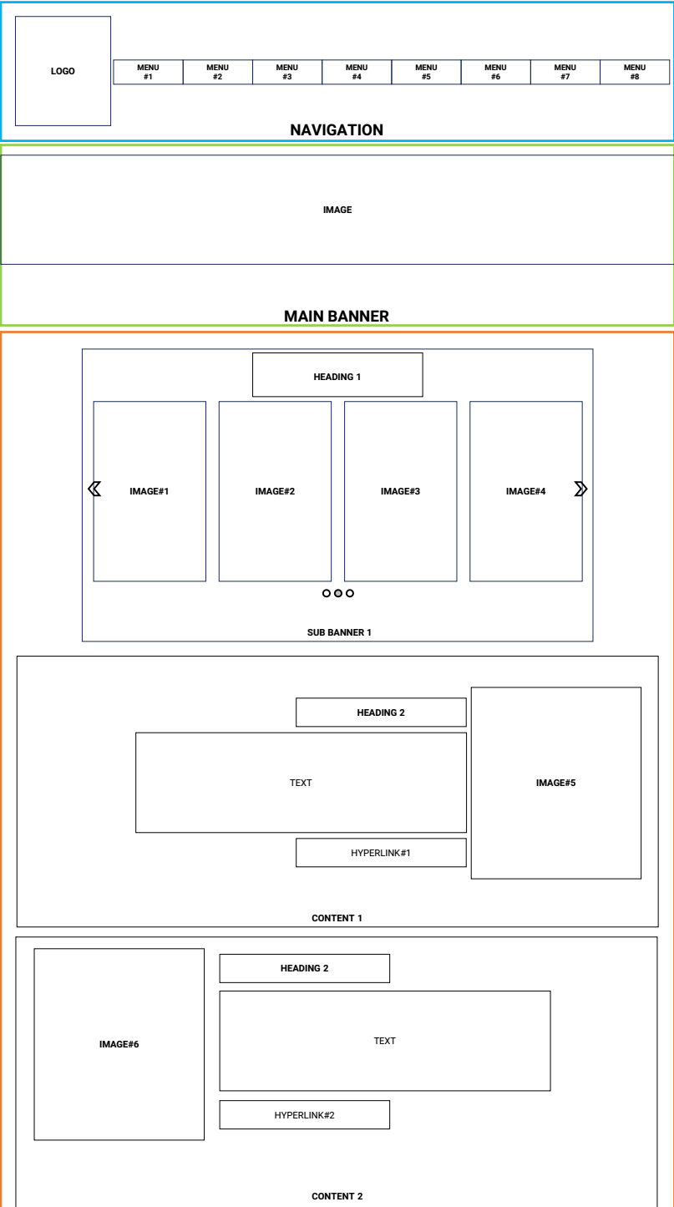

**Figure 1: Homepage – part 1**

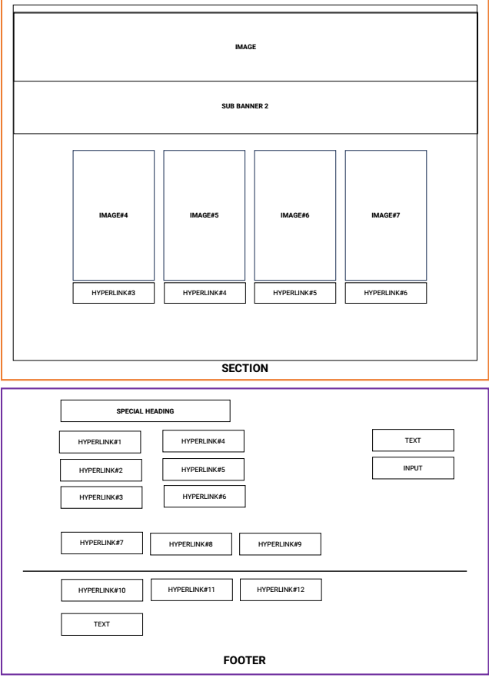

**Figure 2: Homepage – part 2**

## Calligraphy

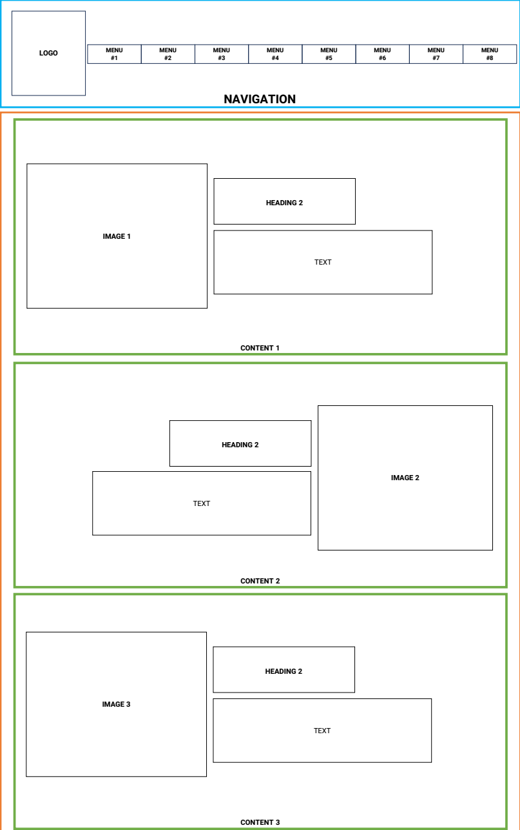

**Figure 3: Calligraphy page – part 1**

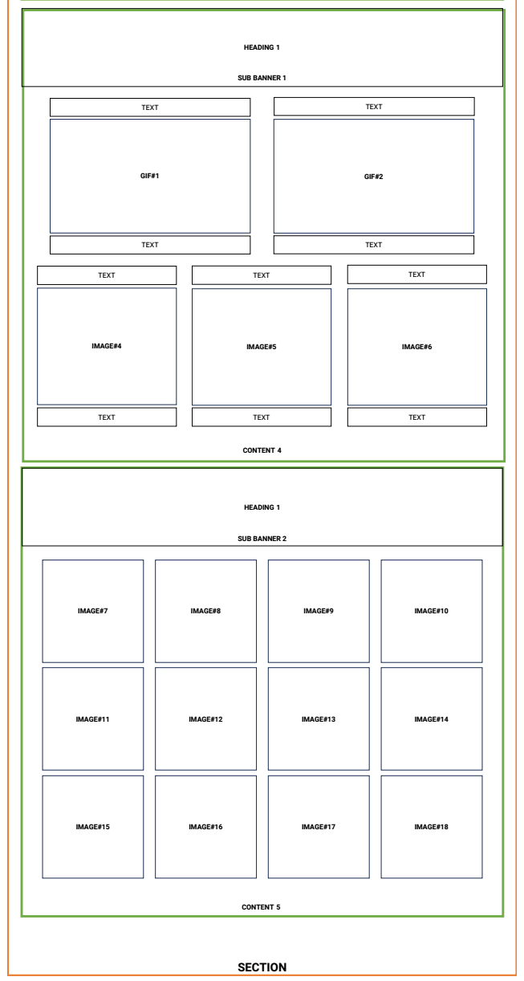

**Figure 4: Calligraphy page – part 2**



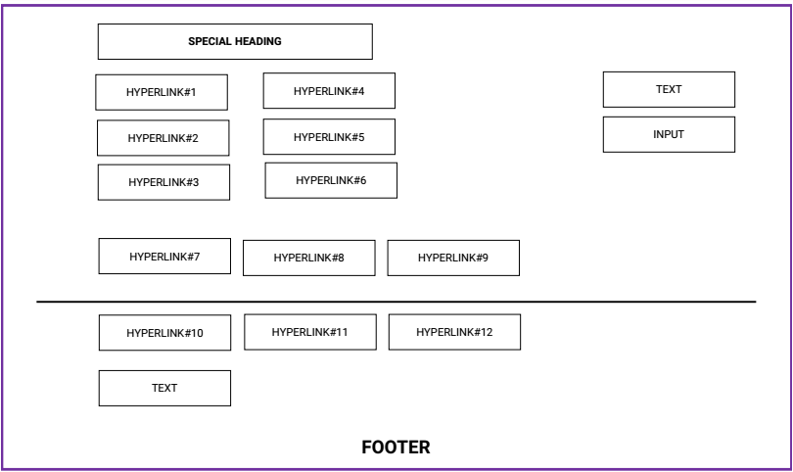

**Figure 5: Calligraphy page – part 3**

## Categories (Western, Arabic, East Asian, Indic, and Greek)

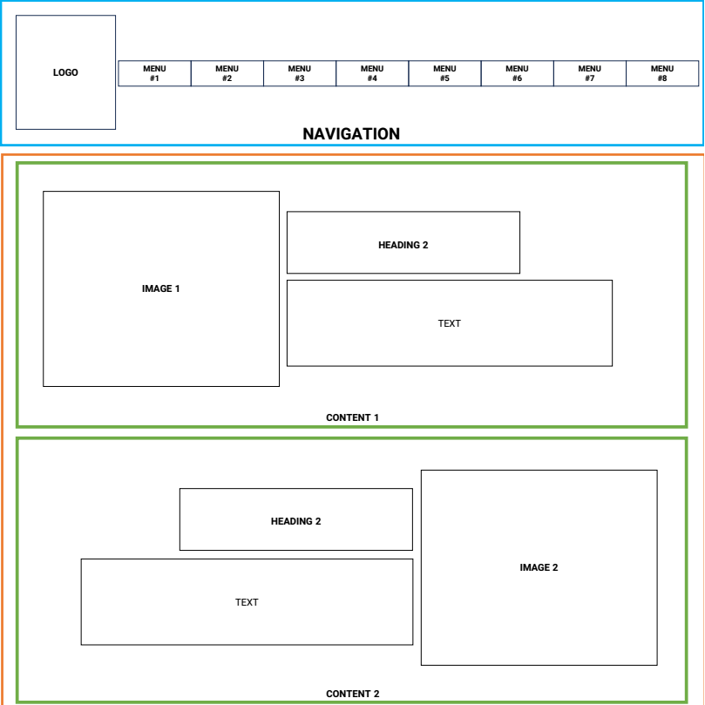

**Figure 6: Categories page – part 1**

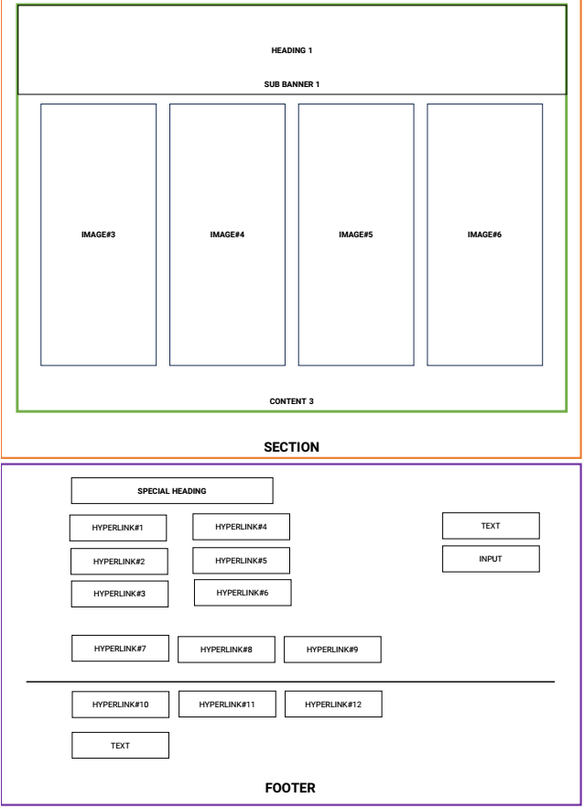

**Figure 7 Categories page – part 2**

## Learn

### Basic level

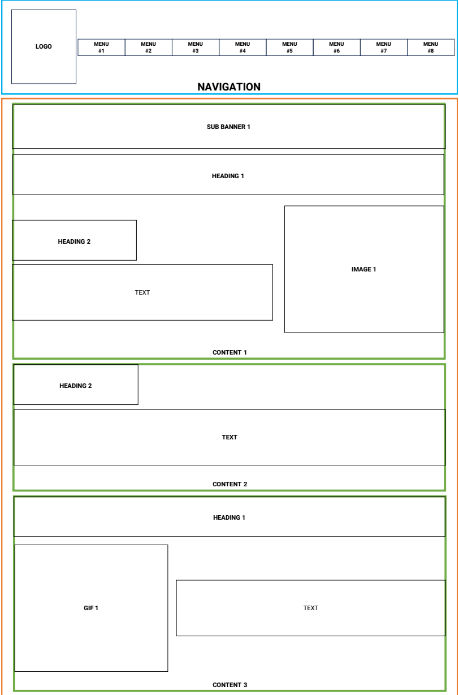

**Figure 8: Learn page – Basic level – part 1**

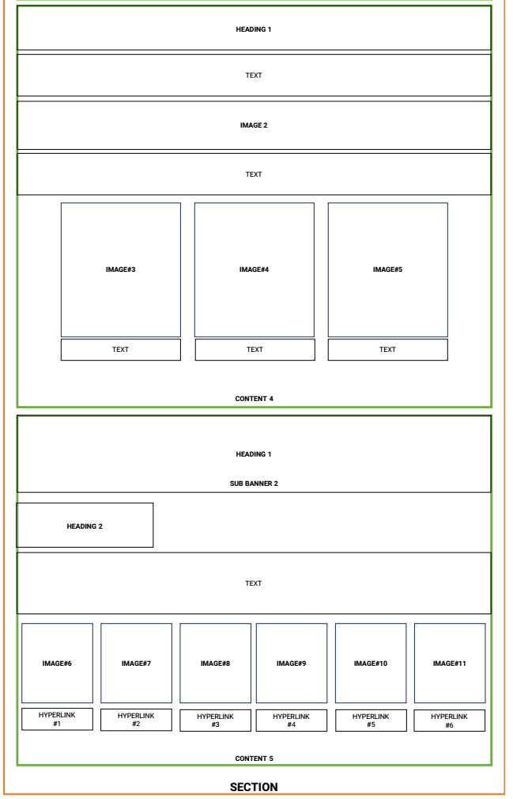

**Figure 9: Learn page – Basic level – part 2**

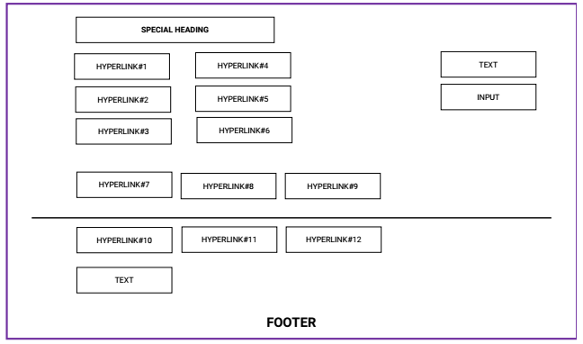

**Figure 10: Learn page – Basic level – part 3**

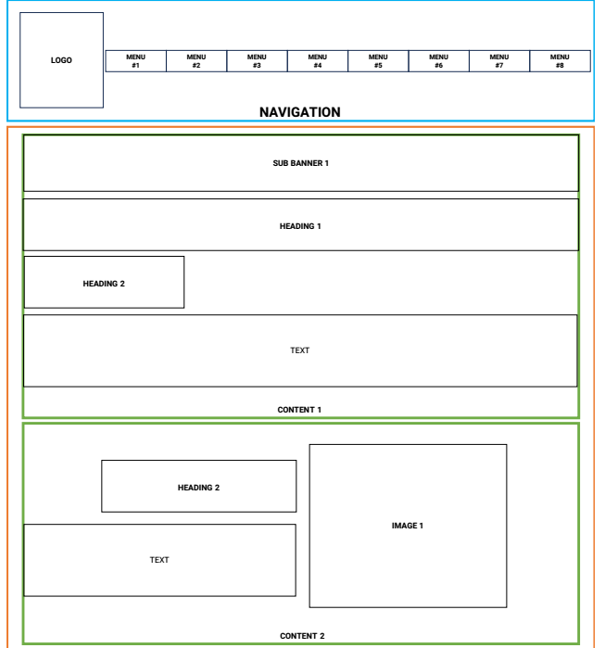

**Figure 11: Learn page – Intermediate Level – part 1**

### Intermediate level

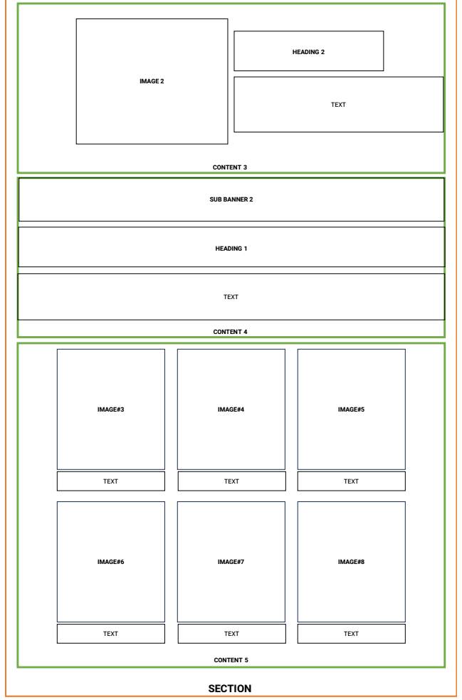

**Figure 12: Learn page – Intermediate Level – part 2**



**Figure 13: Learn page – Intermediate Level – part 3**

### Advanced Level

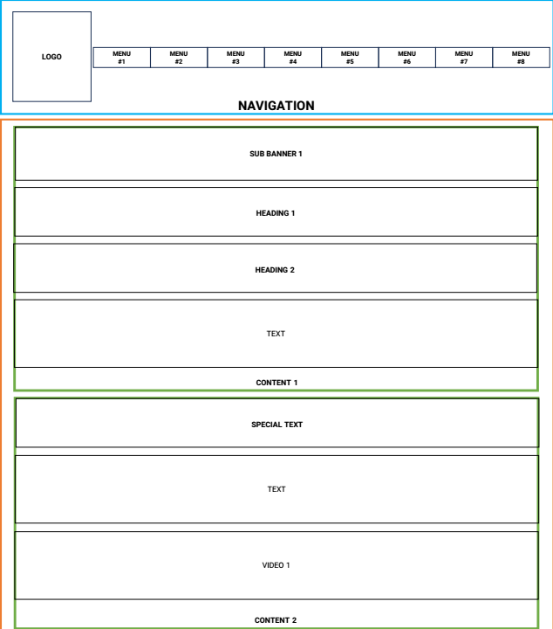

**Figure 14: Learn page – Advanced Level – part 1**

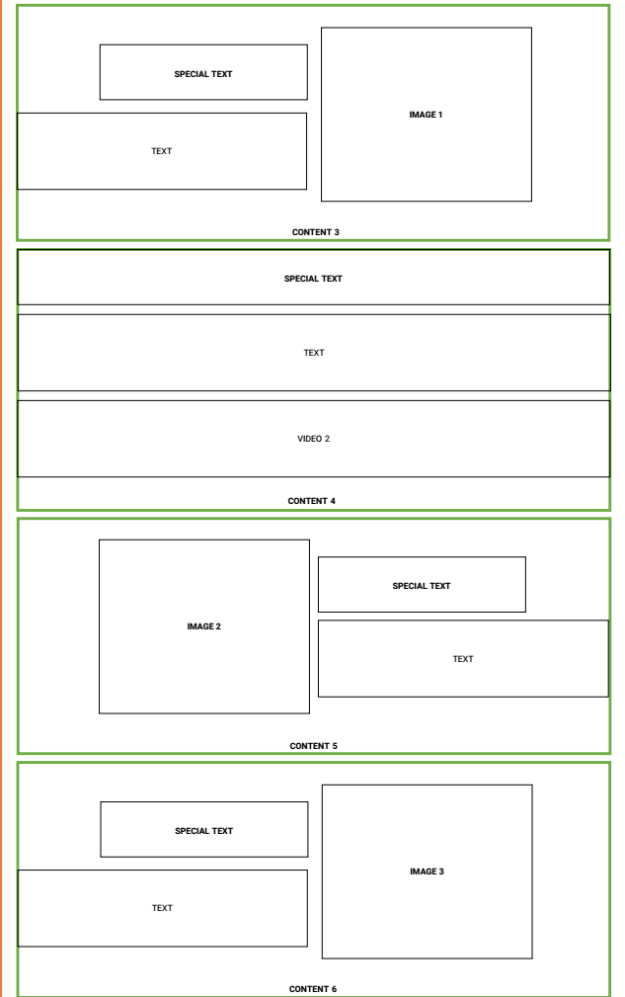

**Figure 15: Learn page – Advanced Level – part 2**

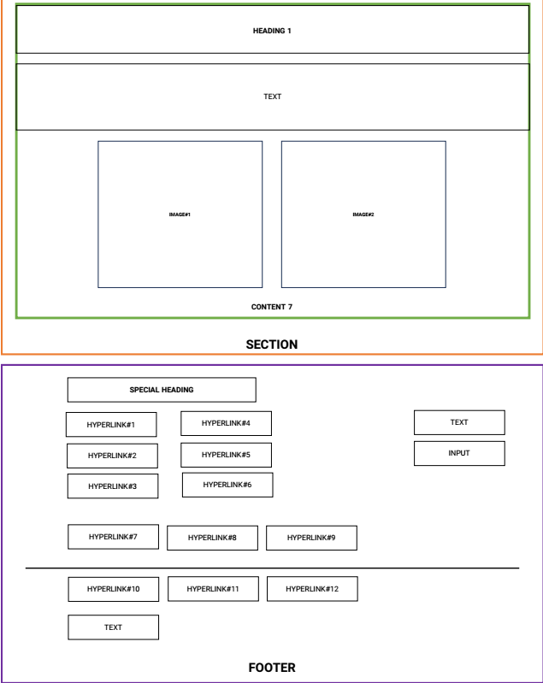

**Figure 16: Learn page – Advanced Level – part 3**

## Gallery

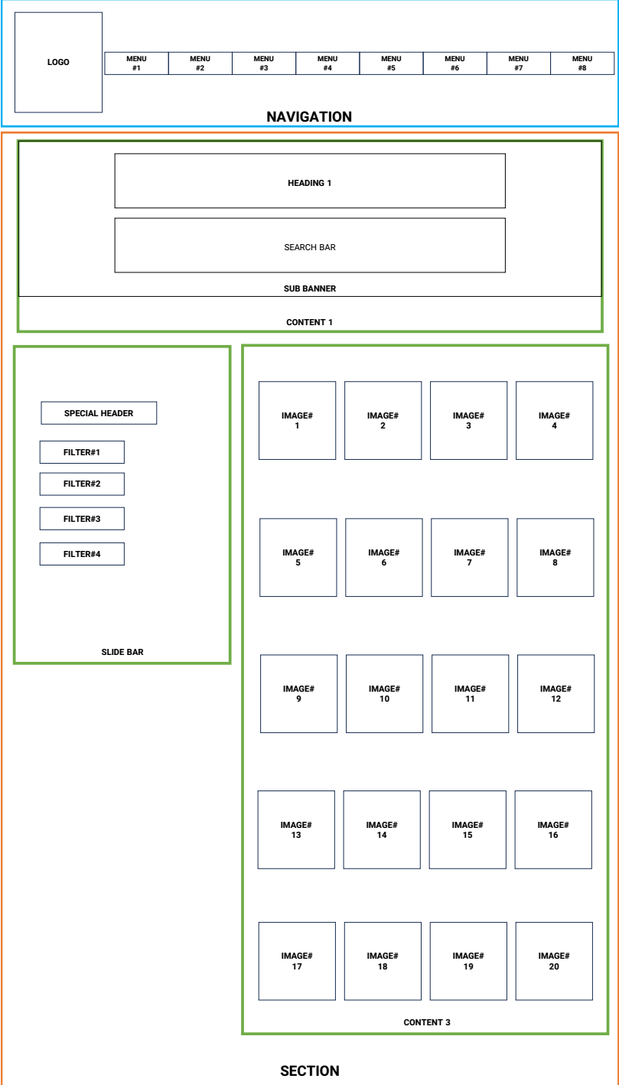

**Figure 17: Gallery page - part 1**



**Figure 18: Gallery page - part 2**

## Contact

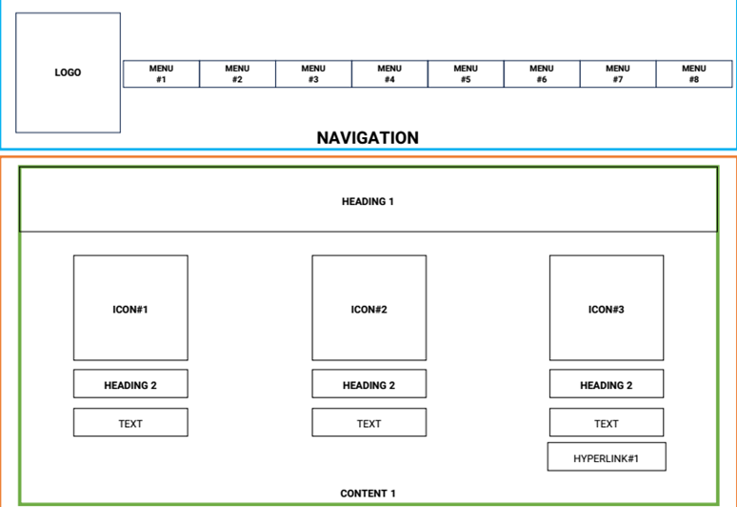

**Figure 19: Contact page - part 1**

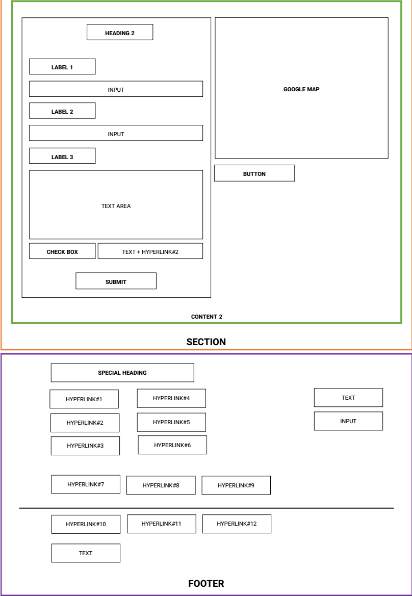

**Figure 20: Contact page - part 2**

## About

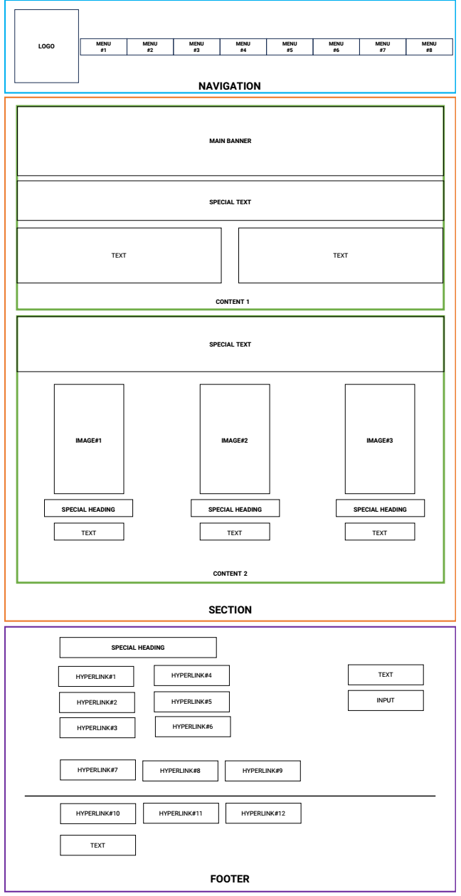

**Figure 21: About page**

## Feedback

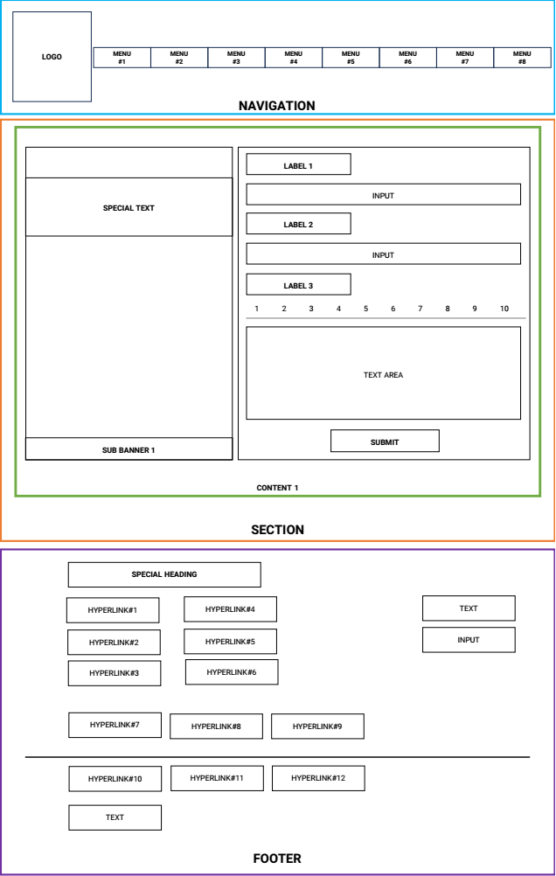

**Figure 22: Feedback page**

# 

# TASK SHEET REVIEW 2

|  |  |  |  |  |  |  |  |
| --- | --- | --- | --- | --- | --- | --- | --- |
| **Project Ref. No.:**  **eP/Advertisement Portal Management**  **System/01** | | **Project Title:** | **Activity Plan Prepared By:** | **Date of Preparation of Activity Plan:** | | | |
| **Sr.**  **No.** | **Task** | **Actual**  **Start**  **Date** | **Actual Days** | **Team**  **Mate Names** | **Status** |
| 1 | Site Map | Quick Calligraphy | Tuan | 20-June-23 | 2 | Tuan | Completed |
| 2 | Mock of the website | 20-June-23 | 7 | Nhung | Completed |
| 3 | Task sheet | 20-June-23 | 1 | Huy | Completed |

|  |  |
| --- | --- |
| **Date:** | |
| Signature of Instructor:  **Ms. Le Mong Thuy** | Signature of Team Leader:  **Vu Minh Tuan** |

# WEBSITE DESCRIPTION

1. **Homepage**
2. Description

Home page displays following information:

- Slide shows the ancient calligraphy in the world.

- Introduction about what calligraphy is and history of its.

- Summary about five traditions of calligraphy (Arabic, East Asian, Greek, Indic, Western).

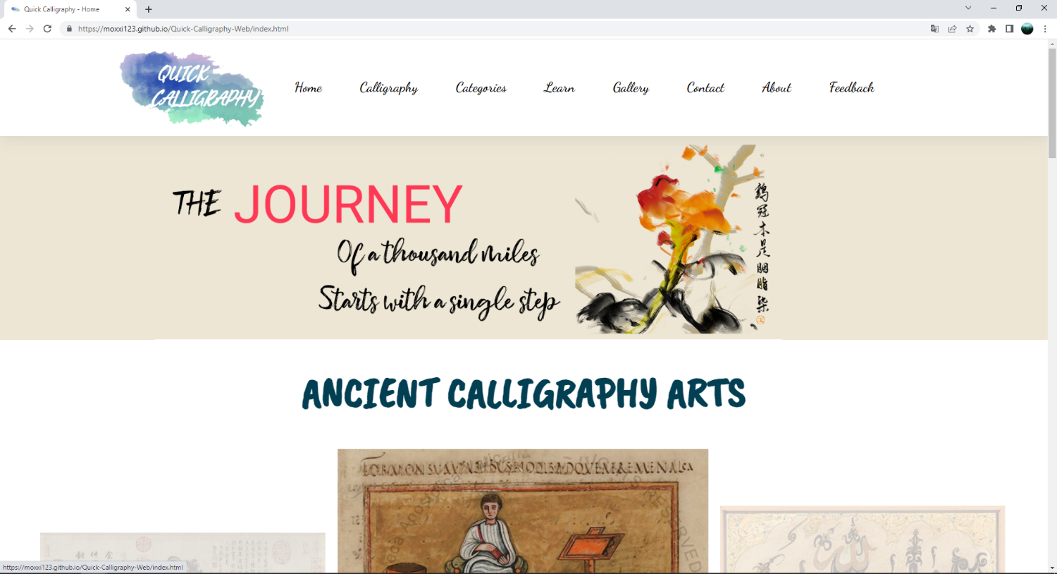

**Figure 23: Home – part 1**

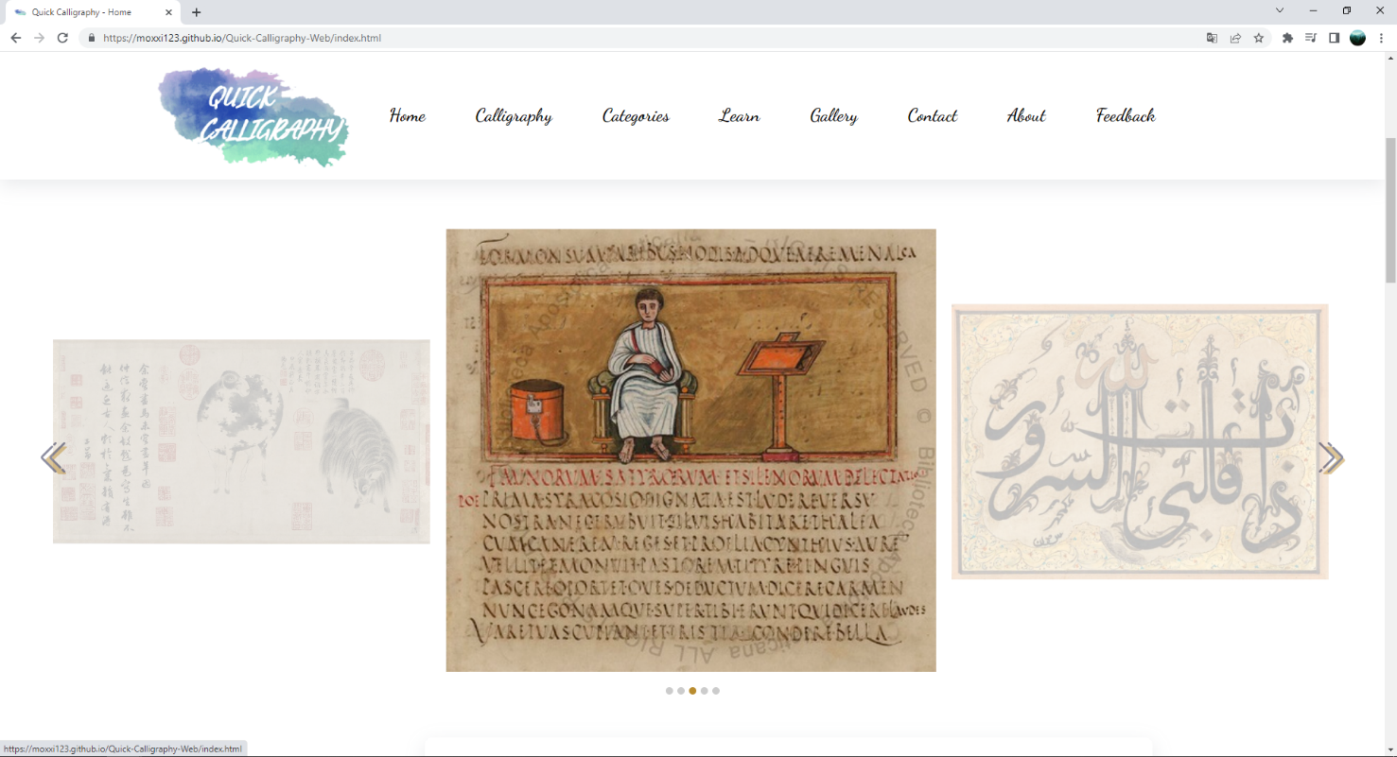

**Figure 24: Home – part 2**

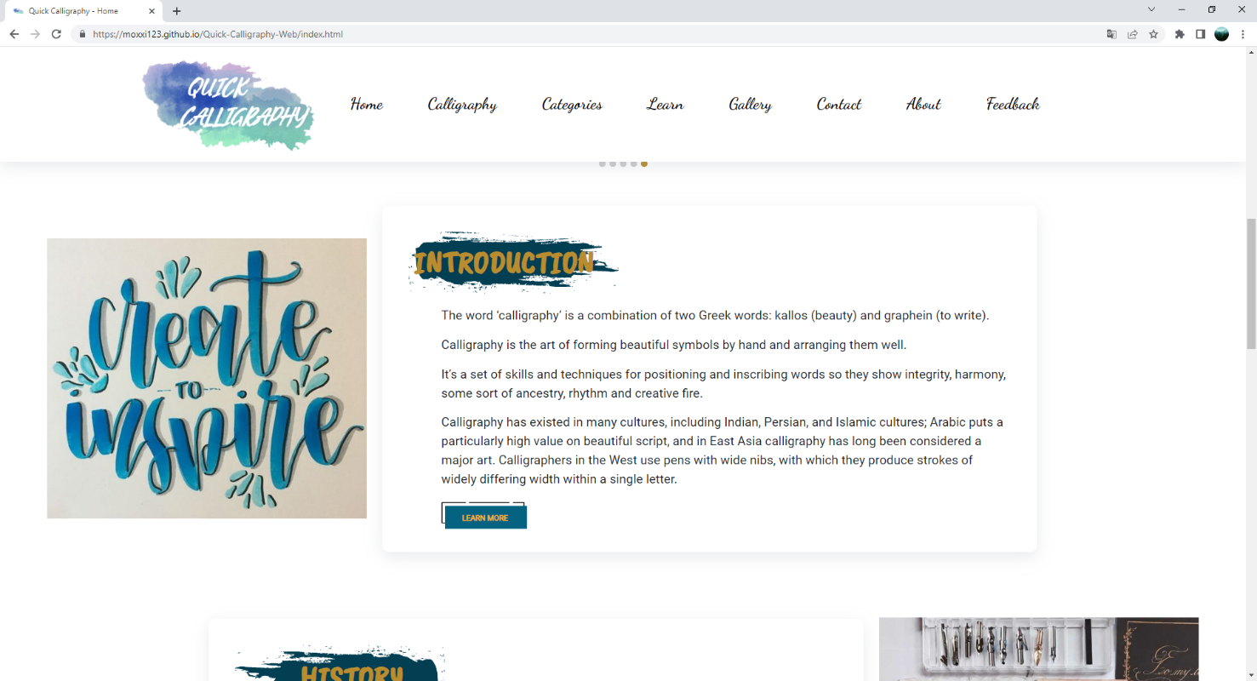

**Figure 25: Home – part 3**

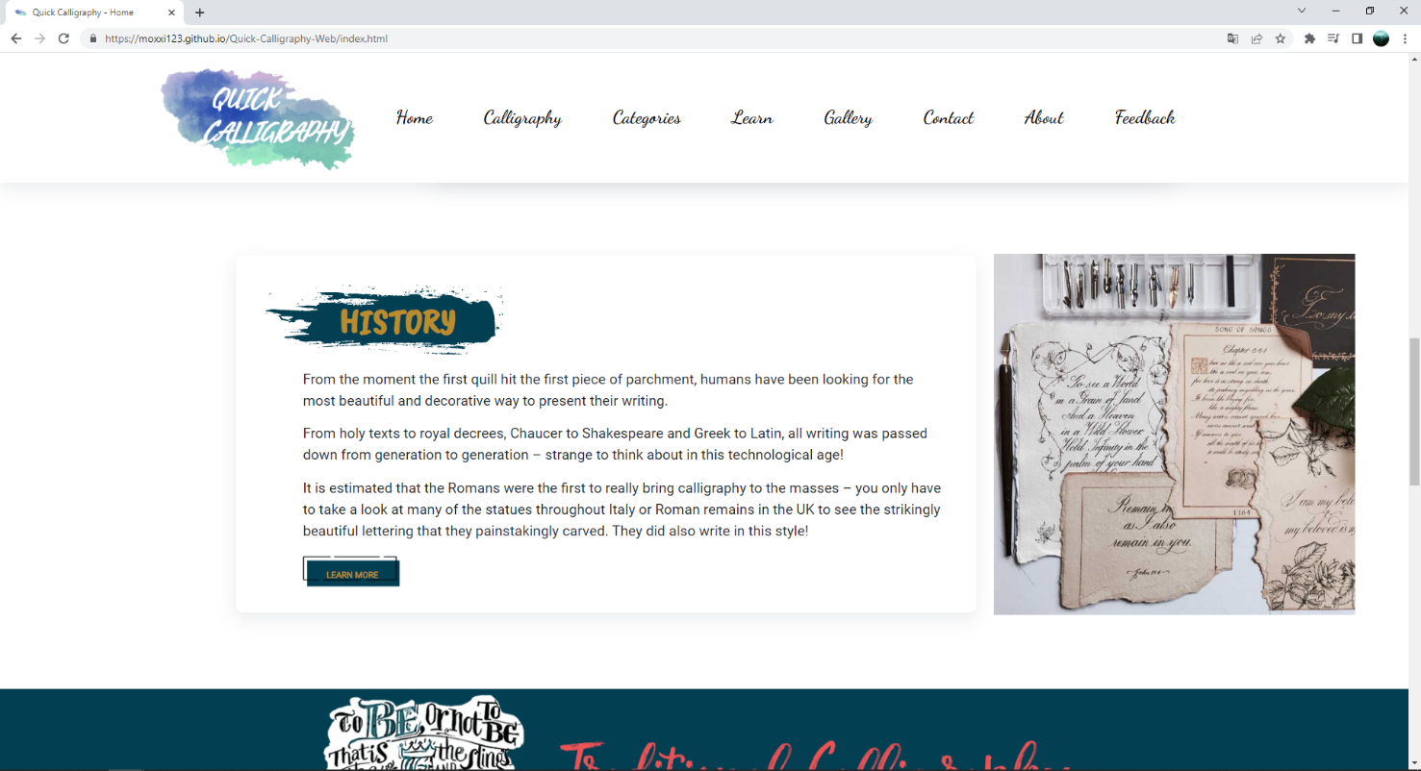

**Figure 26: Home – part 4**

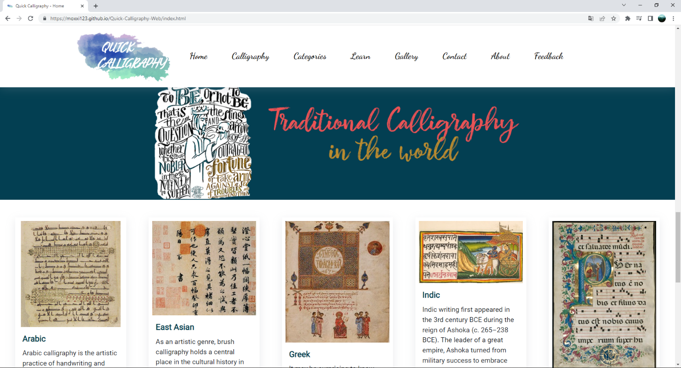

**Figure 27: Home – part 5**

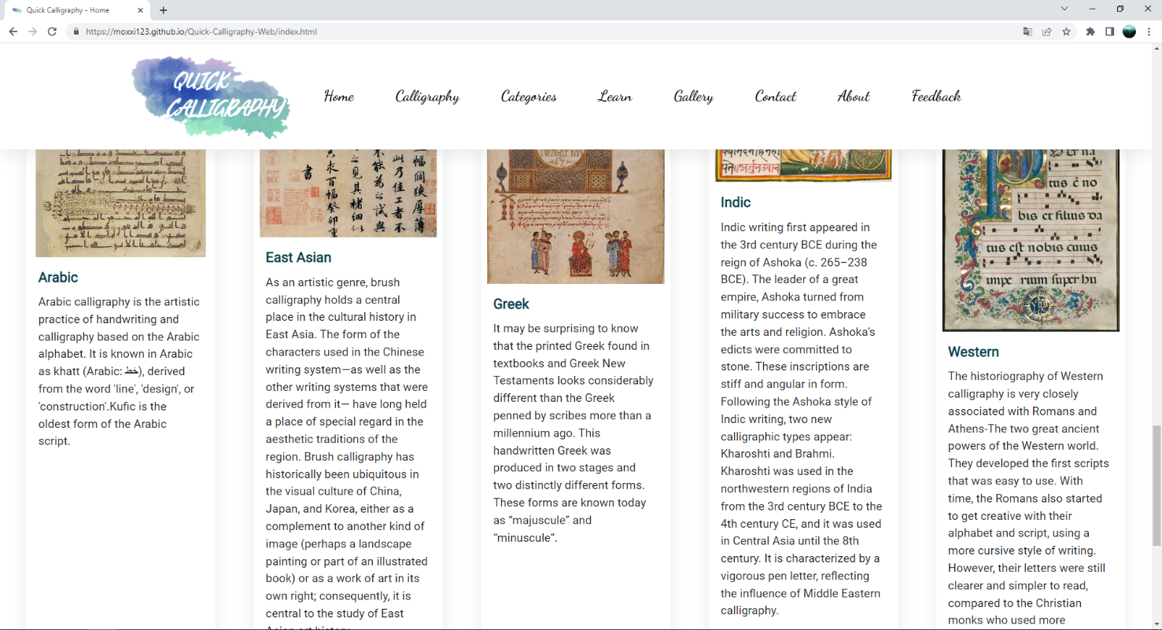

**Figure 28: Home – part 6**

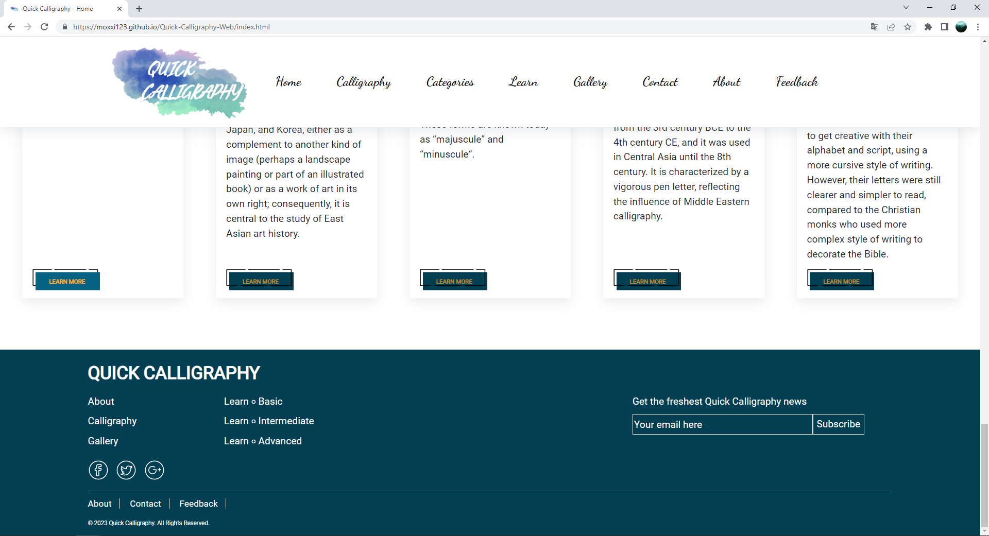

**Figure 29: Home – part 7**

1. **Calligraphy**
2. Description

This calligraphy page displays following information:

- A brief history of calligraphy.

- Introduction about the traditional and modern calligraphy concept.

- Tips to improve your handwriting calligraphy.

- Some motivational calligraphy arts.

1. Screen shot

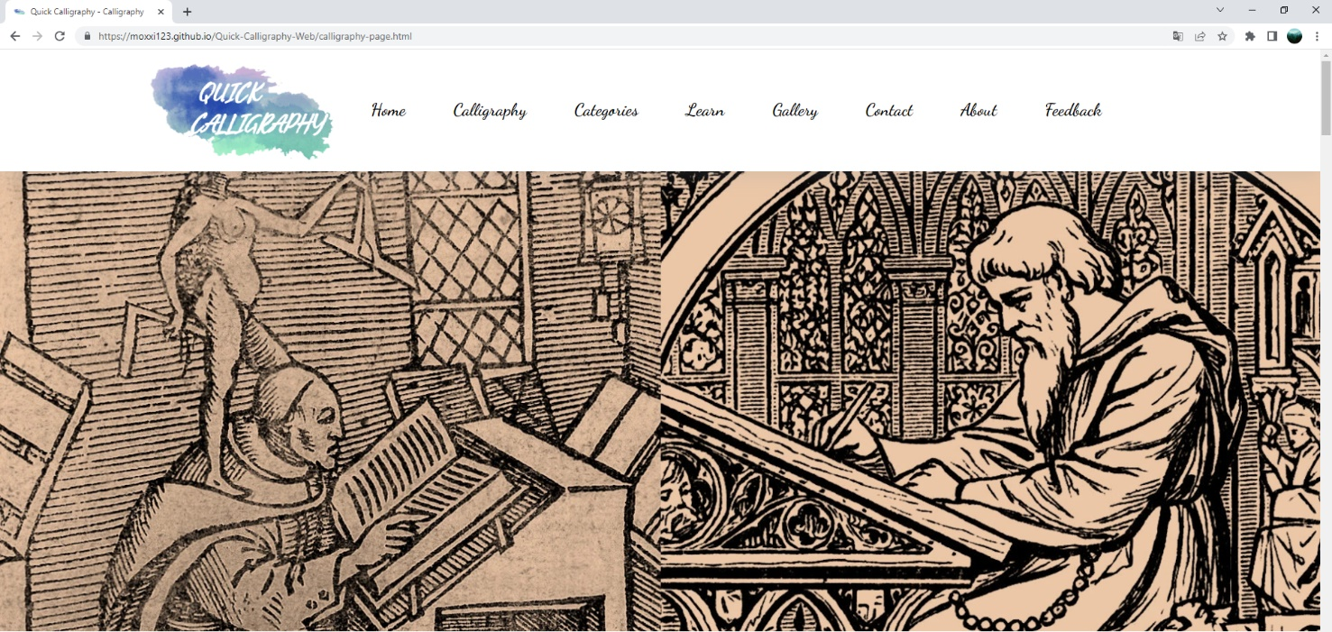

**Figure 30: Calligraphy – part 1**

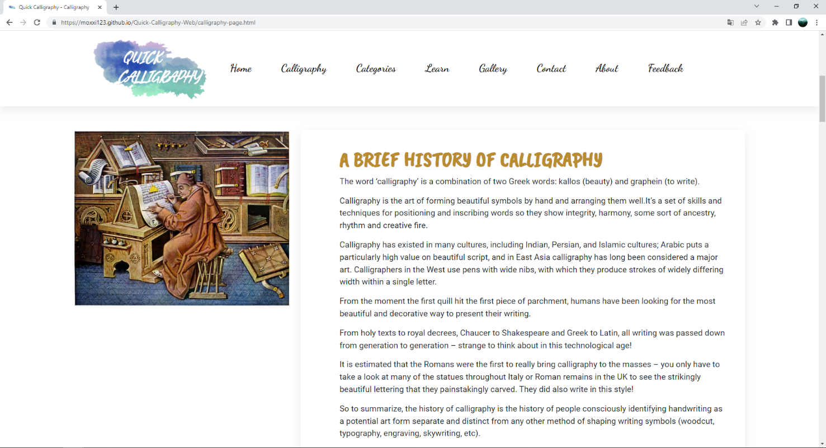

**Figure 31: Calligraphy – part 2**

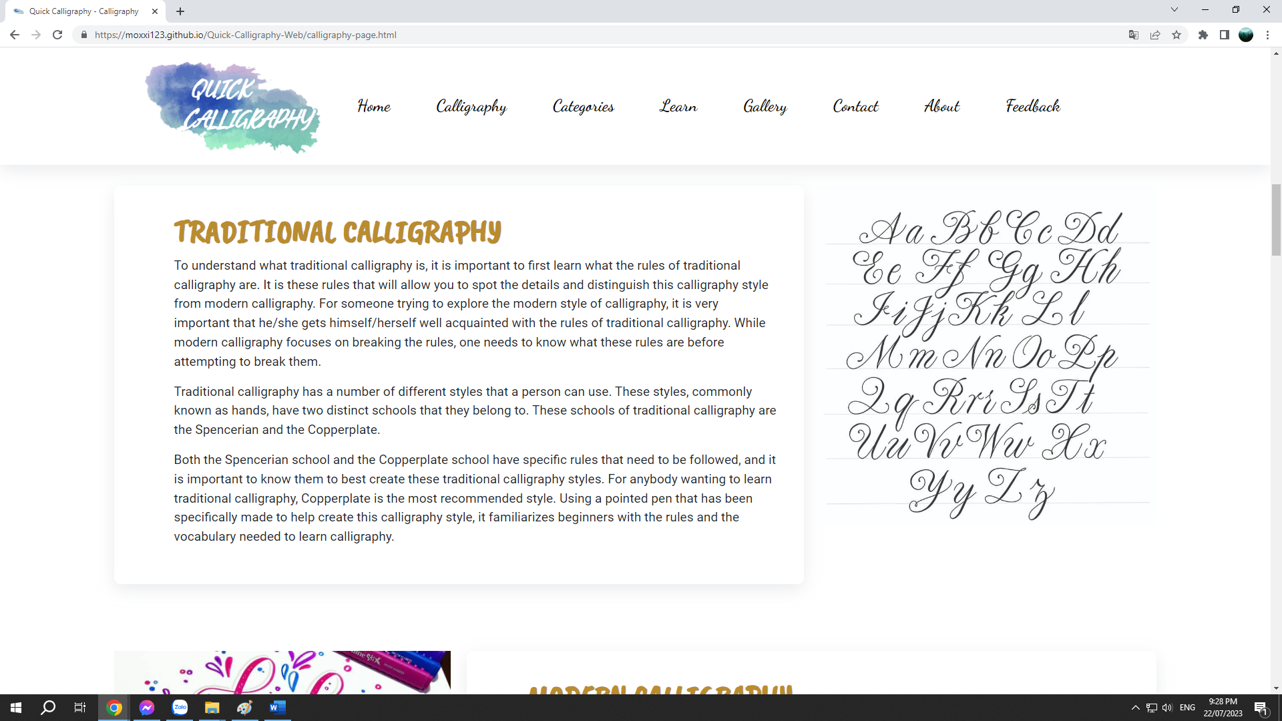

**Figure 32: Calligraphy – part 3**

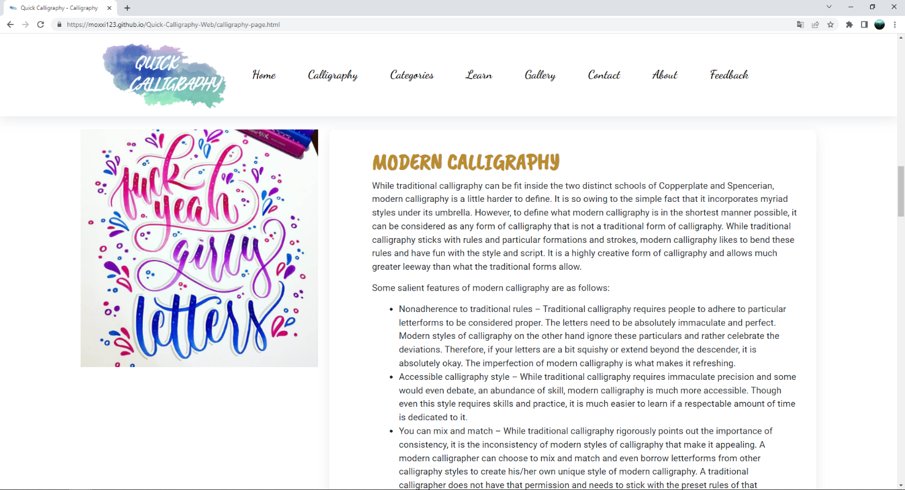

**Figure 33: Calligraphy – part 4**

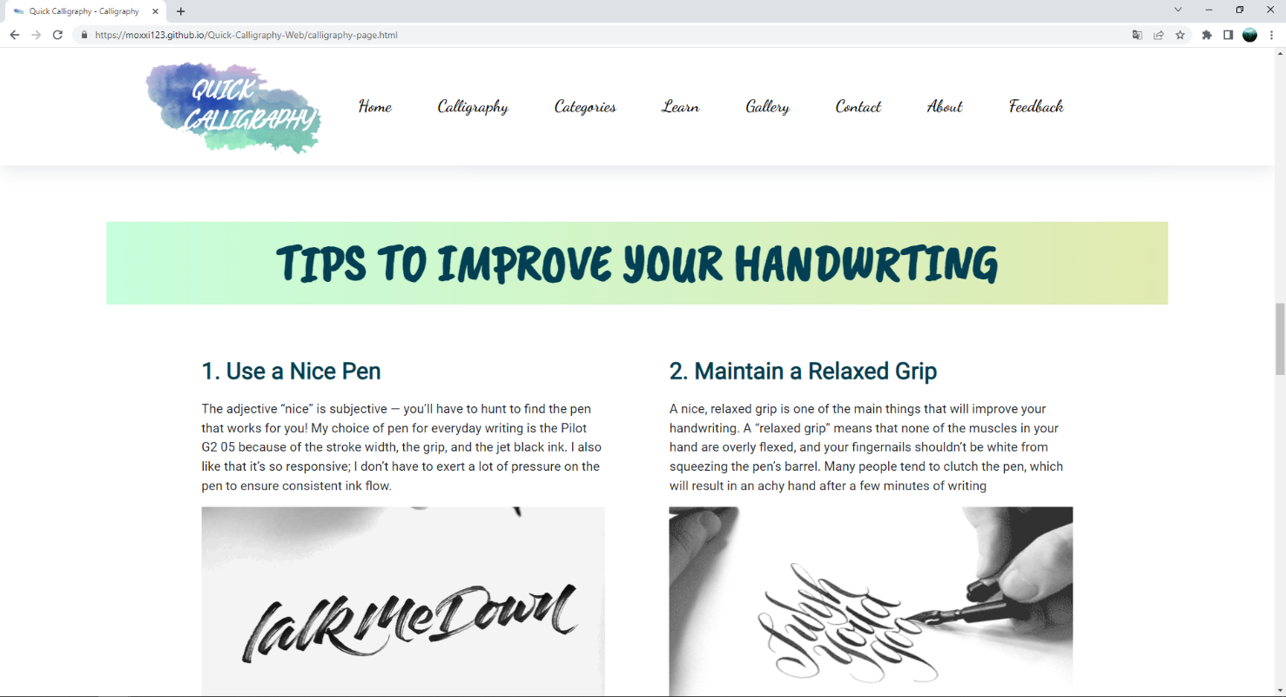

**Figure 34: Calligraphy – part 5**

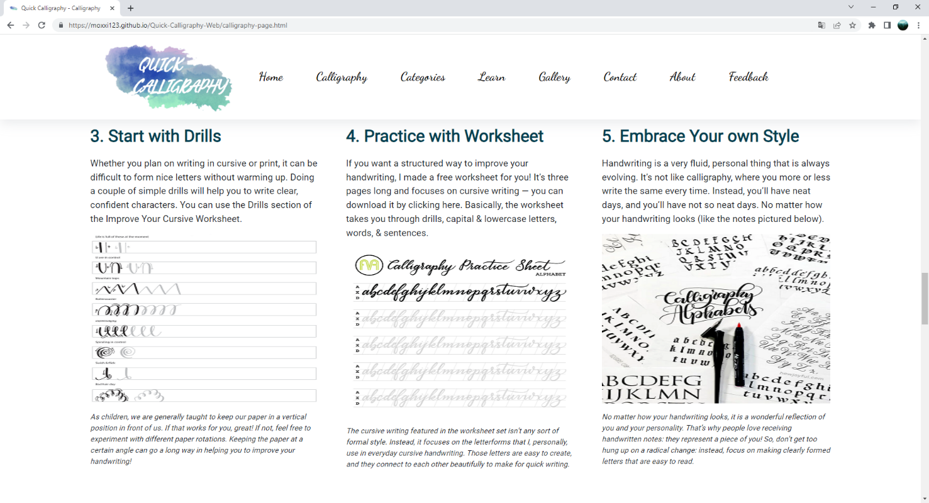

**Figure 35: Calligraphy – part 6**

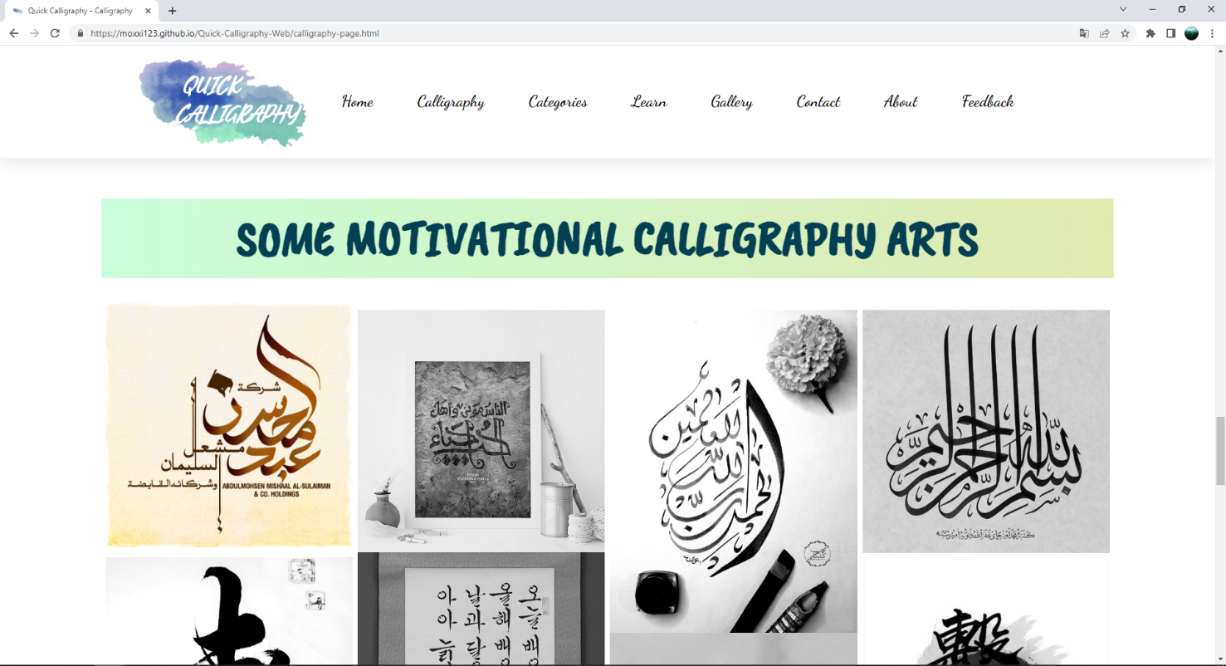

**Figure 36: Calligraphy – part 7**

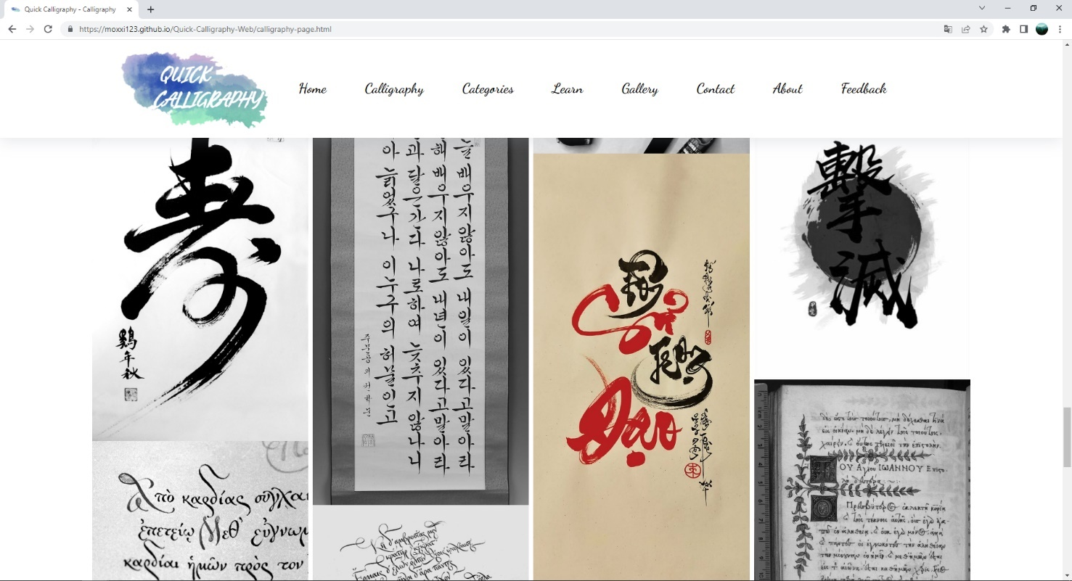

**Figure 37: Calligraphy – part 8**

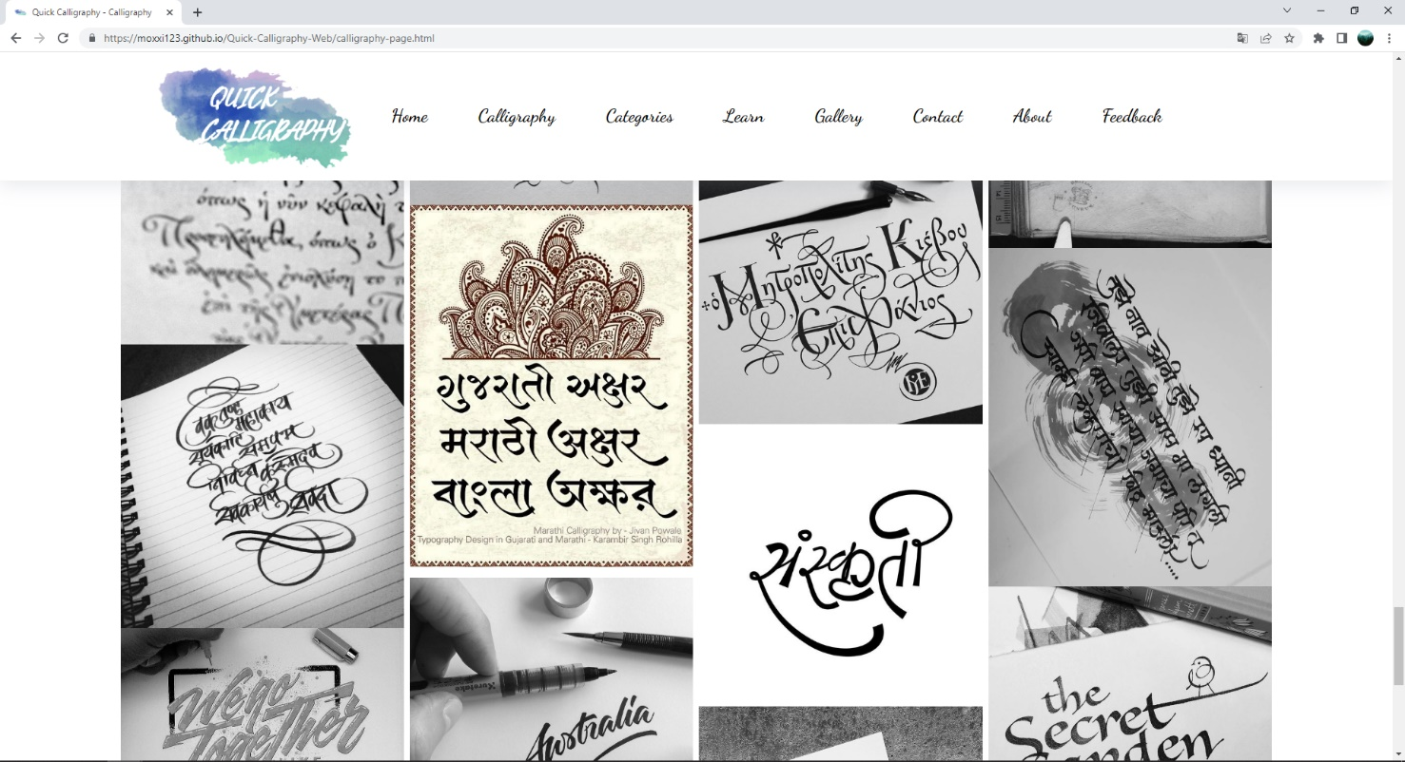

**Figure 38:** **Calligraphy – part 9**

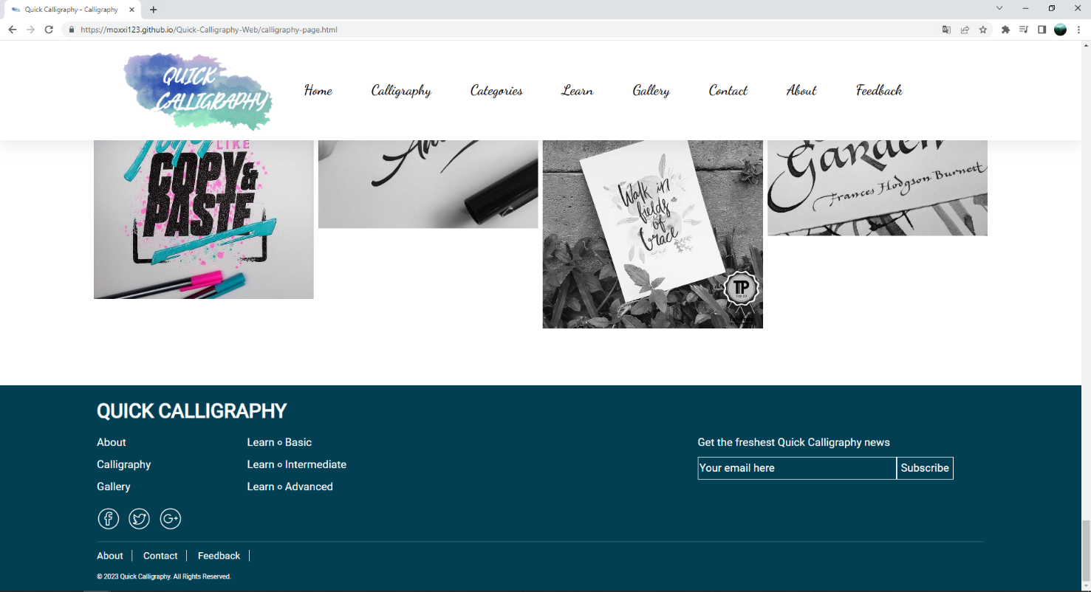

**Figure 39: Calligraphy – part 10**

1. **Arabic calligraphy page**
2. Description

This Arabic page displays following information:

- A brief history of Arabic calligraphy

- Information about Arabic calligraphy font style.

- Some Arabic calligraphy arts.

1. Screen shot

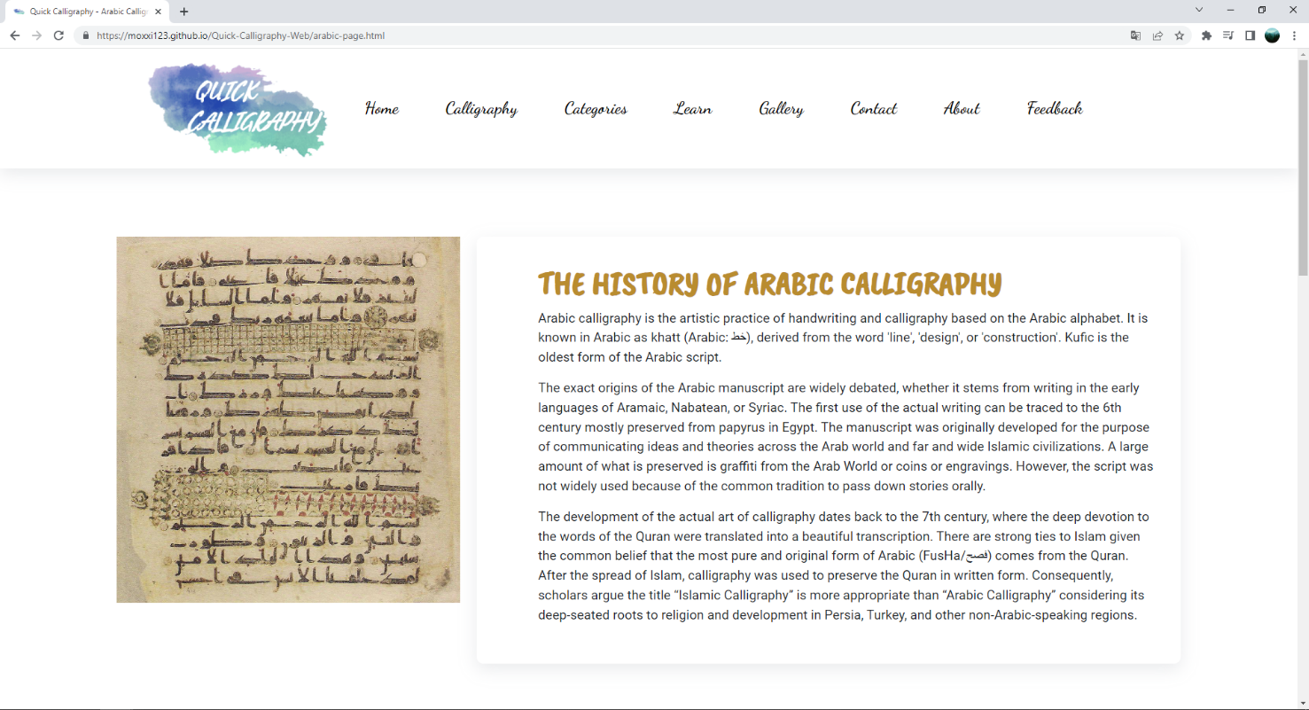

**Figure 40: Arabic – part 1**

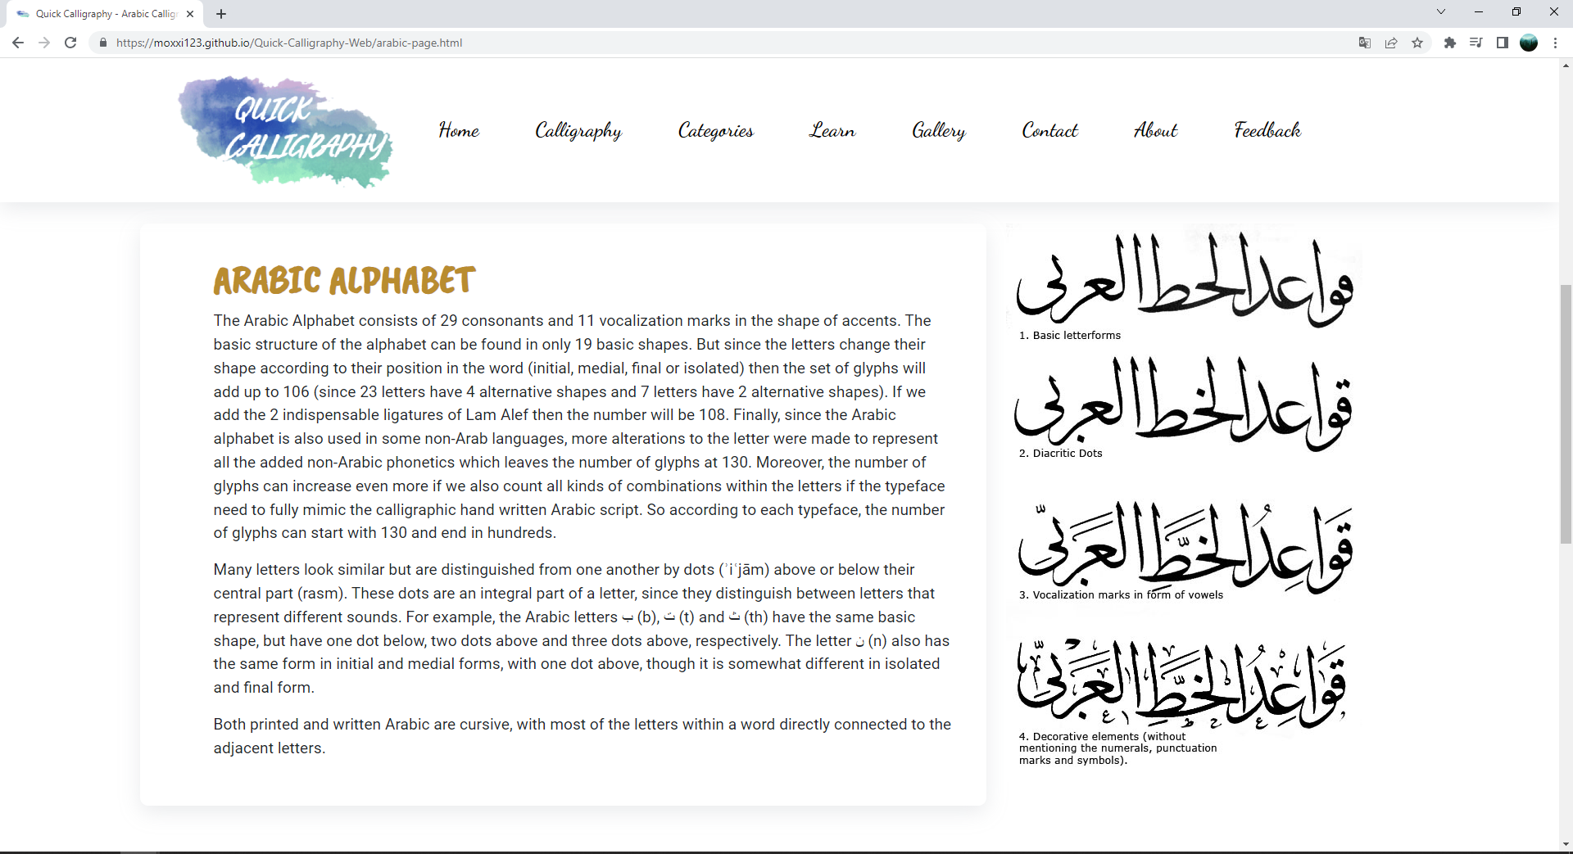

**Figure 41: Arabic – part 2**

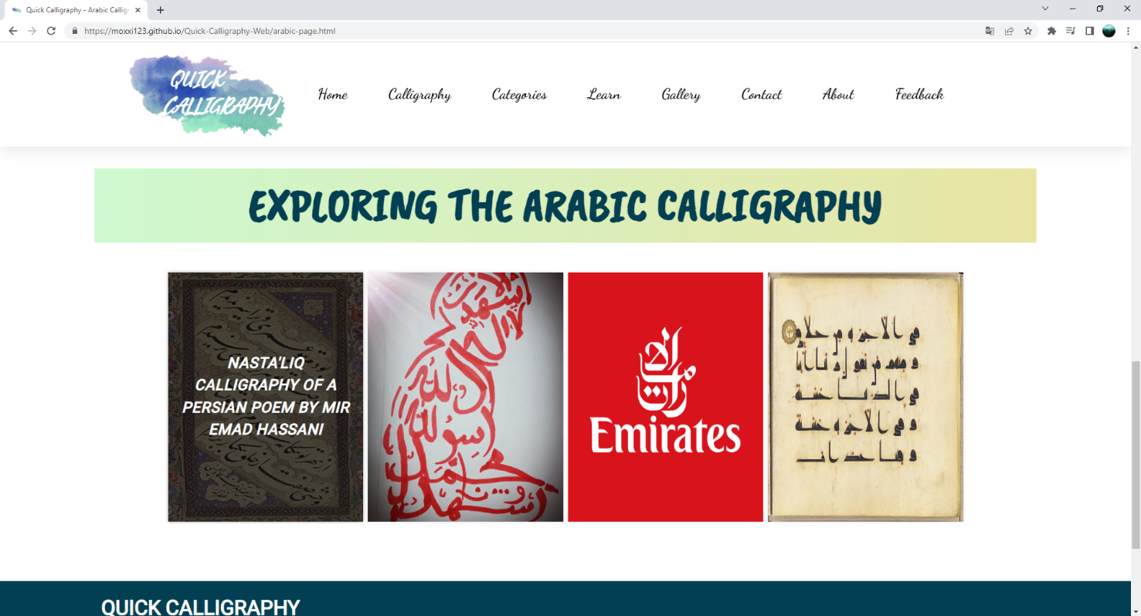

**Figure 42: Arabic – part 3**

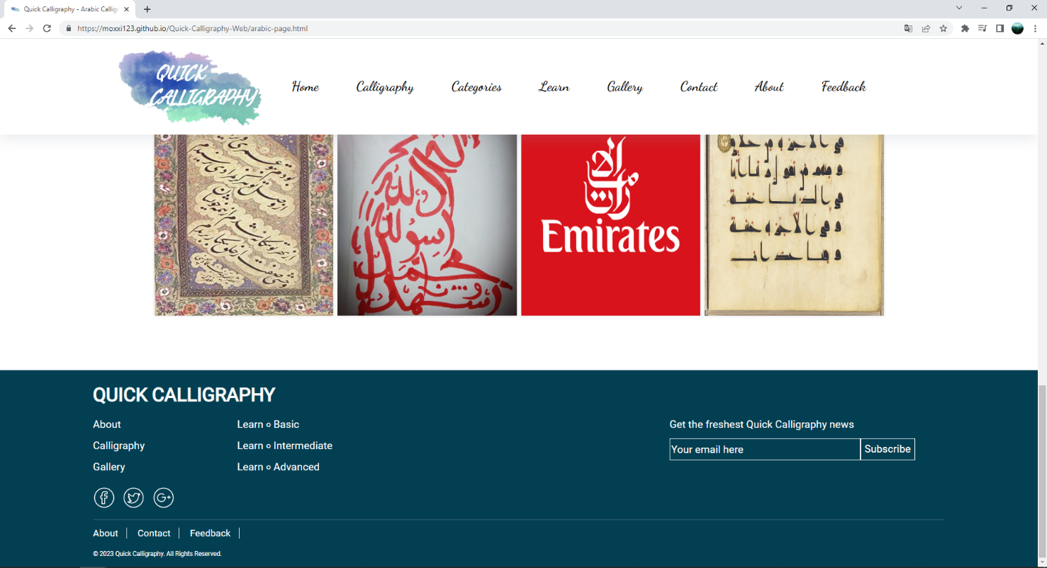

**Figure 43: Arabic – part 4**

1. **East Asian calligraphy page**
2. Description

This East Asian page displays following information:

- A brief history of East Asian calligraphy

- Information about East Asian calligraphy font style.

- Some East Asian calligraphy arts.

1. Screen shot

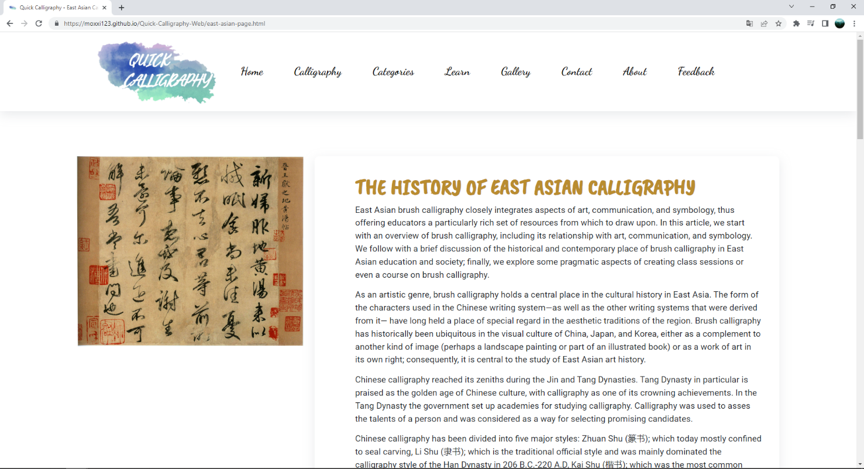

**Figure 44: East Asian – part 1**

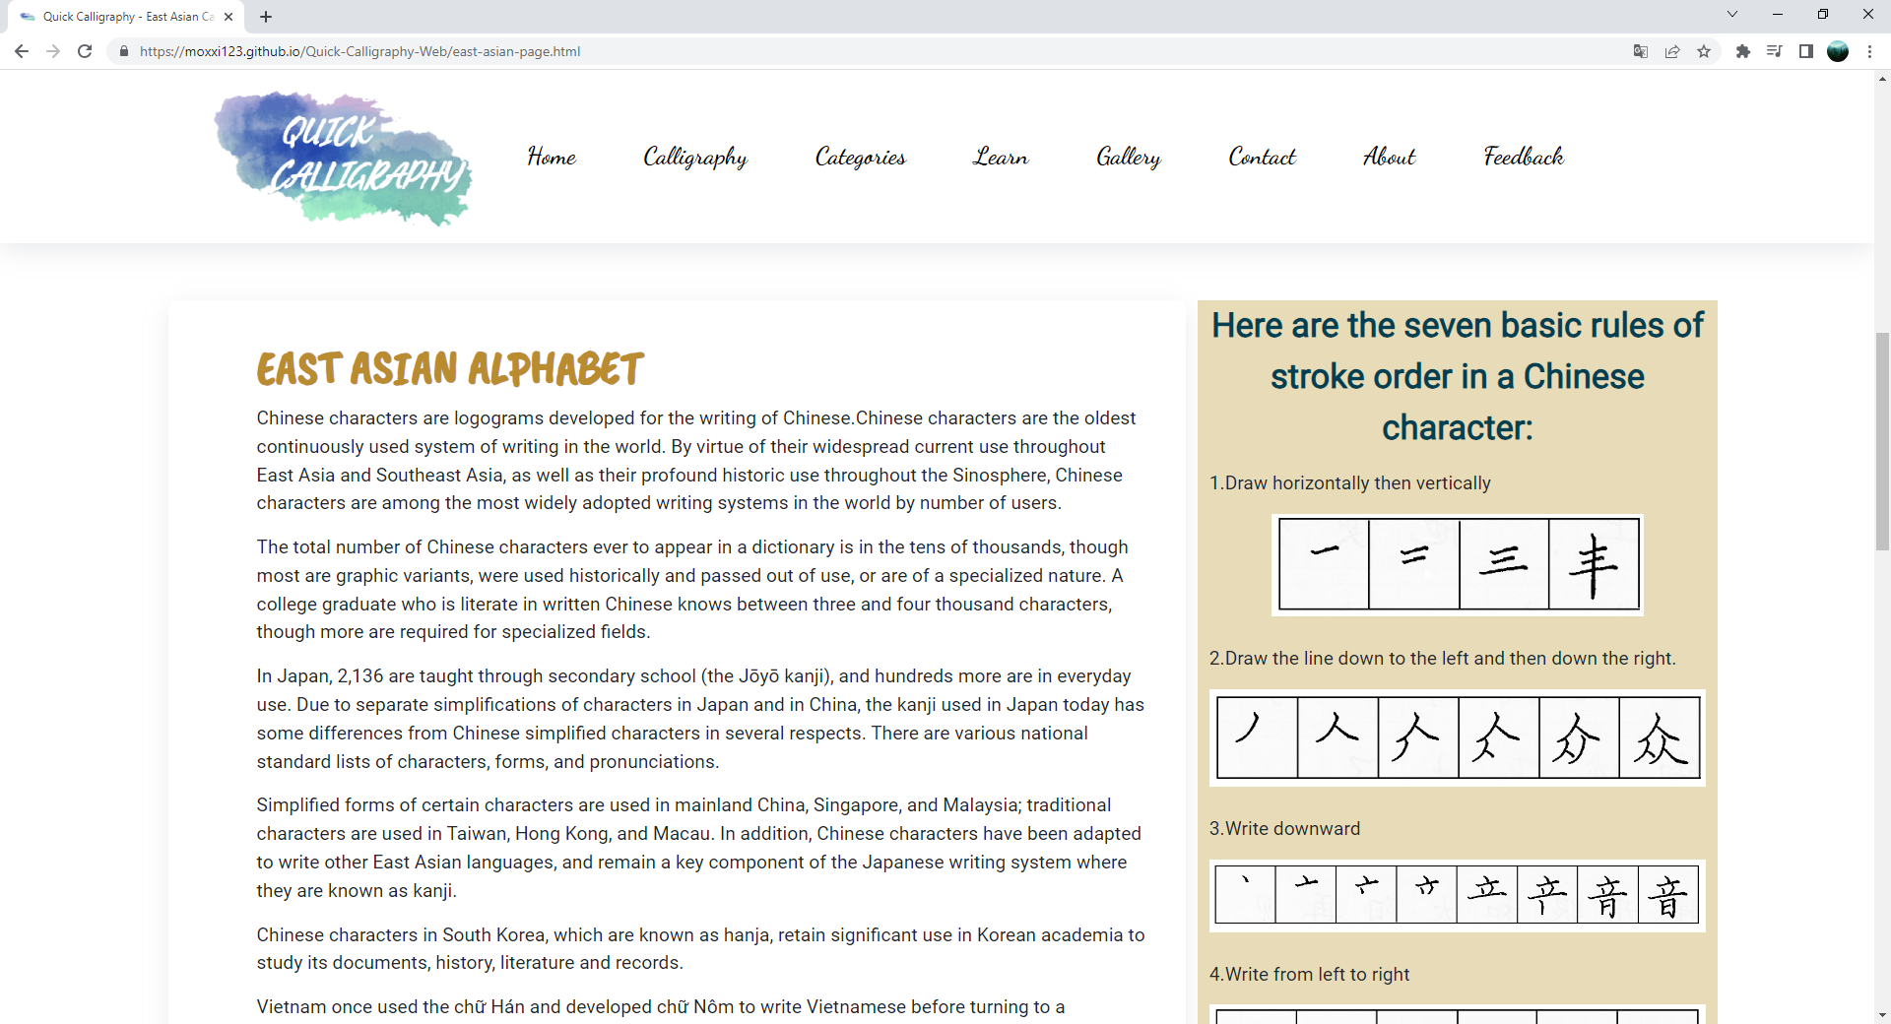

**Figure 45: East Asian – part 2**

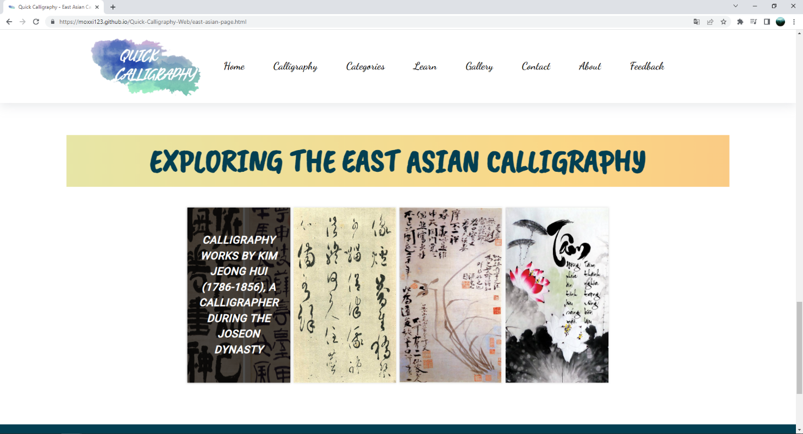

**Figure 46: East Asian – part 3**

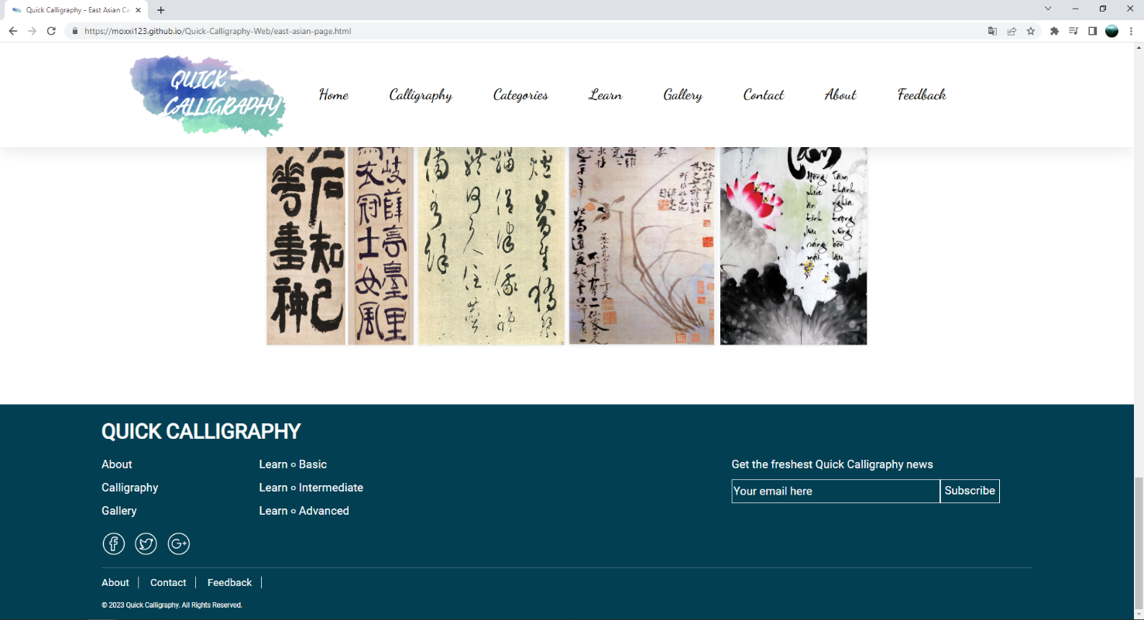

**Figure 47: East Asian – part 4**

1. **Greek calligraphy page**
2. Description

This Greek page displays following information:

- A brief history of Greek calligraphy

- Information about Greek calligraphy font style.

- Some Greek calligraphy arts.

1. Screen shot

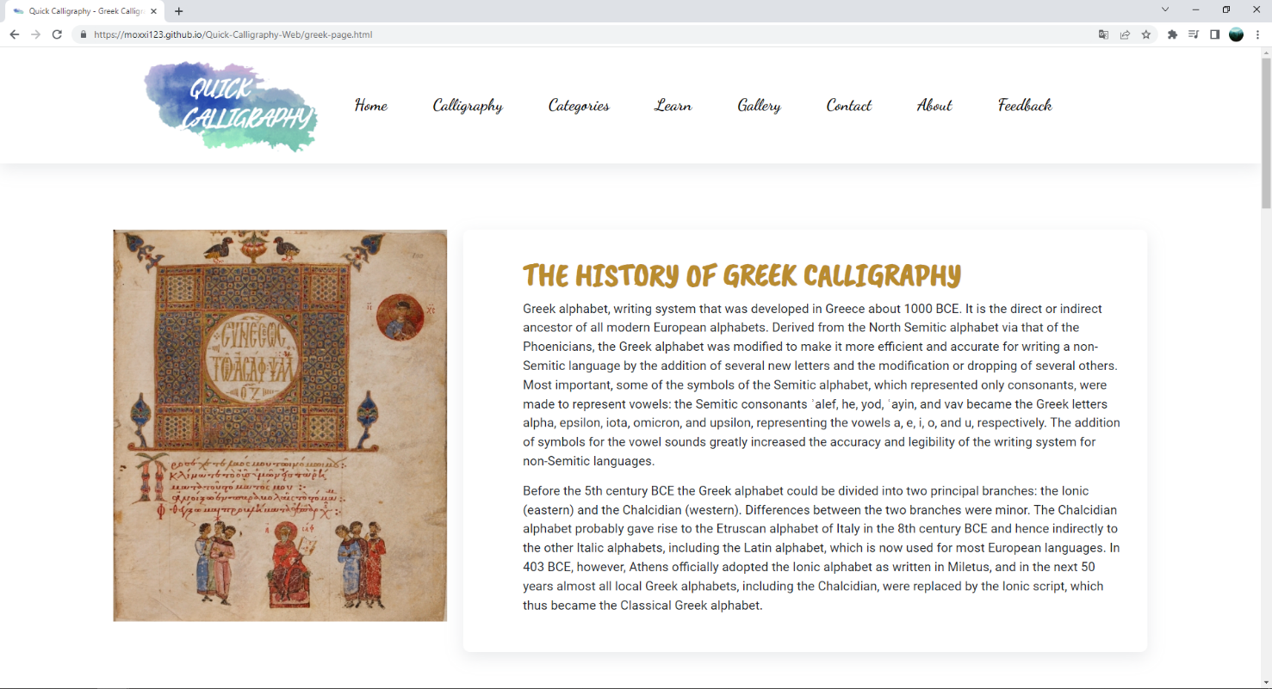

**Figure 48: Greek – part 1**

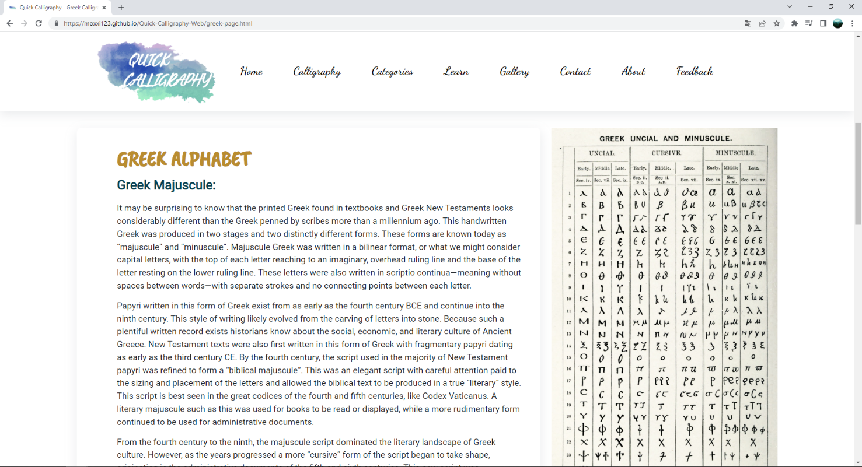

**Figure 49: Greek – part 2**

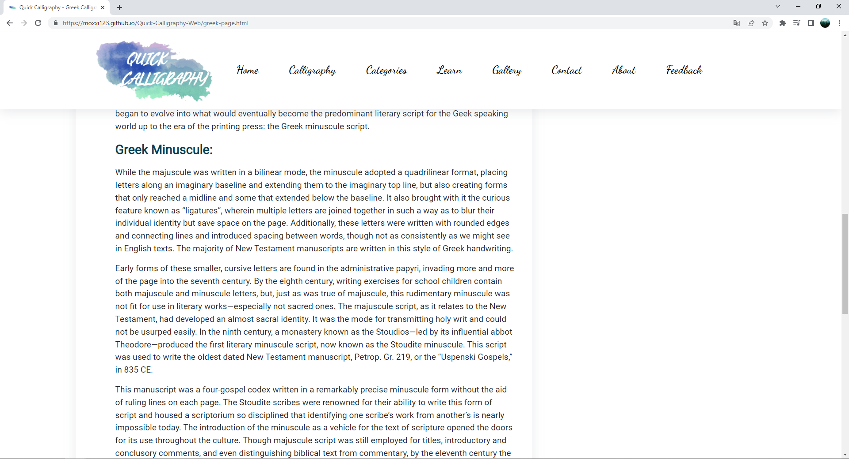

**Figure 50:** **Greek – part 3**

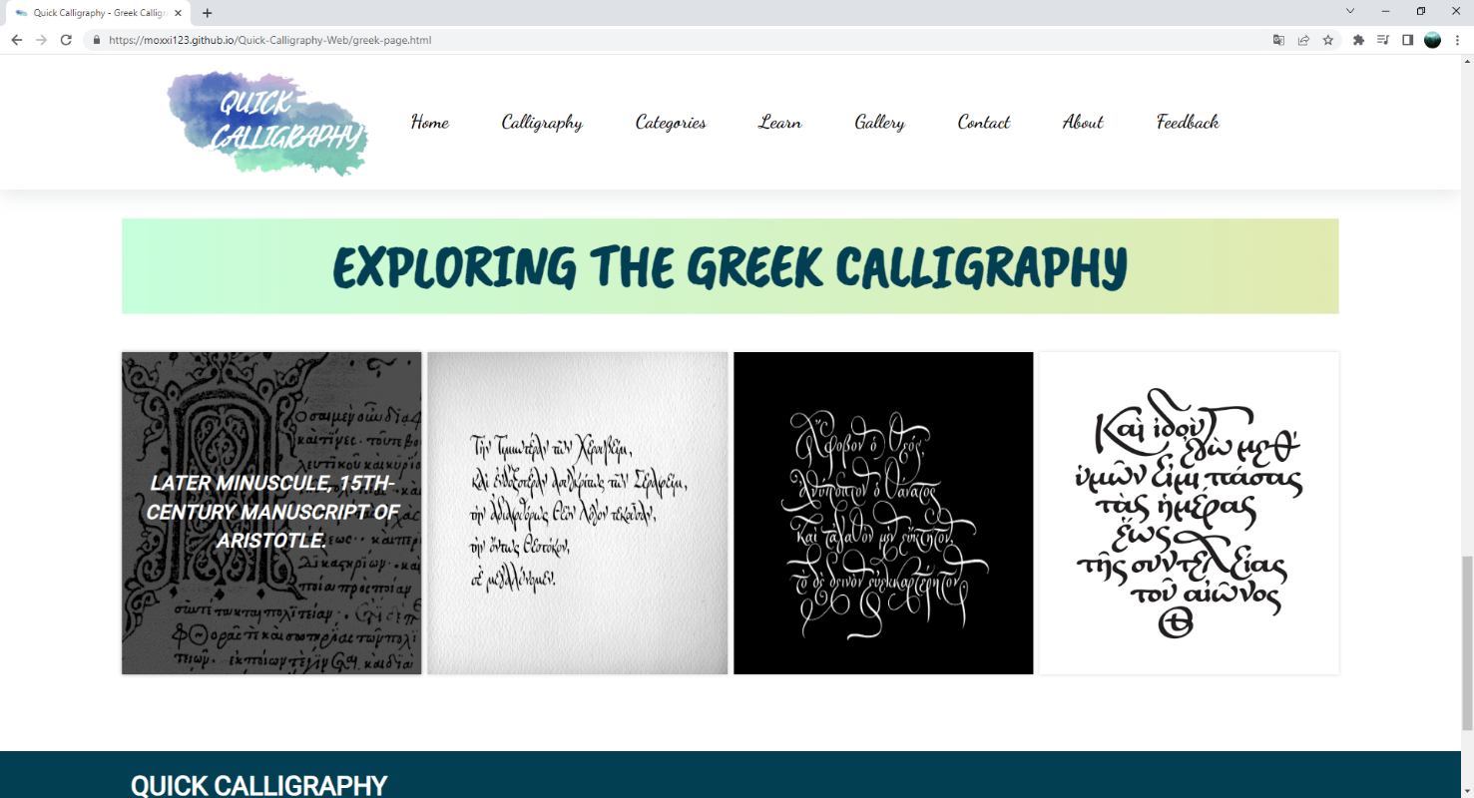

**Figure 51: Greek – part 4**

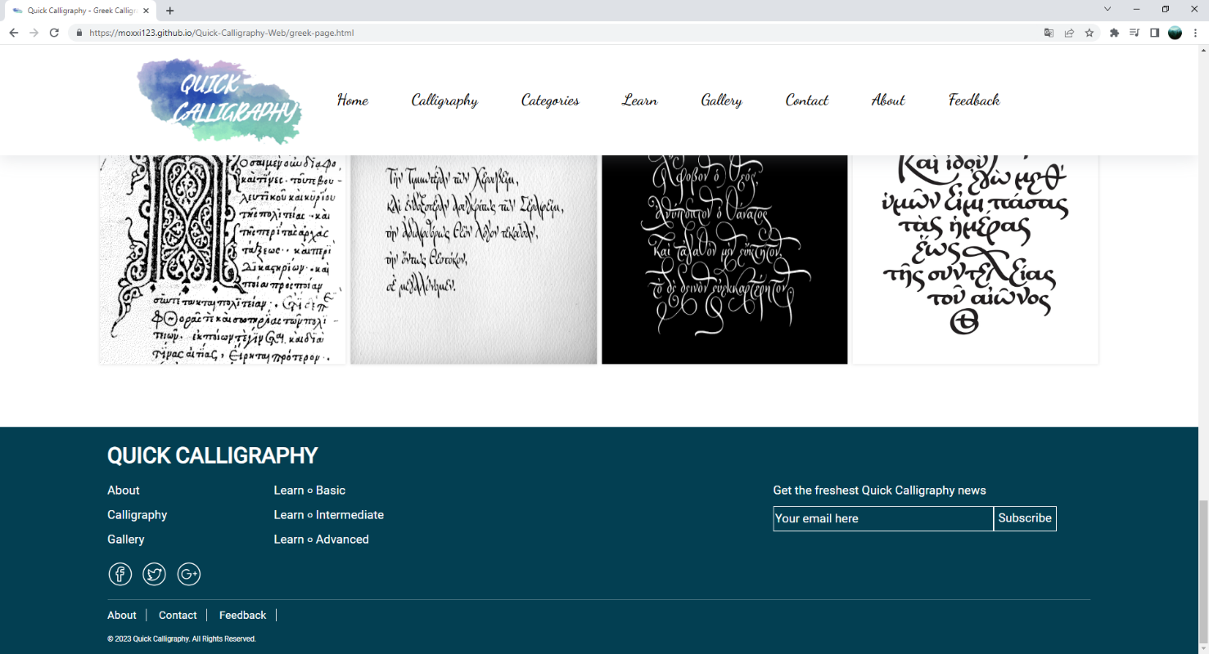

**Figure 52: Greek – part 5**

1. **Indic calligraphy page**
2. Description

This Indic page displays following information:

- A brief history of Indic calligraphy

- Information about Indic calligraphy font style.

- Some Indic calligraphy arts.

1. Screen shot

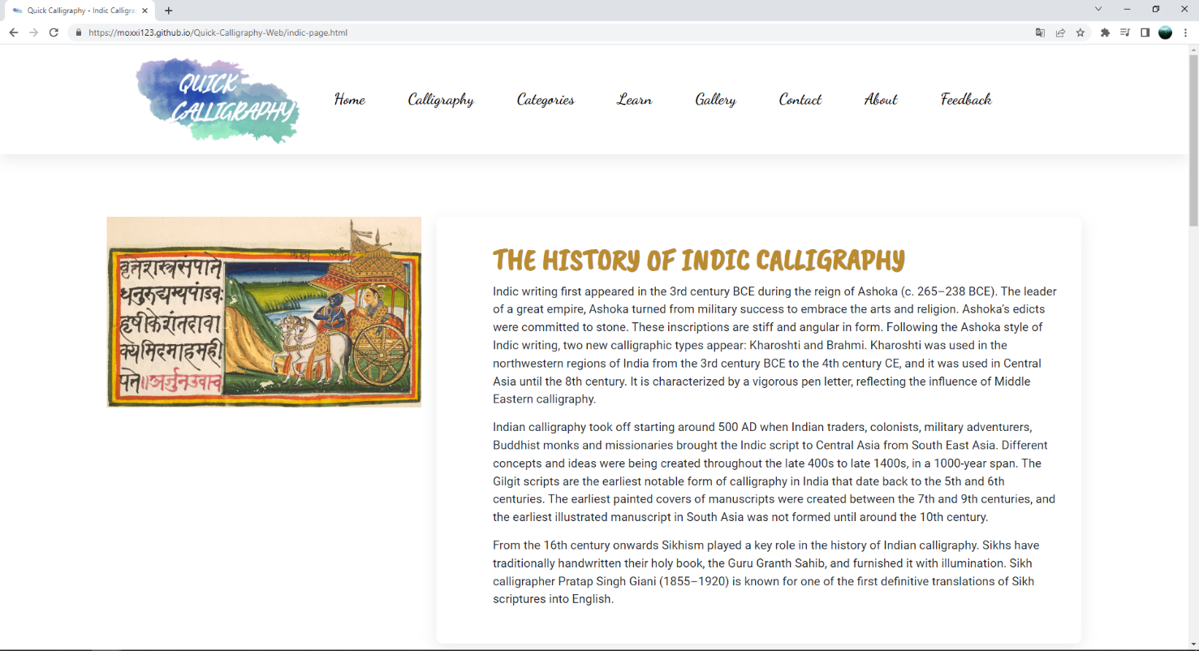

**Figure 53: Indic – part 1**

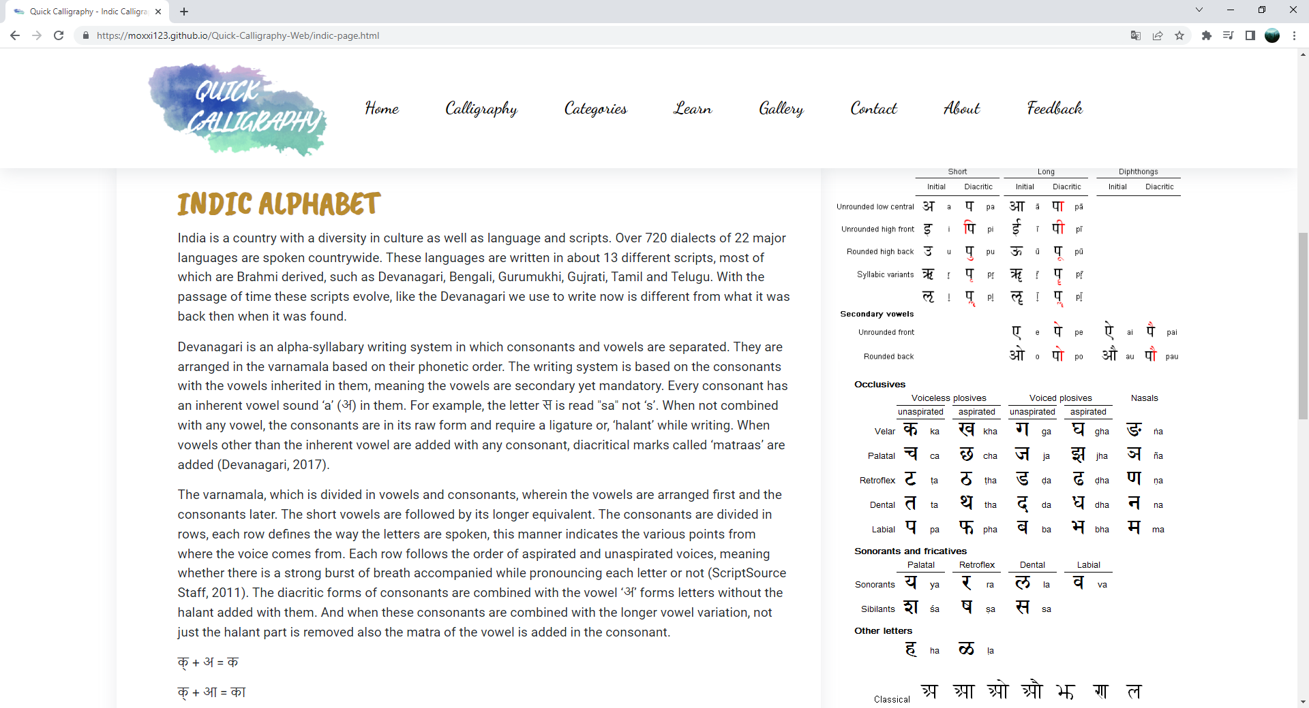

**Figure 54: Indic – part 2**

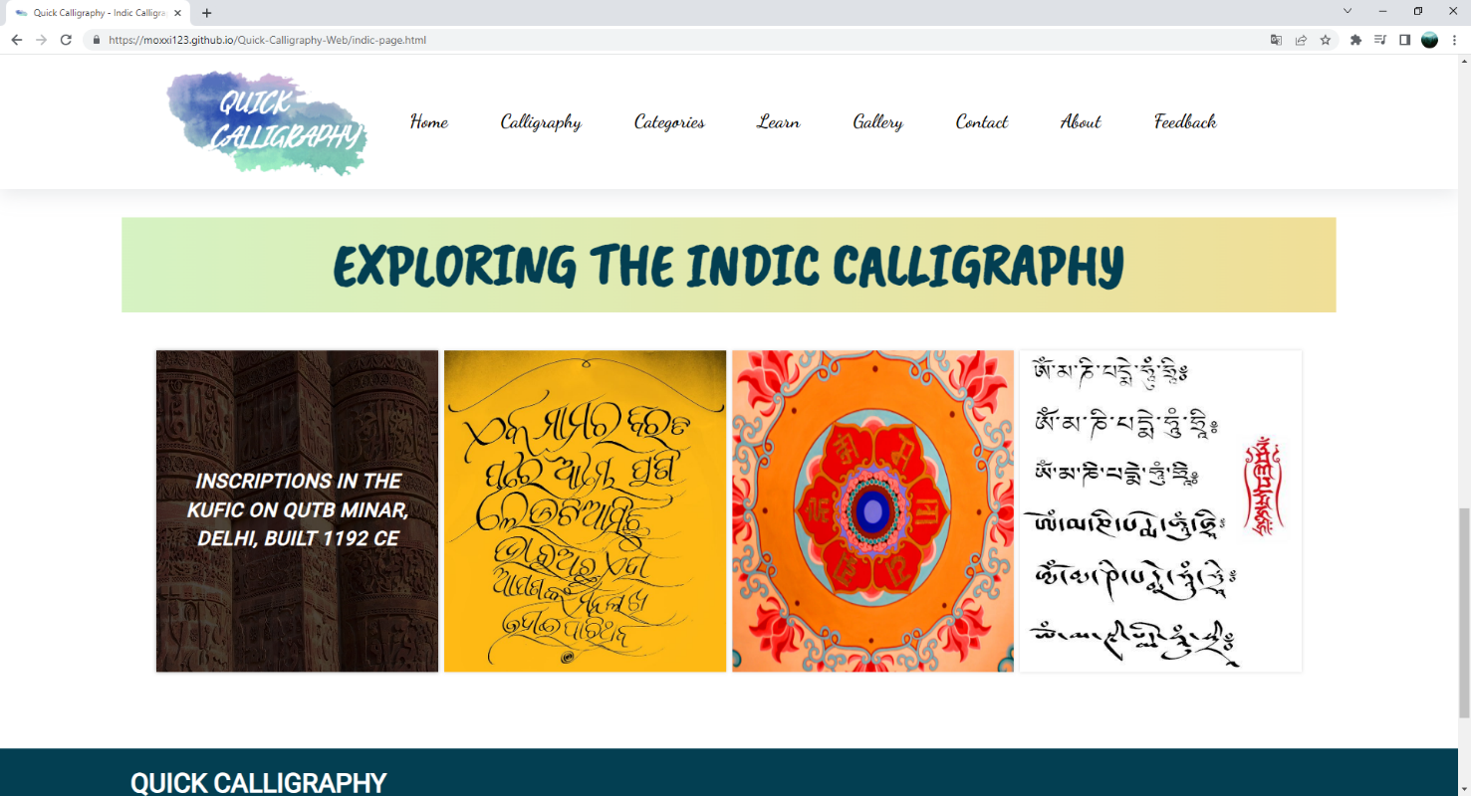

**Figure 55: Indic – part 3**

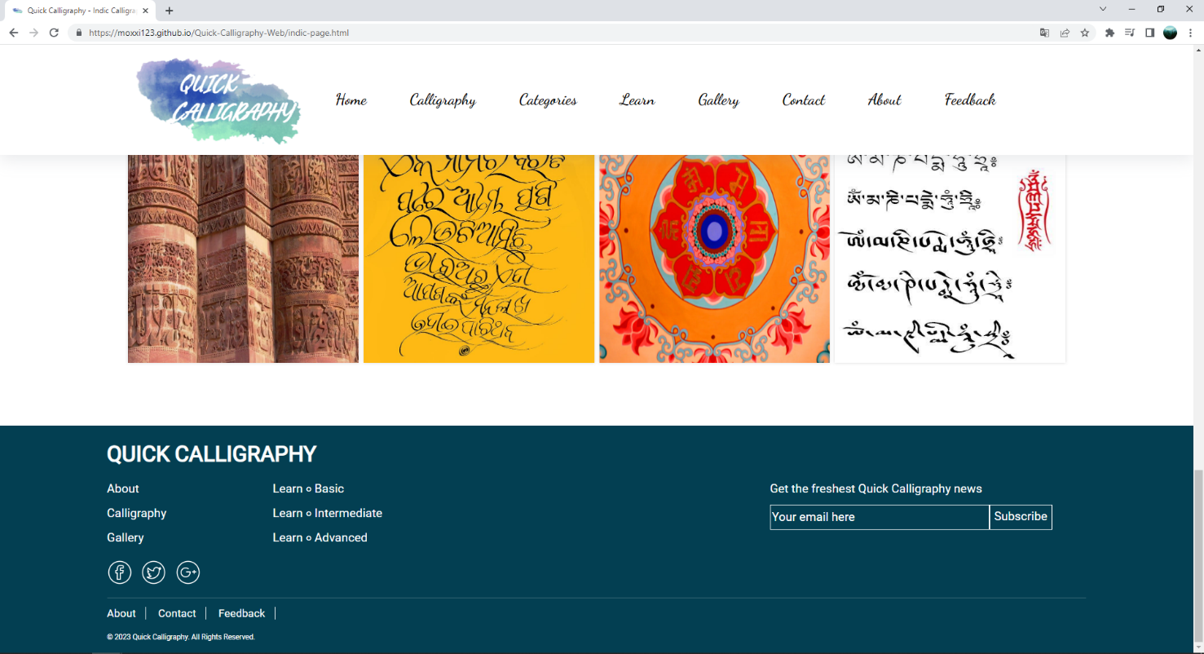

**Figure 56: Indic – part 4**

1. **Western calligraphy page**
2. Description

This Western page displays following information:

- A brief history of Western calligraphy

- Information about Western calligraphy font style.

- Some Western calligraphy arts.

1. Screen shot

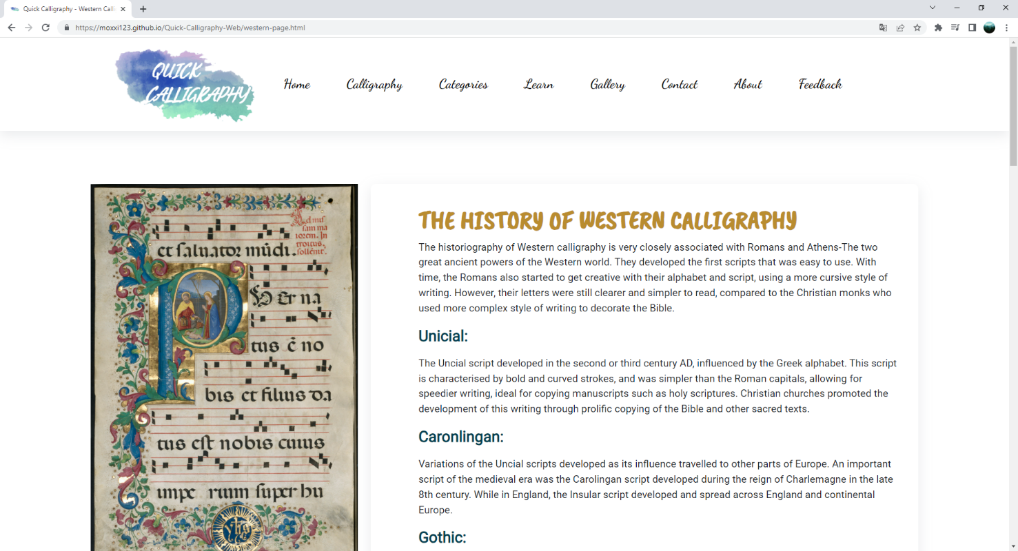

**Figure 57:** **Western – part 1**

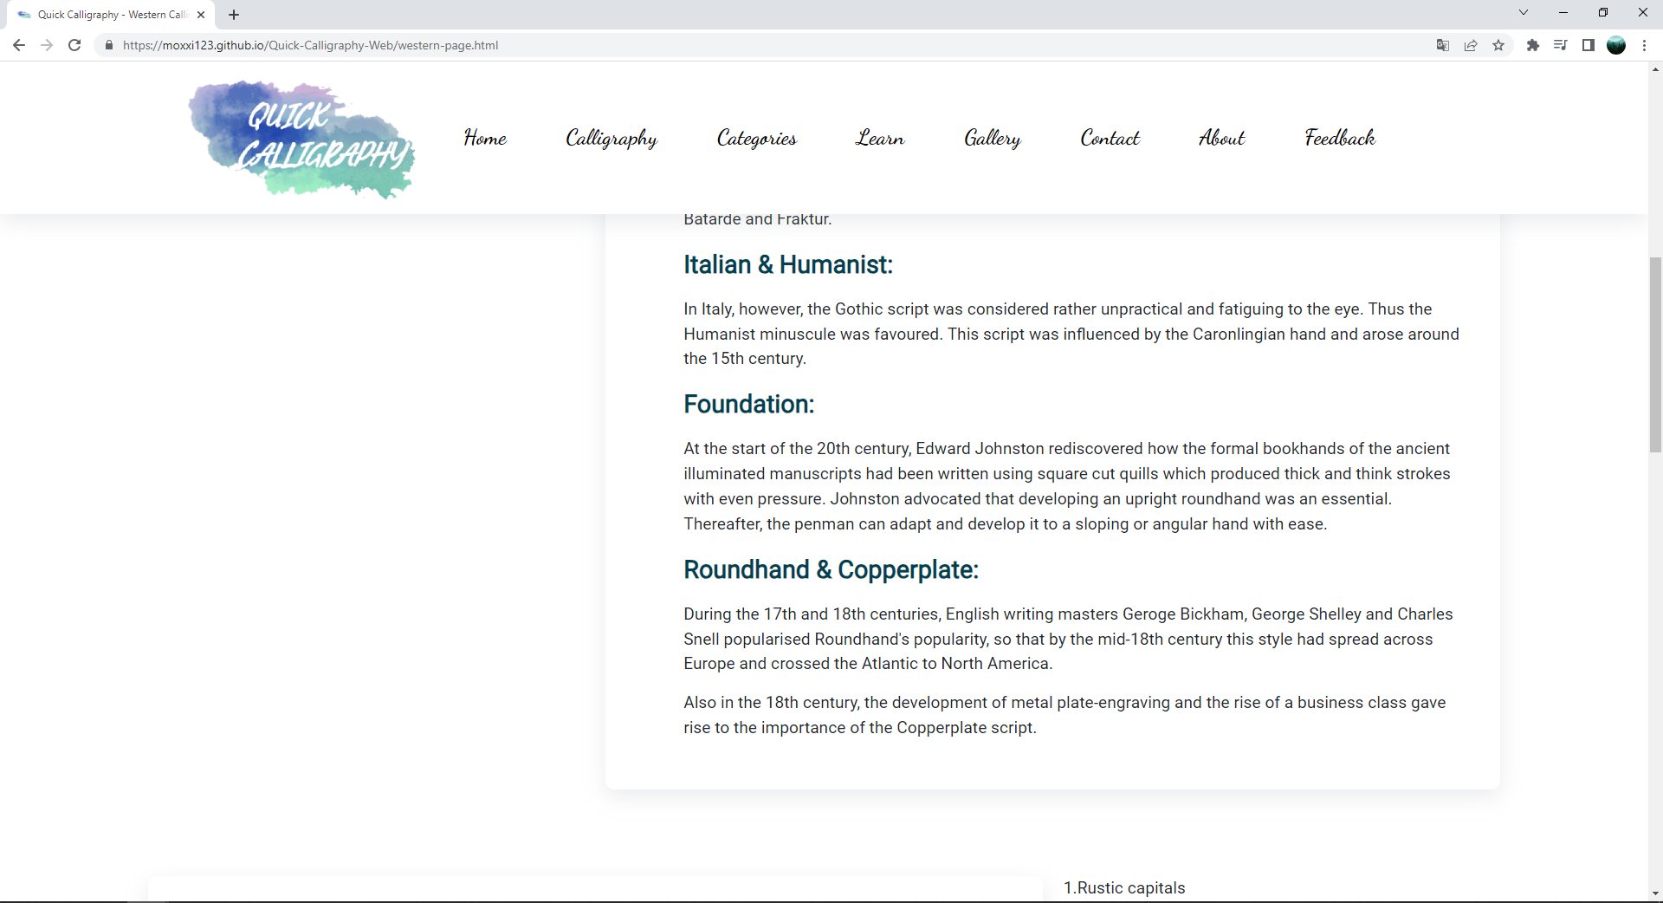

**Figure 58: Western – part 2**

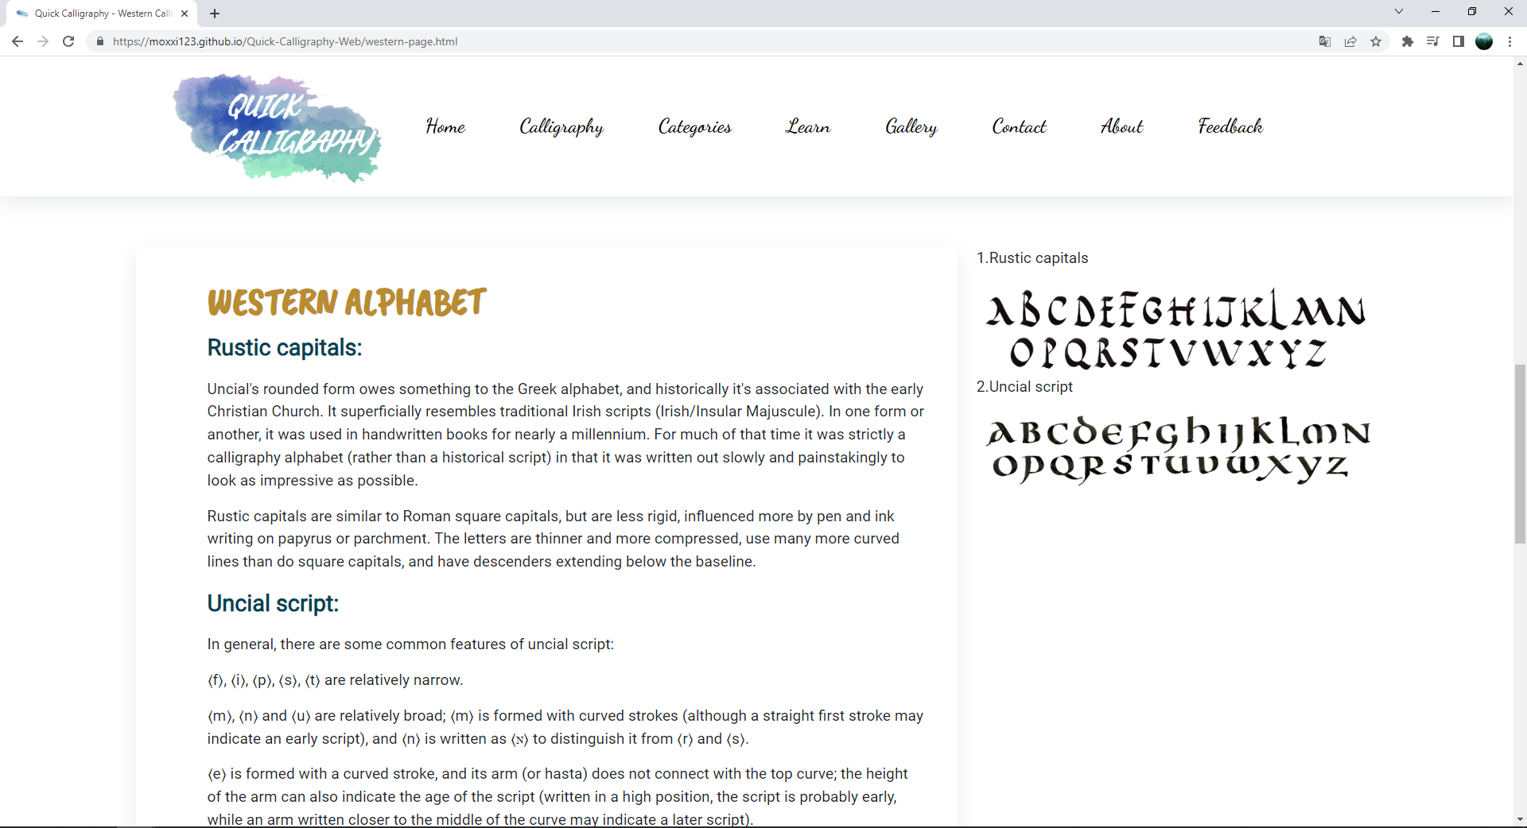

**Figure 59:** **Western – part 3**

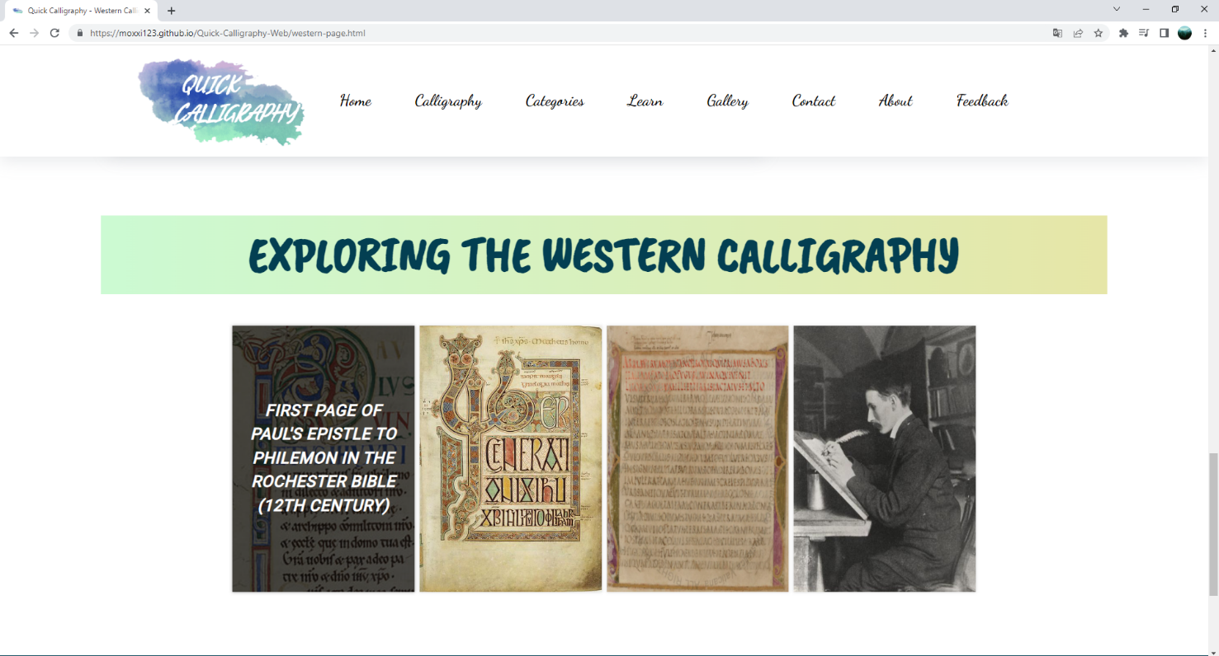

**Figure 60: Western – part 4**

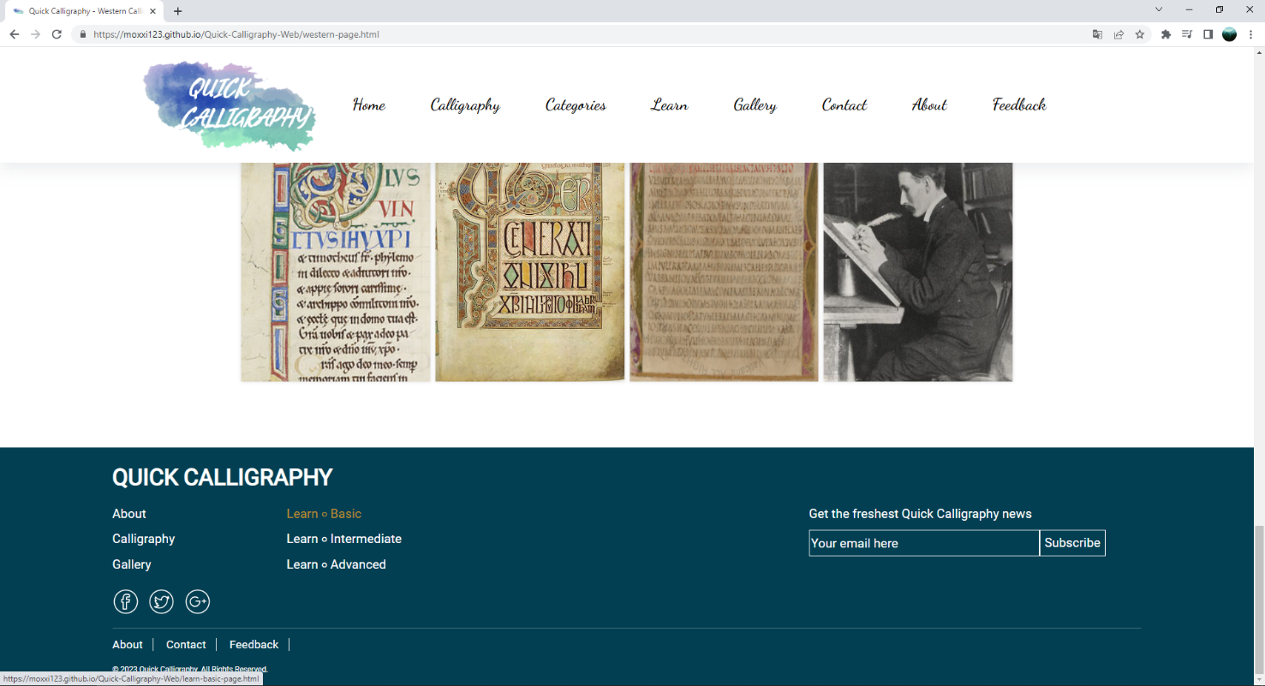

**Figure 61: Western – part 5**

1. **Learn Basic page**
2. Description

This Learn Basic page displays following information:

- Repeat the concept calligraphy definition.

- Instructions for choosing paper and guiding lines to start writing calligraphy.

- Some basic techniques for slant, hairline, and stroke.

- Some more information about types of equipment used for writing.

1. Screen shot

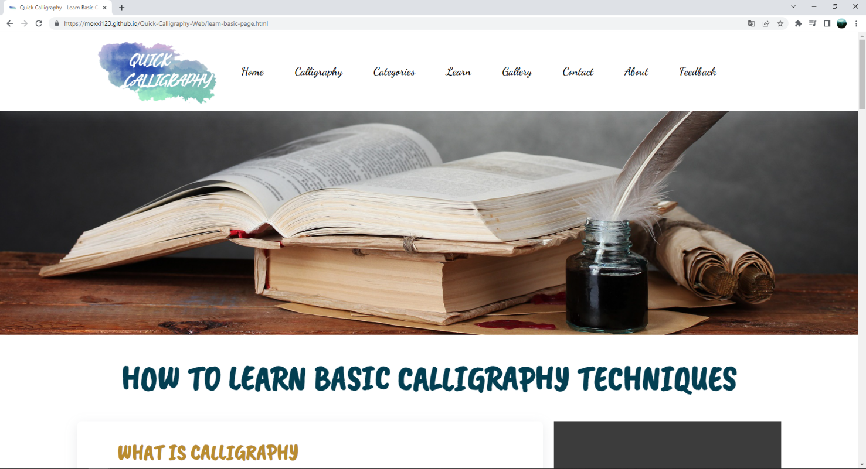

**Figure 62: Learn Basic – part 1**

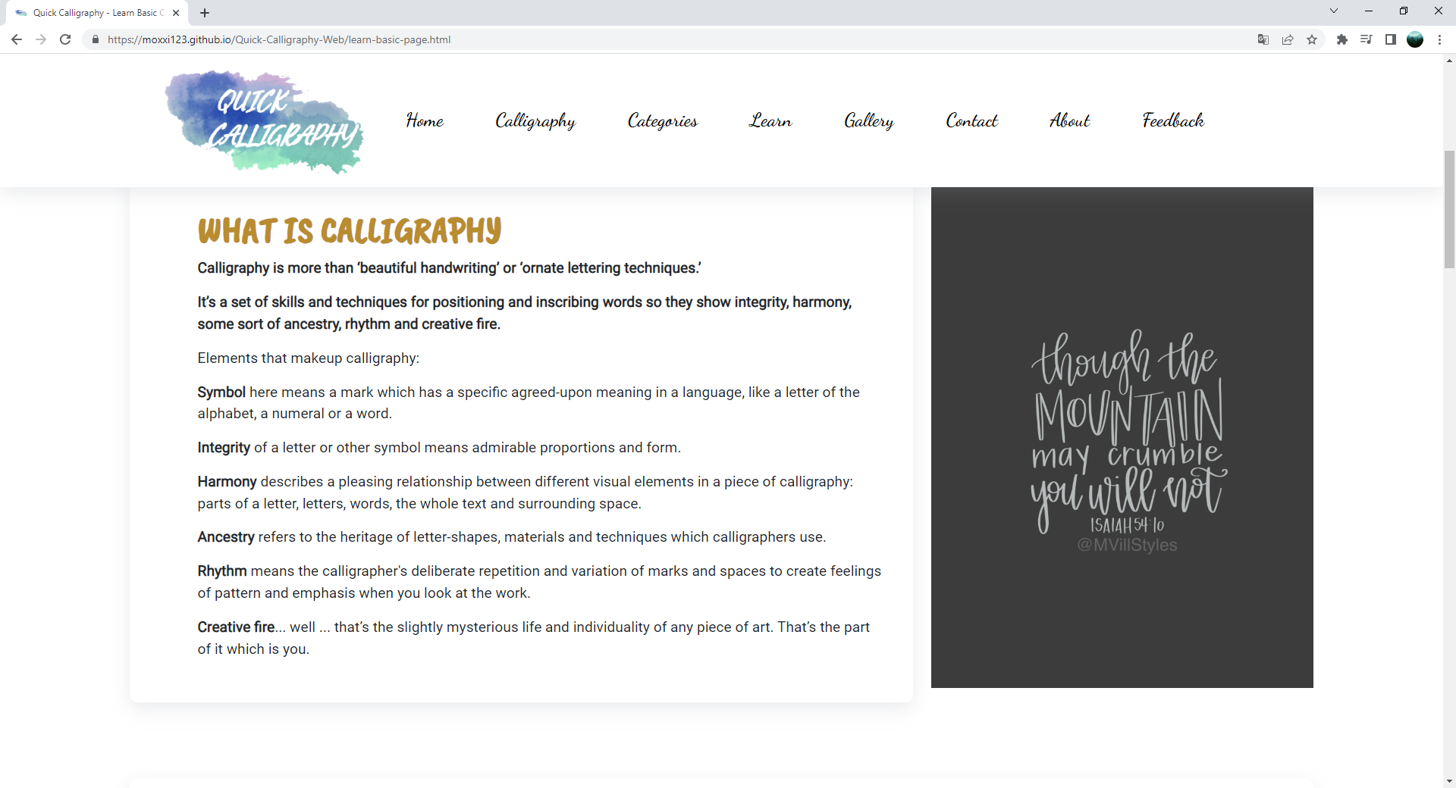

**Figure 63: Learn Basic – part 2**

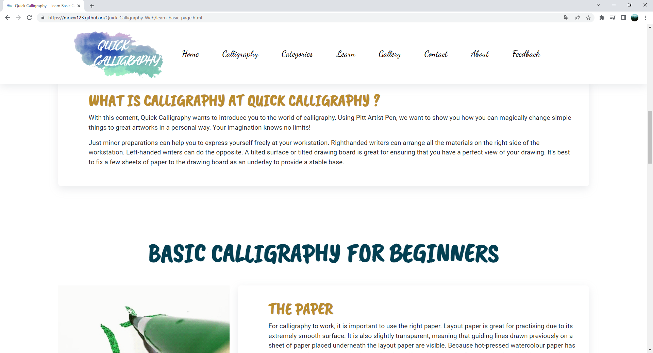

**Figure 64: Learn Basic – part 3**

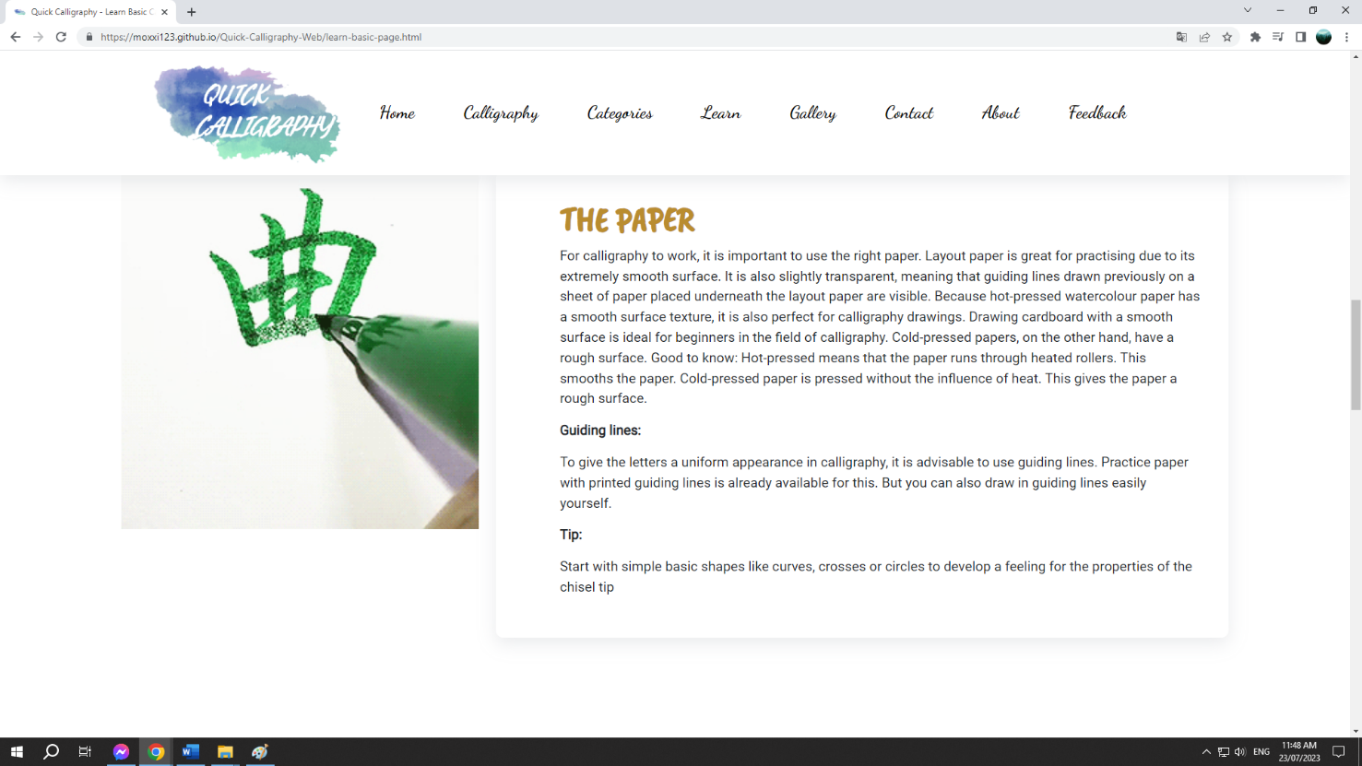

**Figure 65: Learn Basic – part 4**

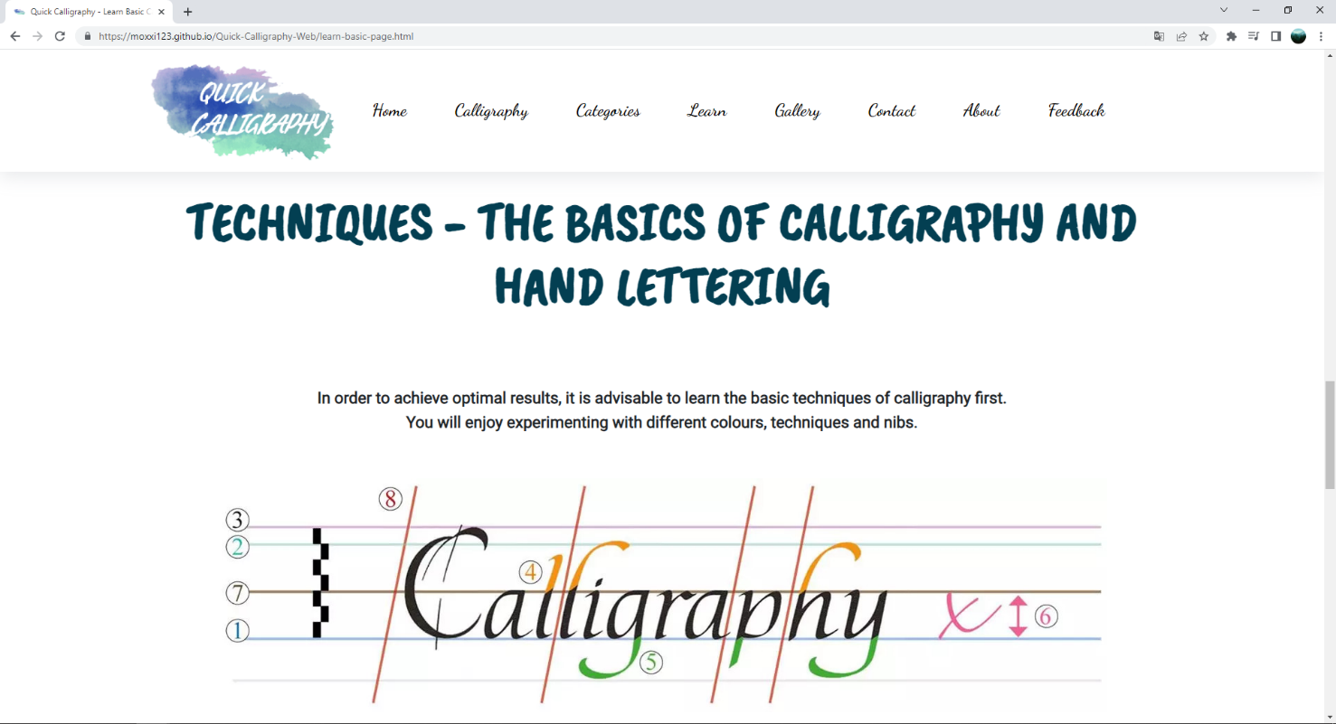

**Figure 66: Learn Basic – part 5**

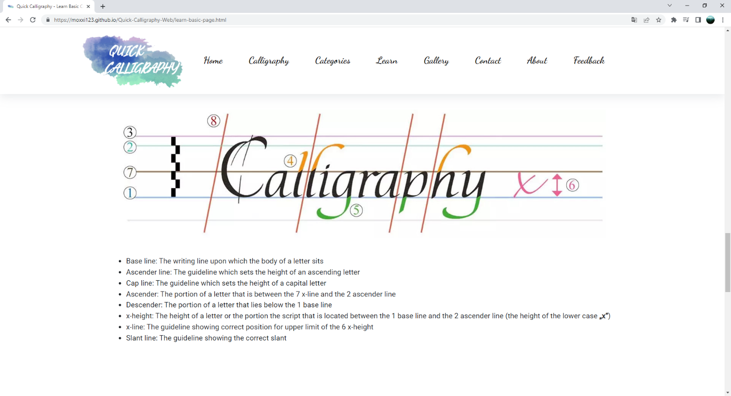

**Figure 67: Learn Basic – part 6**

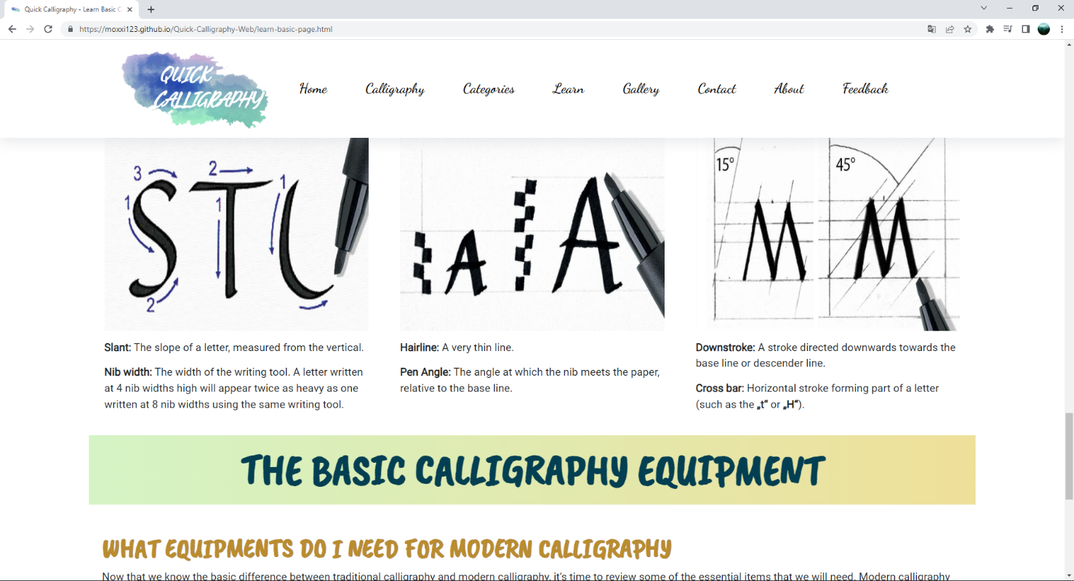

**Figure 68: Learn Basic – part 7**

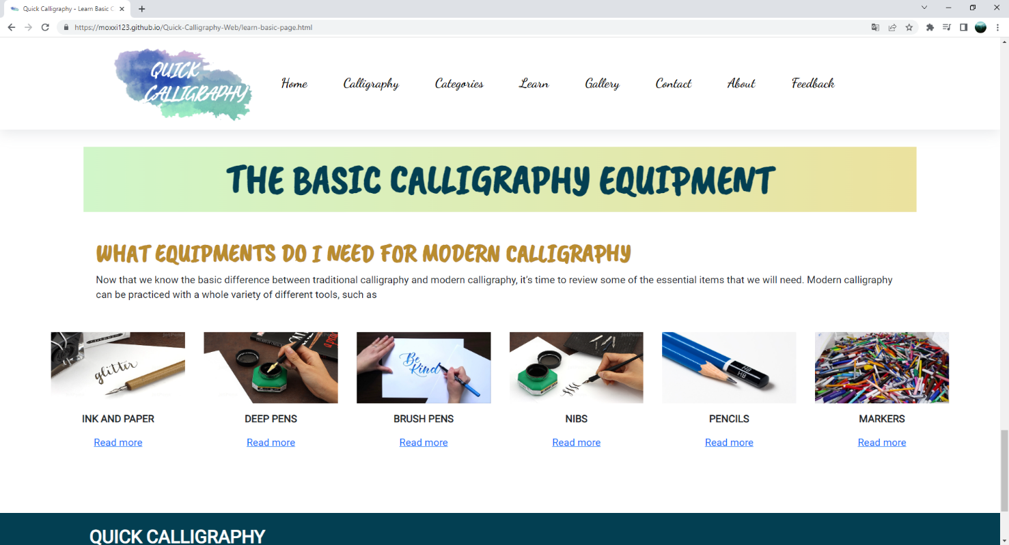

**Figure 69: Learn Basic – part 8**

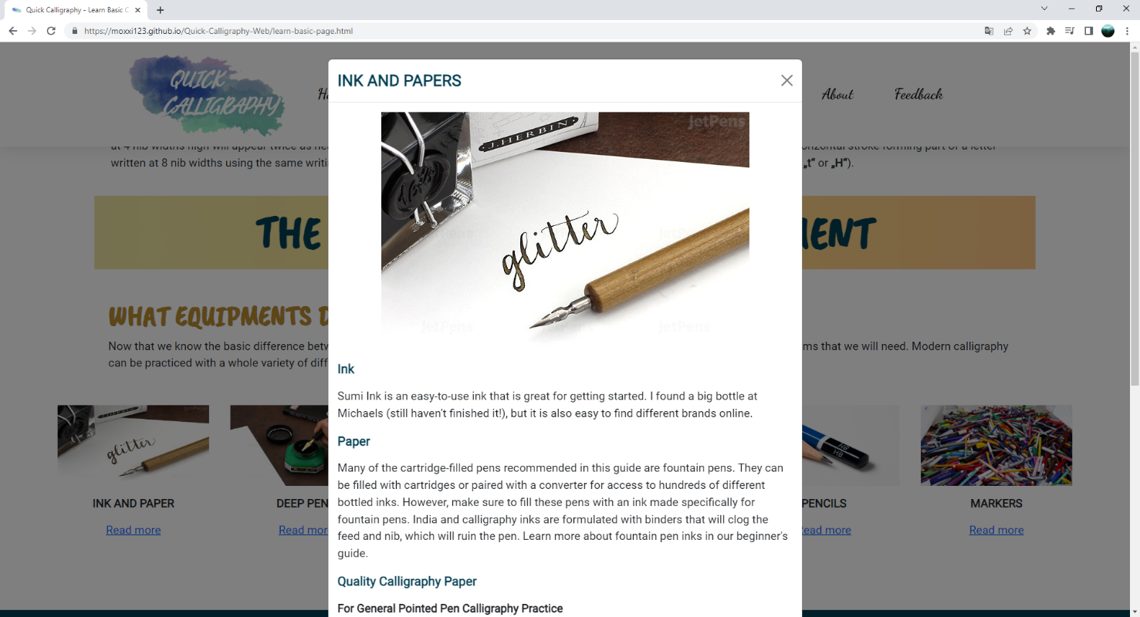

**Figure 70: Learn Basic – part 9**

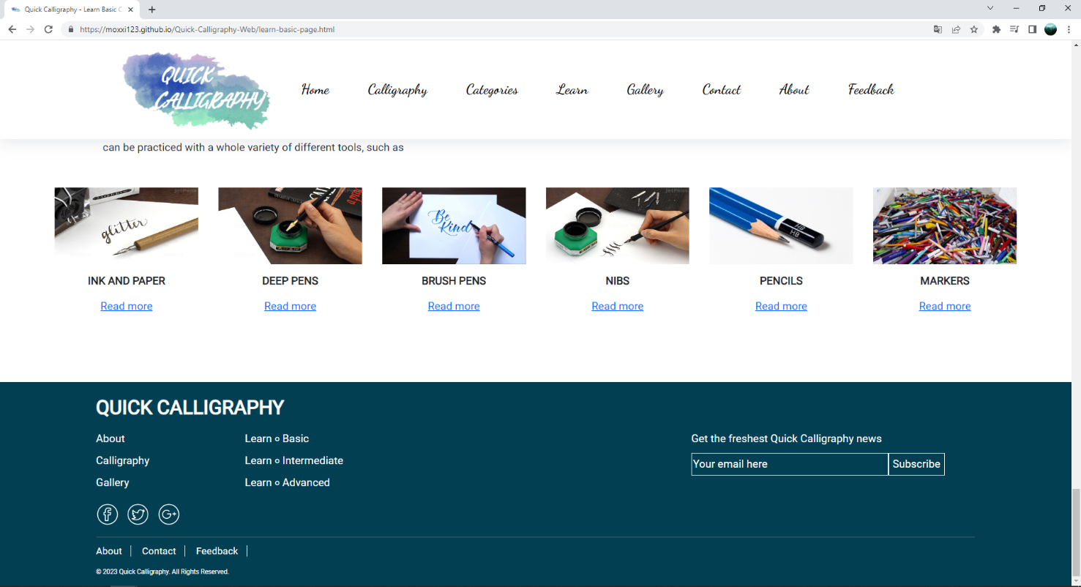

**Figure 71: Learn Basic – part 10**

1. **Learn Intermediate page**
2. Description

This Learn Intermediate page displays following information:

- Tips to be better at calligraphy.

- Instructions for holding pen.

- Some basic techniques for stroke to improve handwriting.

1. Screen shot

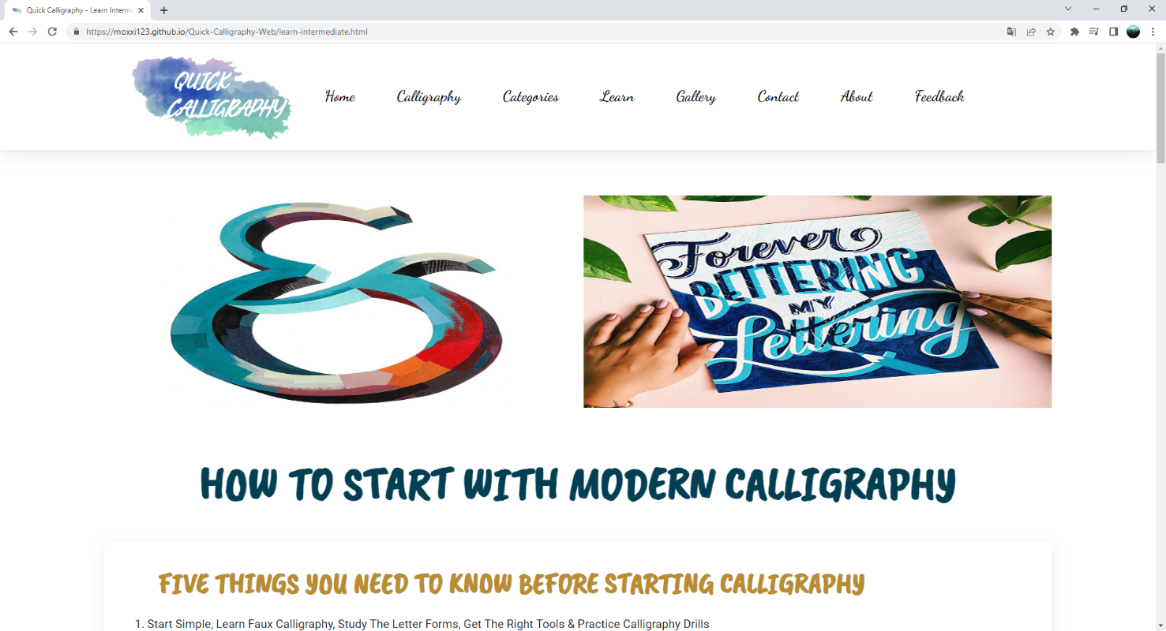

**Figure 72: Learn Intermediate – part 1**

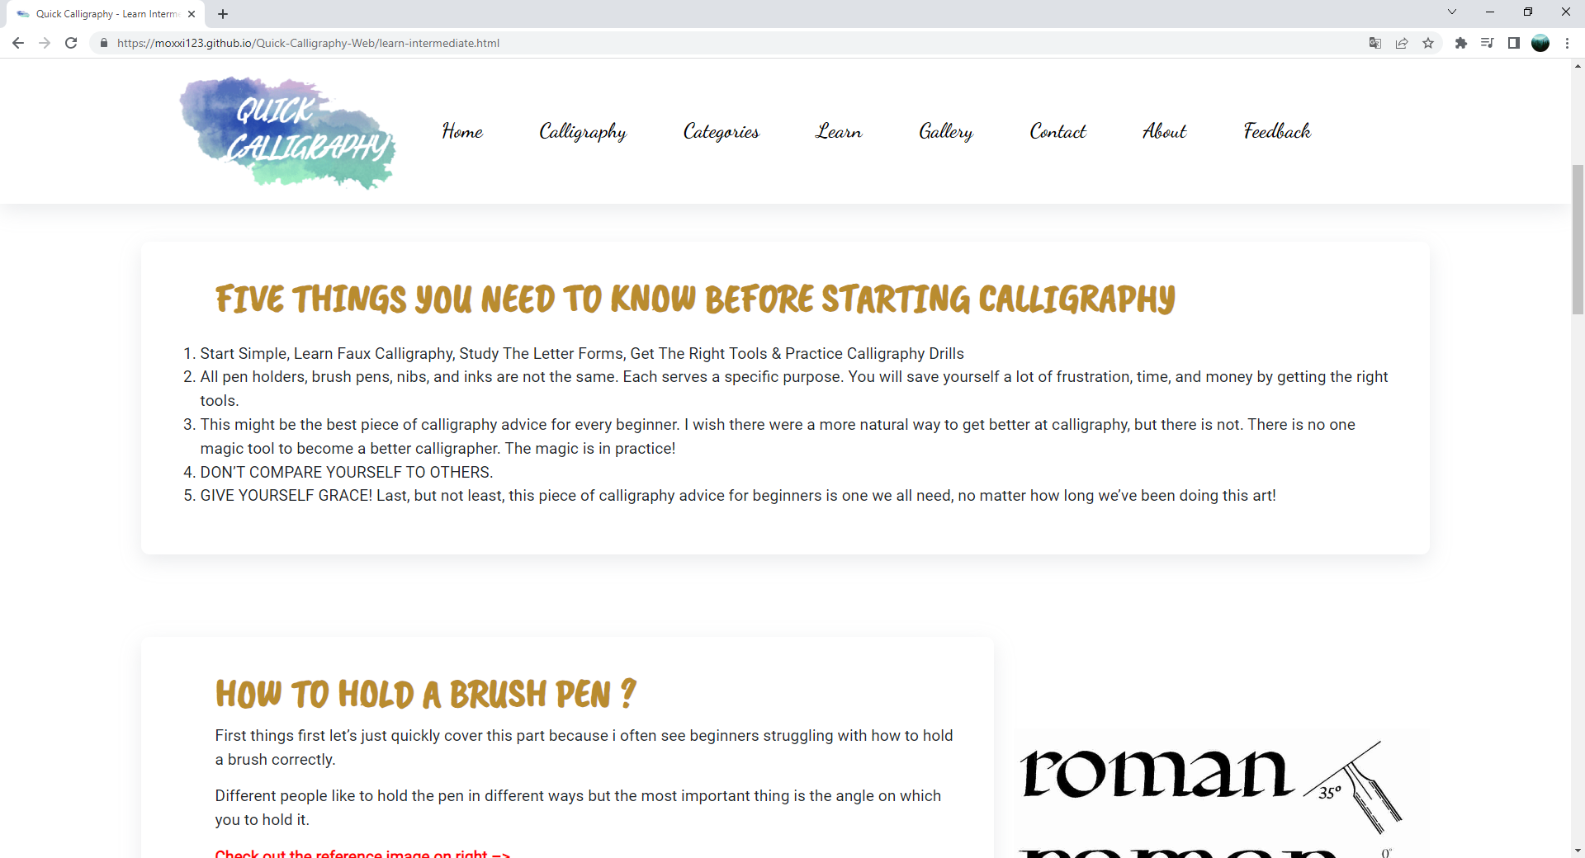

**Figure 73: Learn Intermediate – part 2**

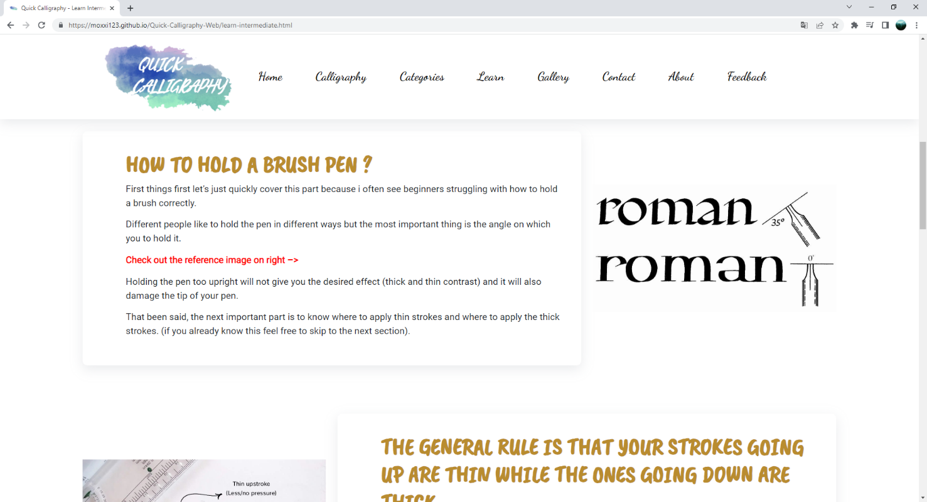

**Figure 74: Learn Intermediate – part 3**

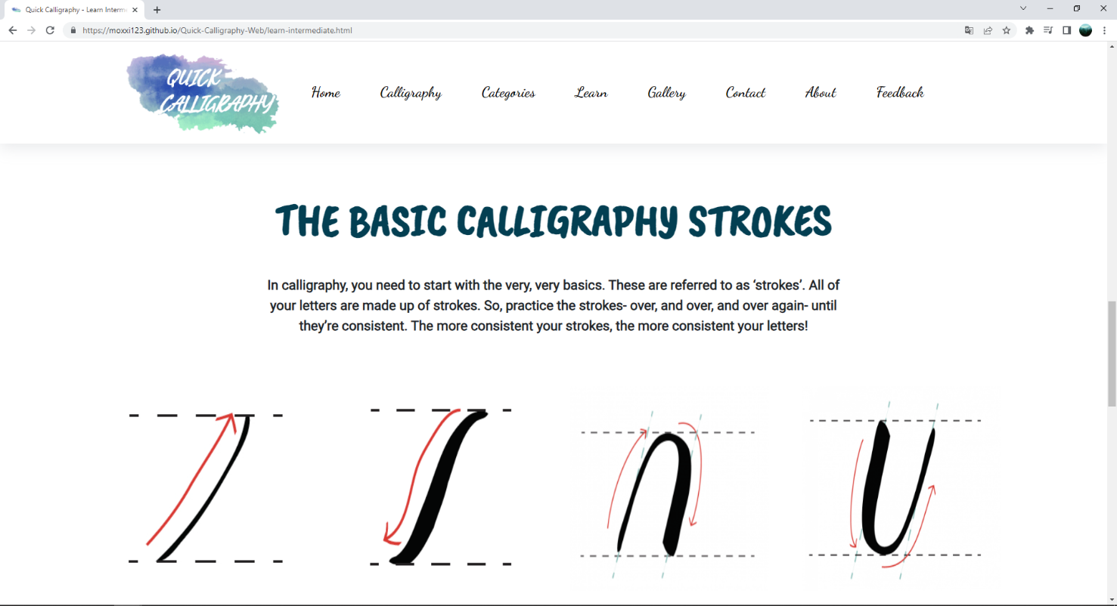

**Figure 75: Learn Intermediate – part 4**

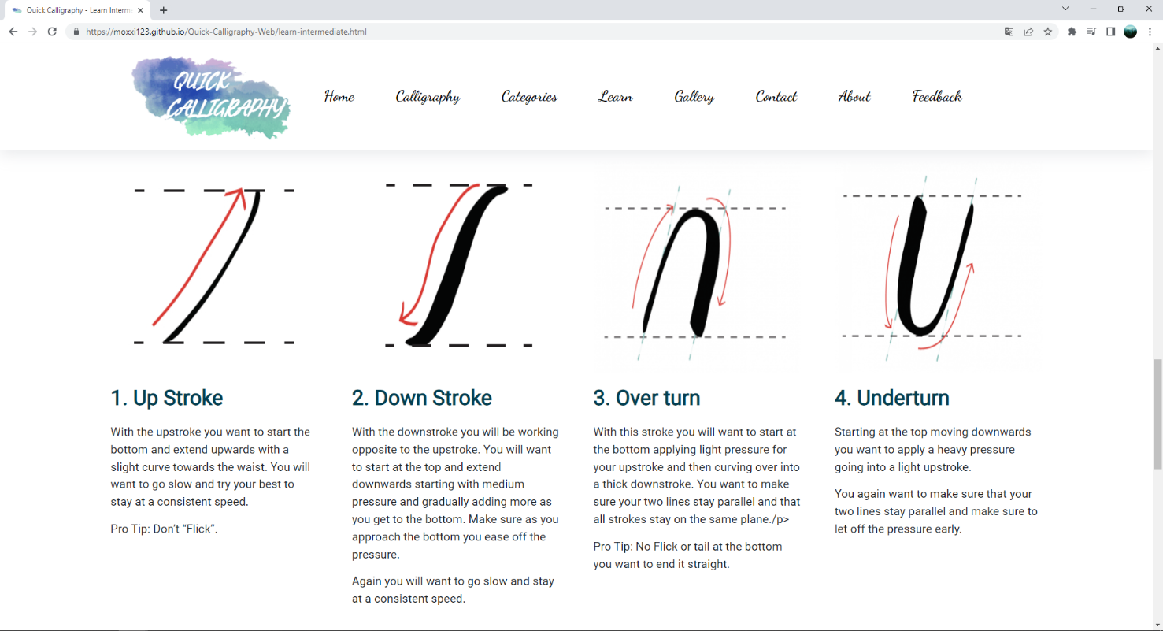

**Figure 76: Learn Intermediate – part 5**

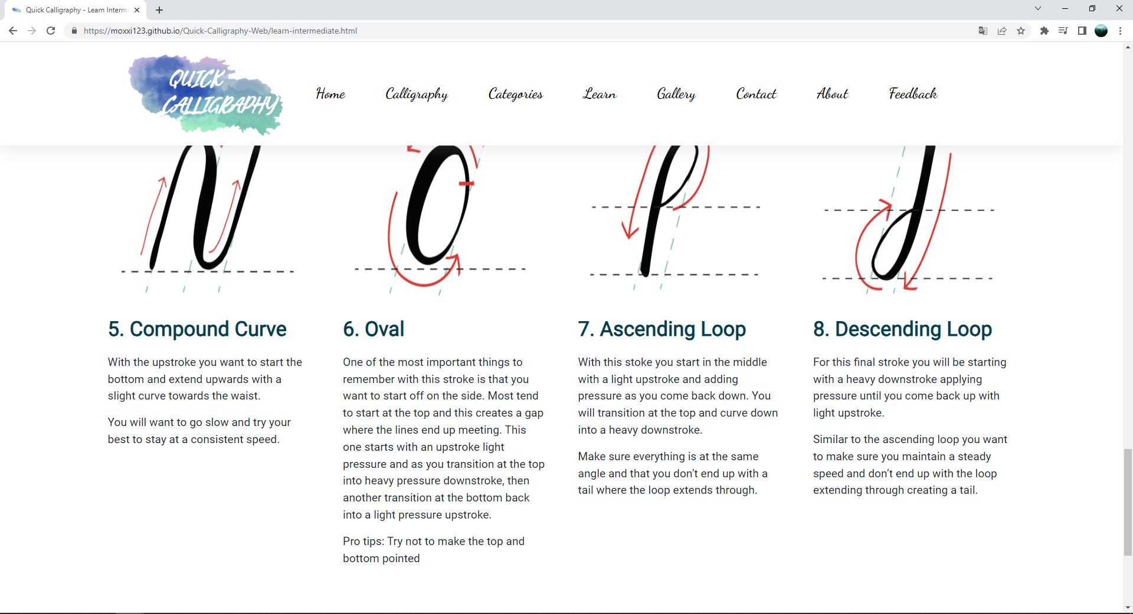

**Figure 77: Learn Intermediate – part 6**

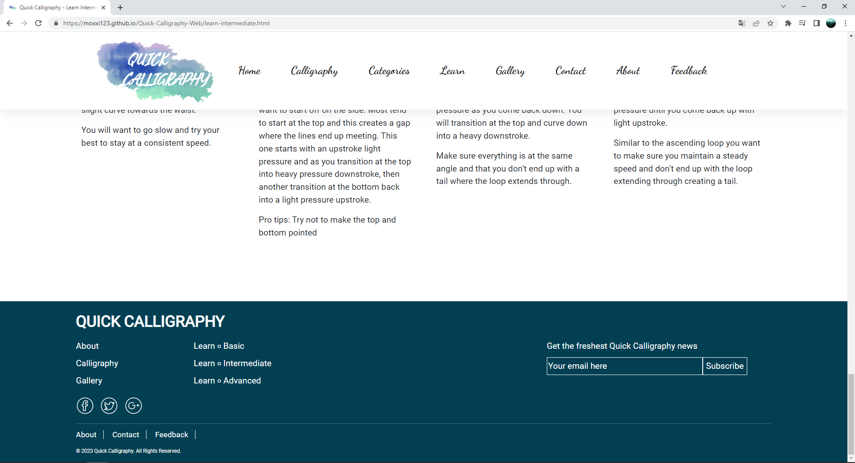

**Figure 78: Learn Intermediate – part 7**

1. **Learn Advanced page**
2. Description

This Learn Advanced page displays following information:

- Instructions for choosing the suitable type of pen with a video.

- Practice lettering for birthdays and holidays with video tutorials.

- Distinguish between traditional and modern calligraphy.

1. Screen shot

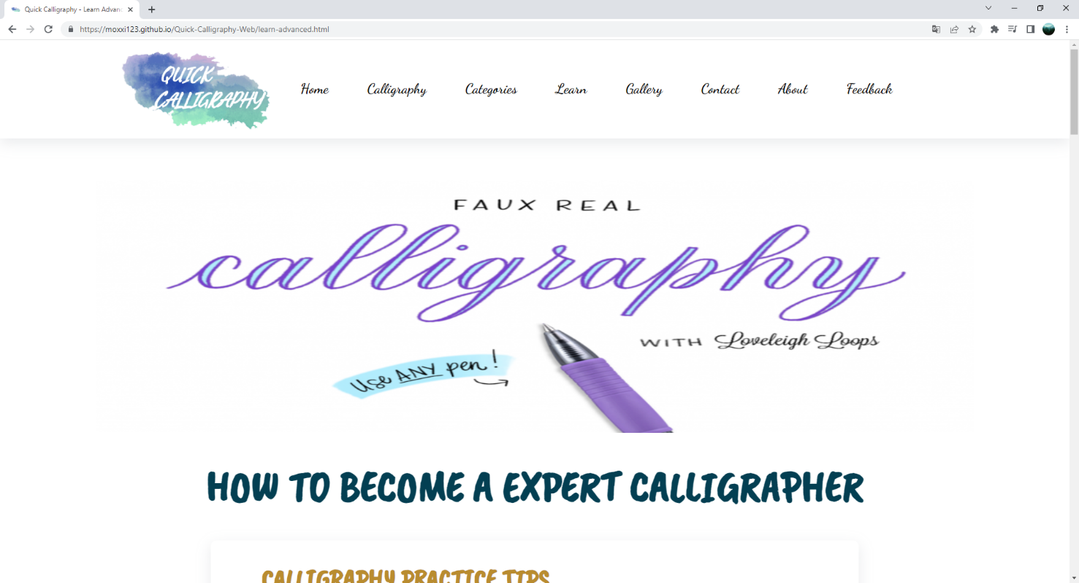

**Figure 79: Learn Advanced – part 1**

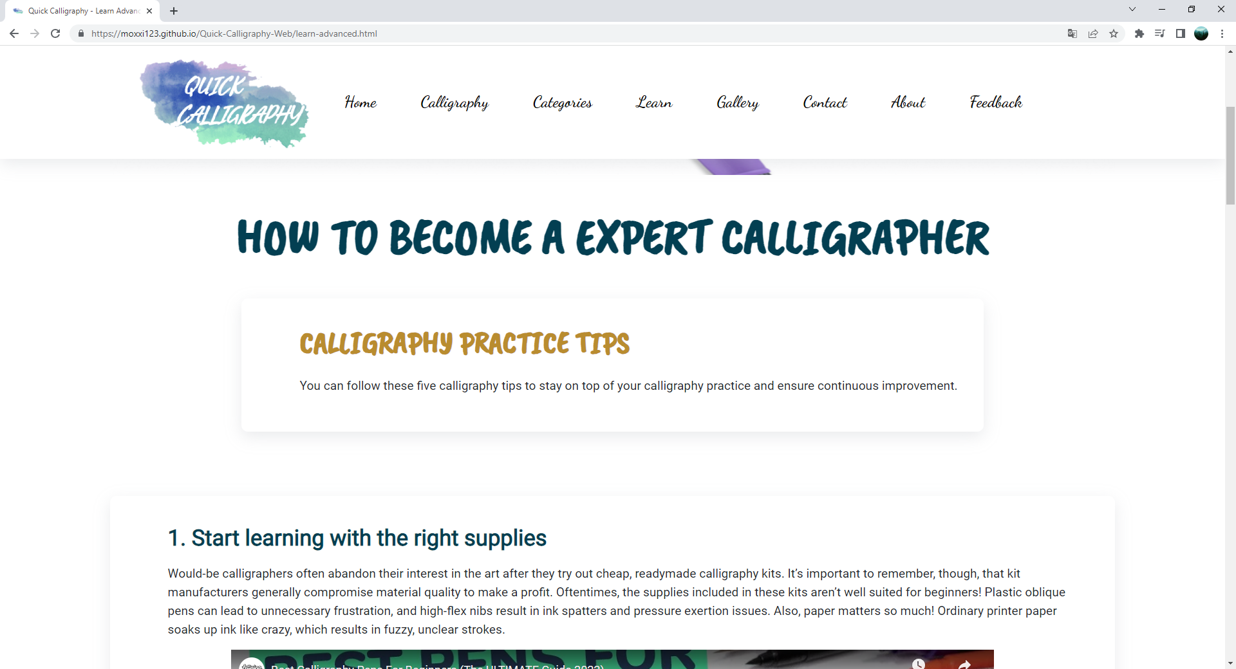

**Figure 80: Learn Advanced – part 2**

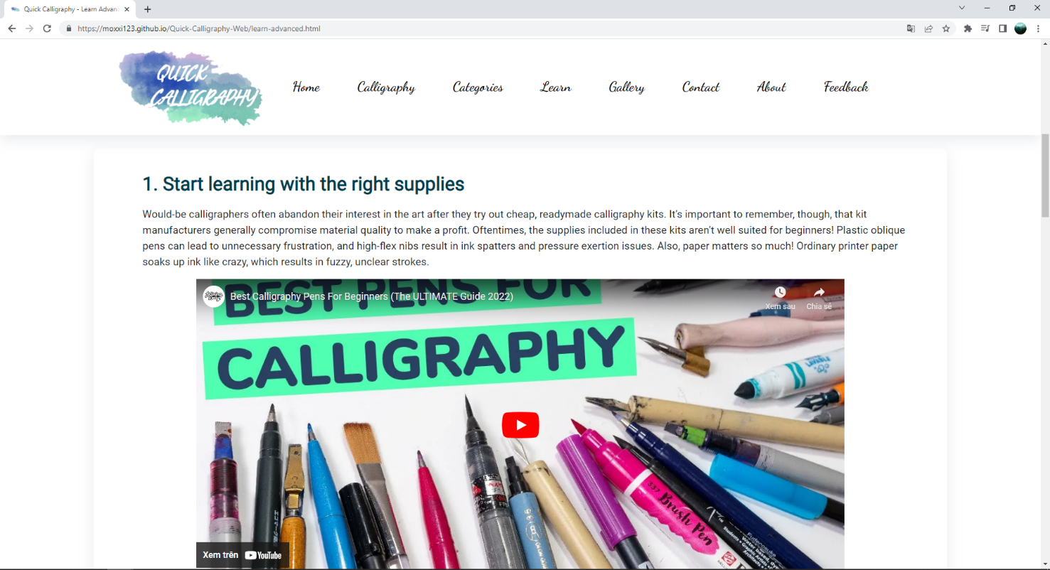

**Figure 81: Learn Advanced – part 3**

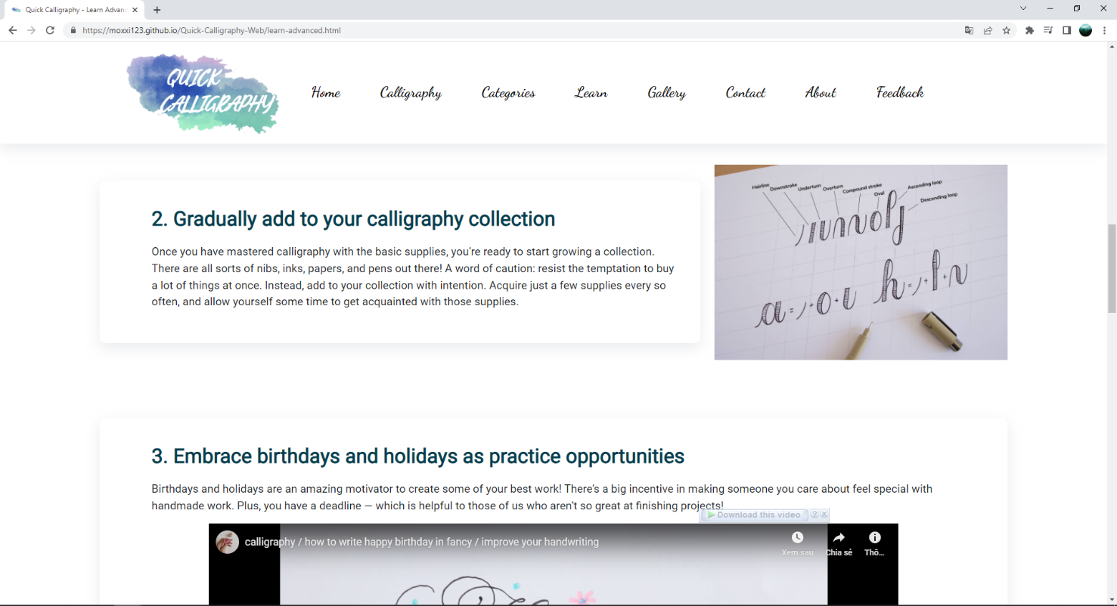

**Figure 82: Learn Advanced – part 4**

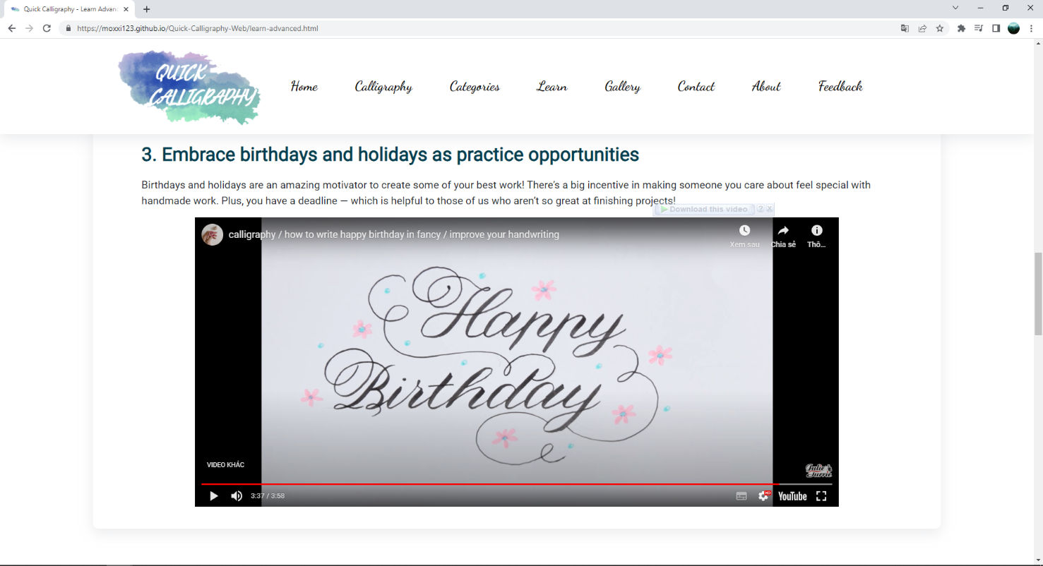

**Figure 83: Learn Advanced – part 5**

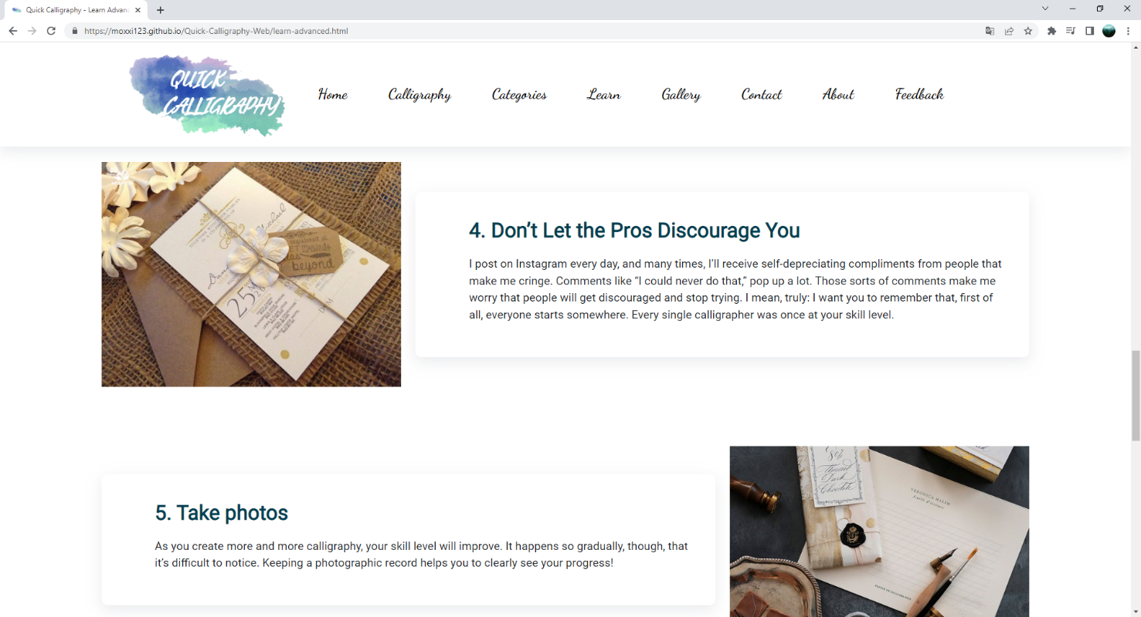

**Figure 84: Learn Advanced – part 6**

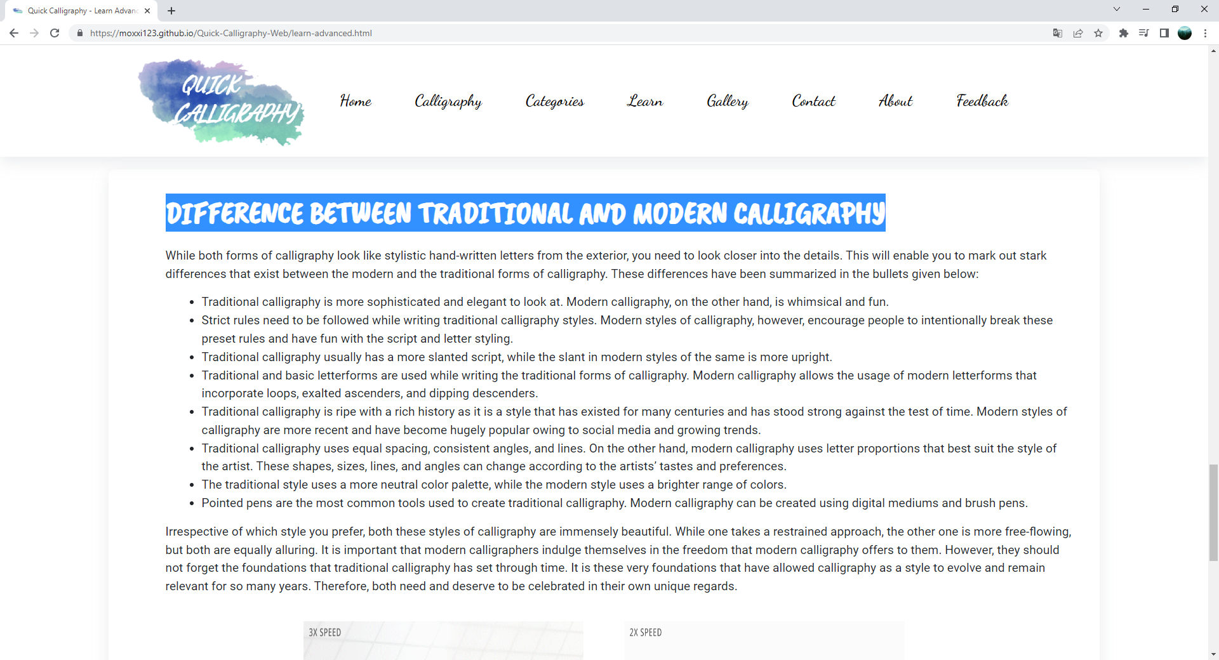

**Figure 85: Learn Advanced – part 7**

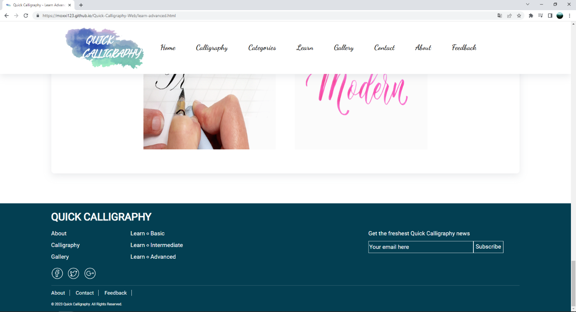

**Figure 86: Learn Advanced – part 8**

1. **Gallery page**
2. Description

This Gallery page displays following information:

- Exhibiting calligraphy works.

- Display view and like count for each image.

- Slideshow image.

- Search and sort by categories.

1. Screen shot

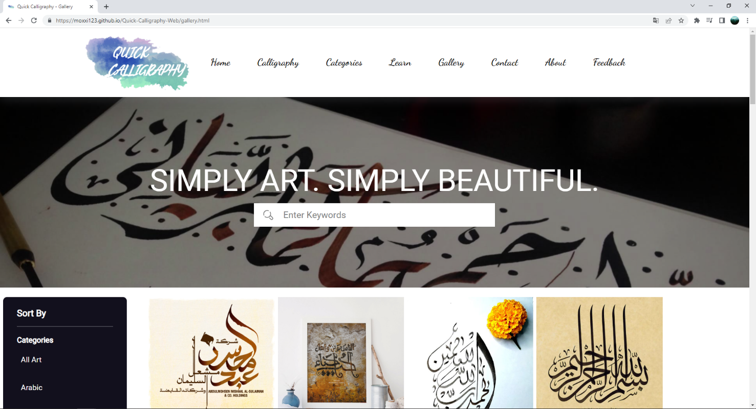

**Figure 87: Gallery – part 1**

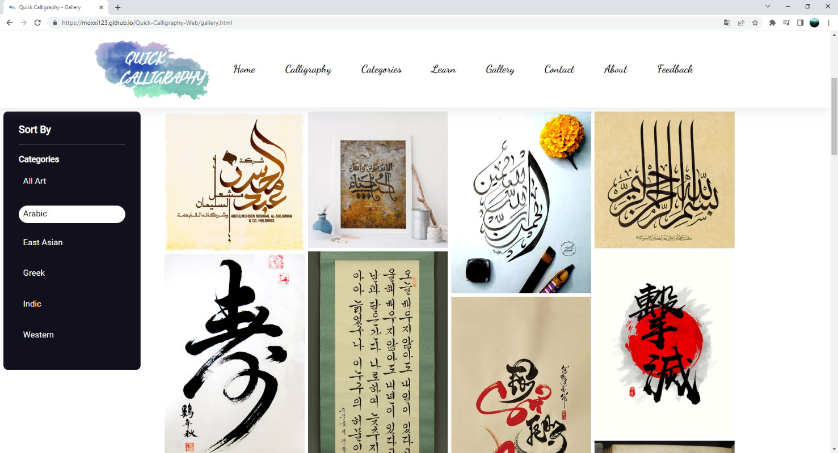

**Figure 88: Gallery – part 2**

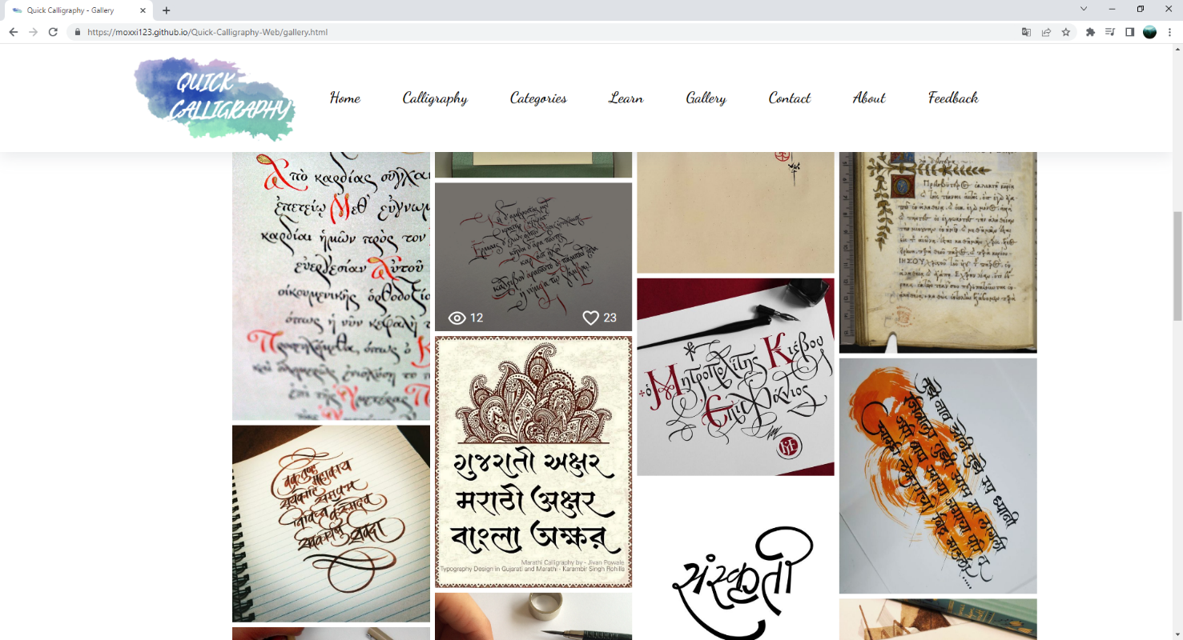

**Figure 89: Gallery – part 3**

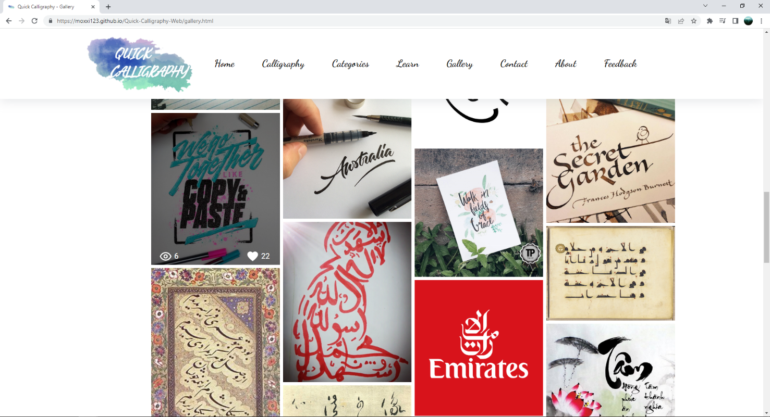

**Figure 90: Gallery – part 4**

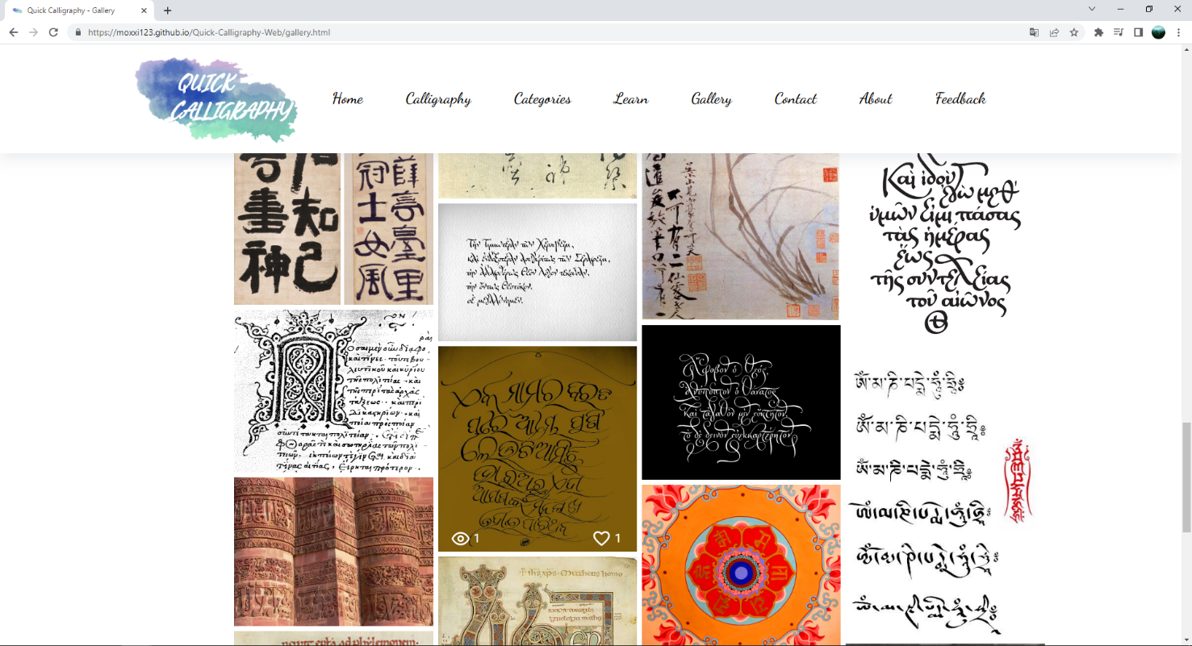

**Figure 91: Gallery – part 5**

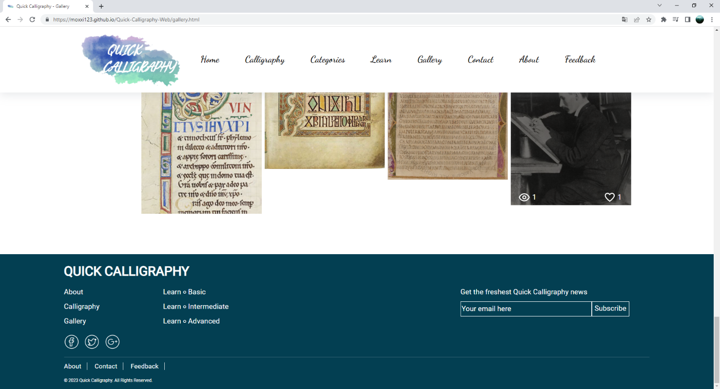

**Figure 92:** **Gallery – part 6**

1. **Contact Us page**
2. Description

This Contact Us page displays following information:

- Display contact information: location, telephone number, email, and a quick contact form for viewers.

- Display google maps and directions for viewers.

- Display the term of service.

1. Screen shot

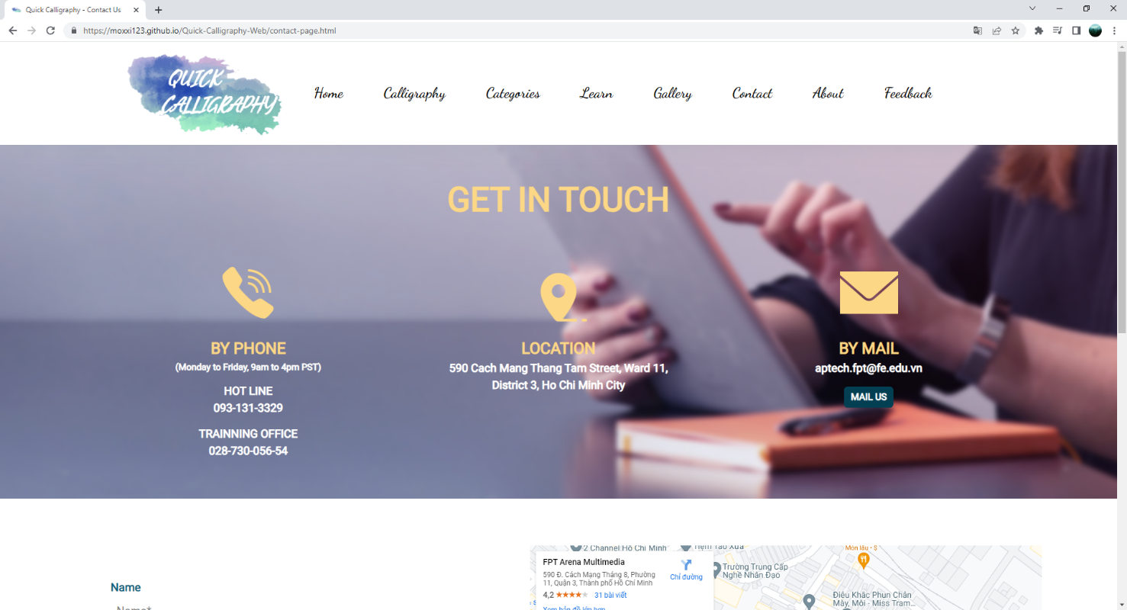

**Figure 93: Contact – part 1**

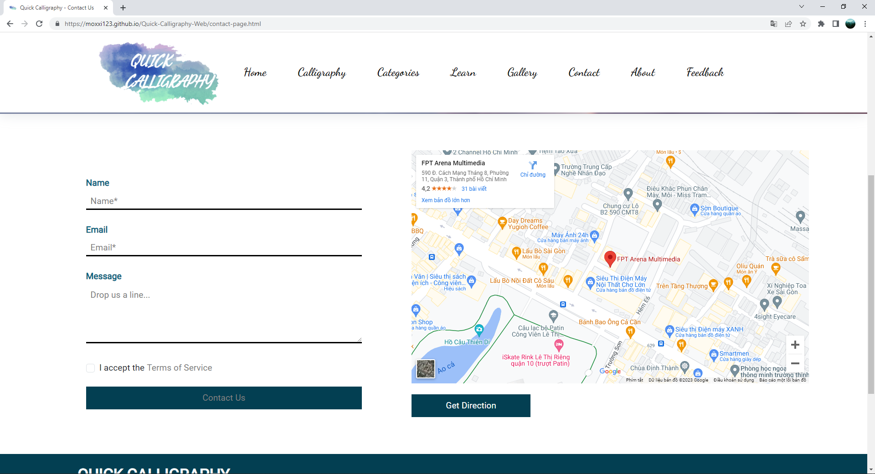

**Figure 94: Contact – part 2**

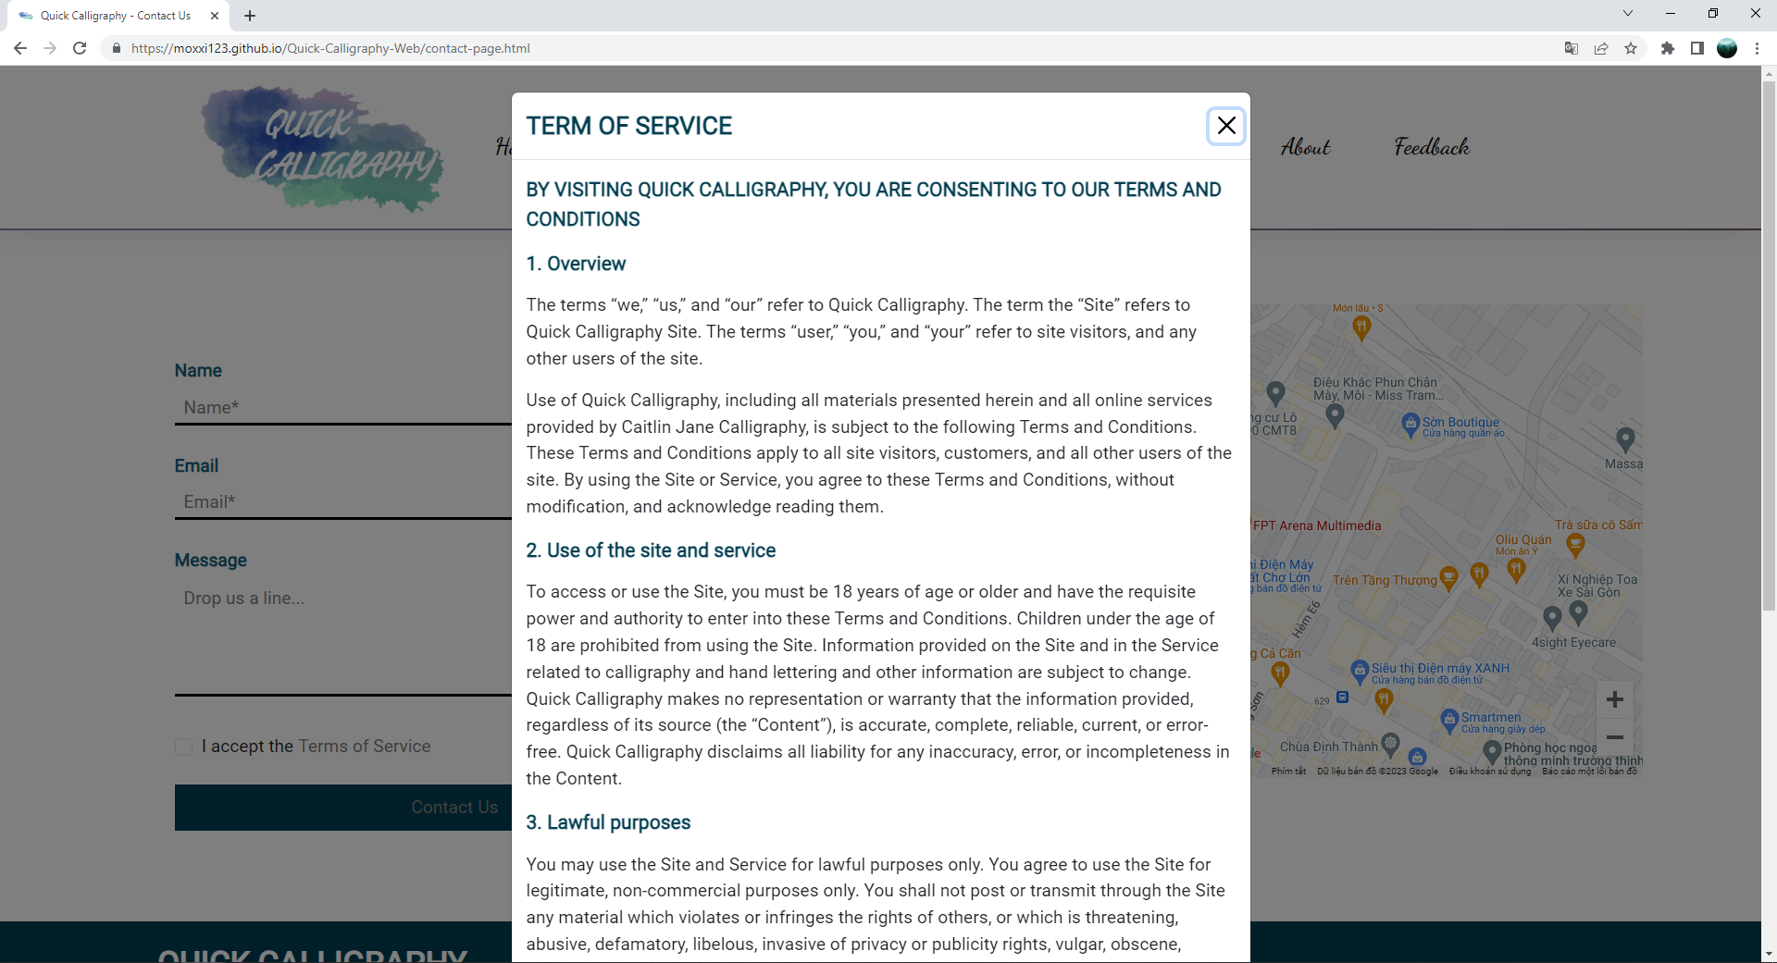

**Figure 95: Contact – part 3**

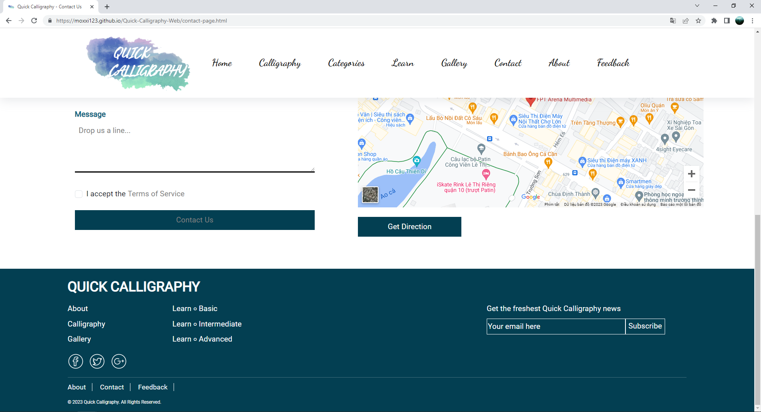

**Figure 96:** **Contact – part 4**

1. **About Us page**
2. Description

This About Us page displays following information:

- Show our sentiments about the Quick Calligraphy website.

- Introduction about members team of Group 1.

1. Screen shot

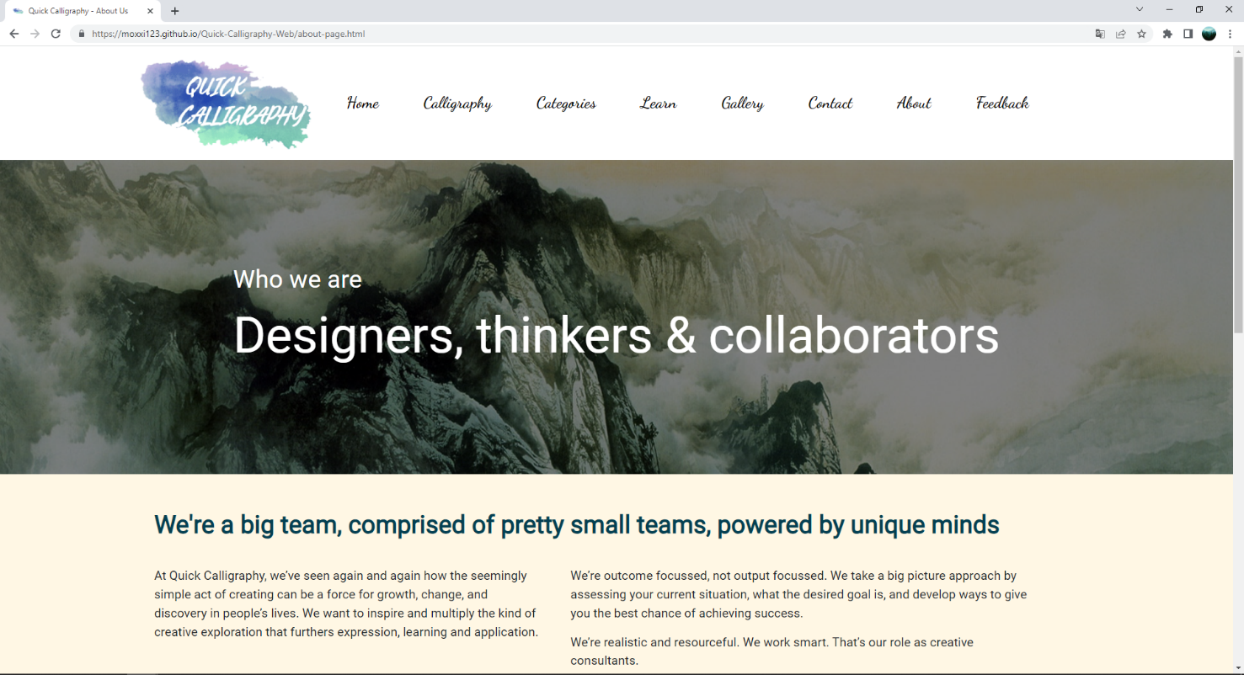

**Figure 97: About – part 1**

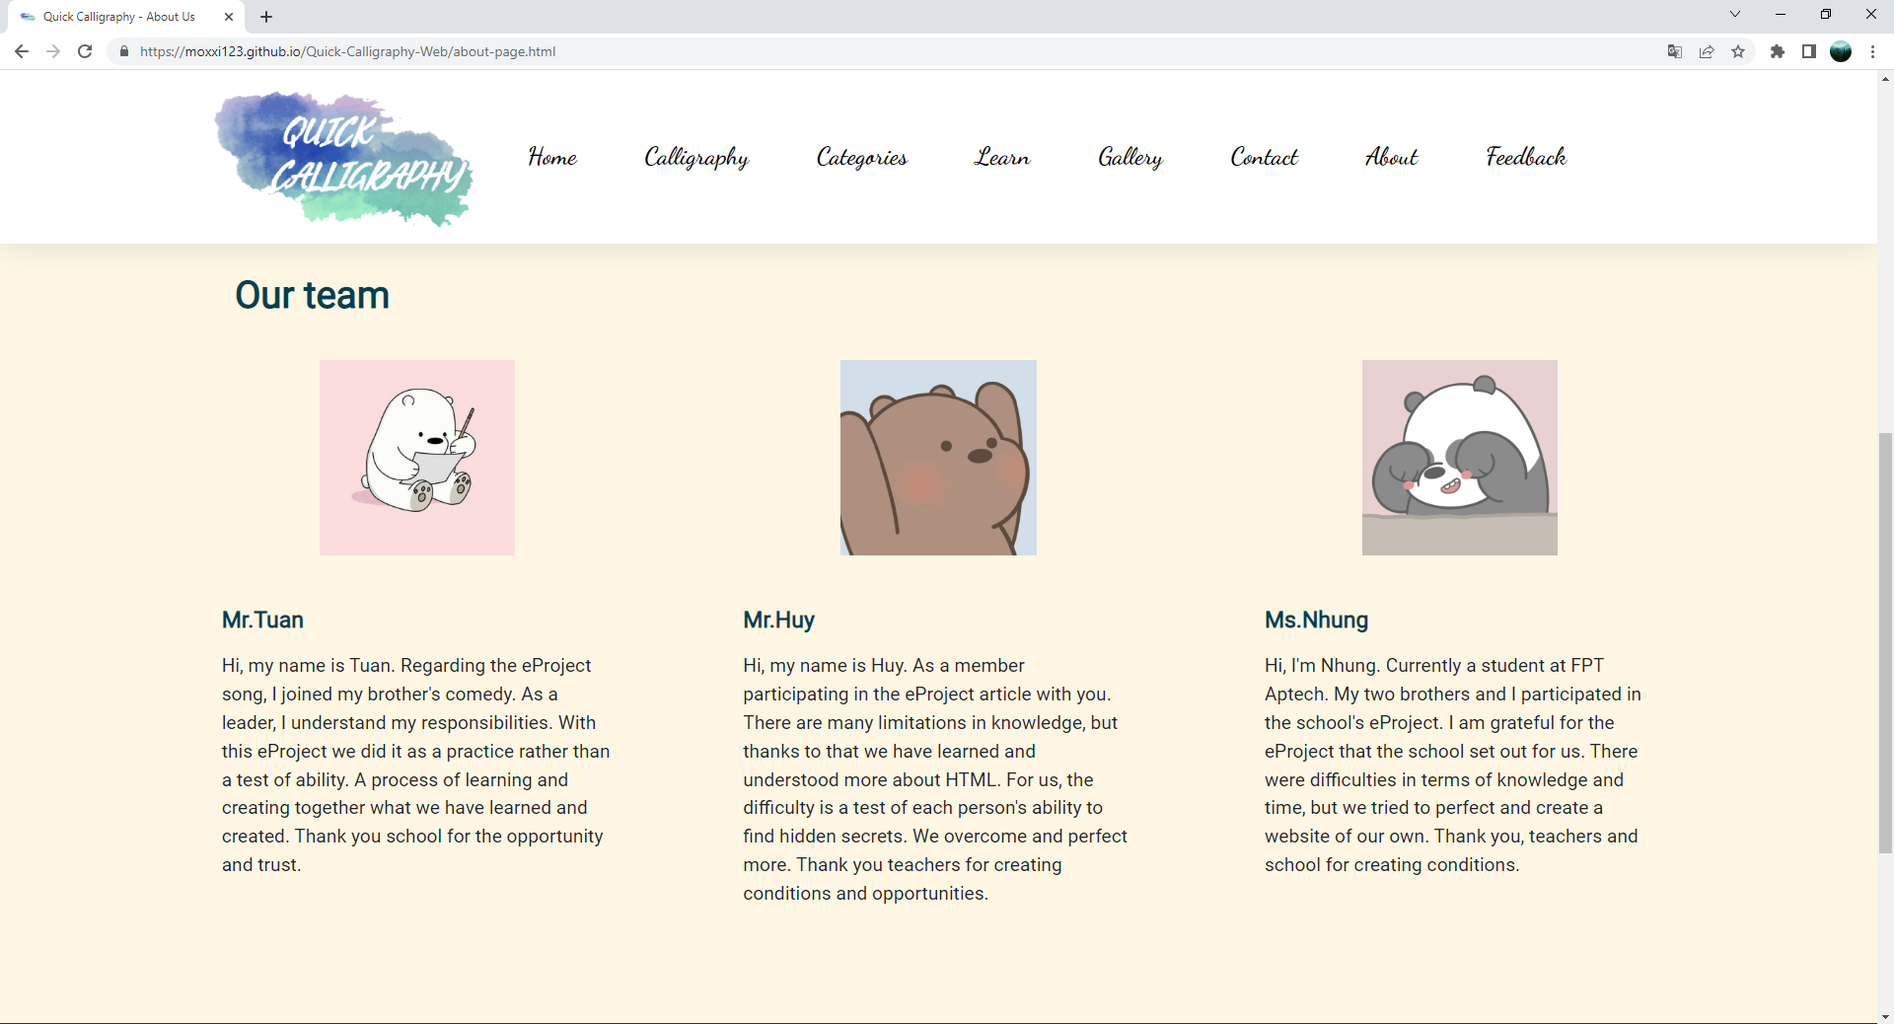

**Figure 98: About – part 2**

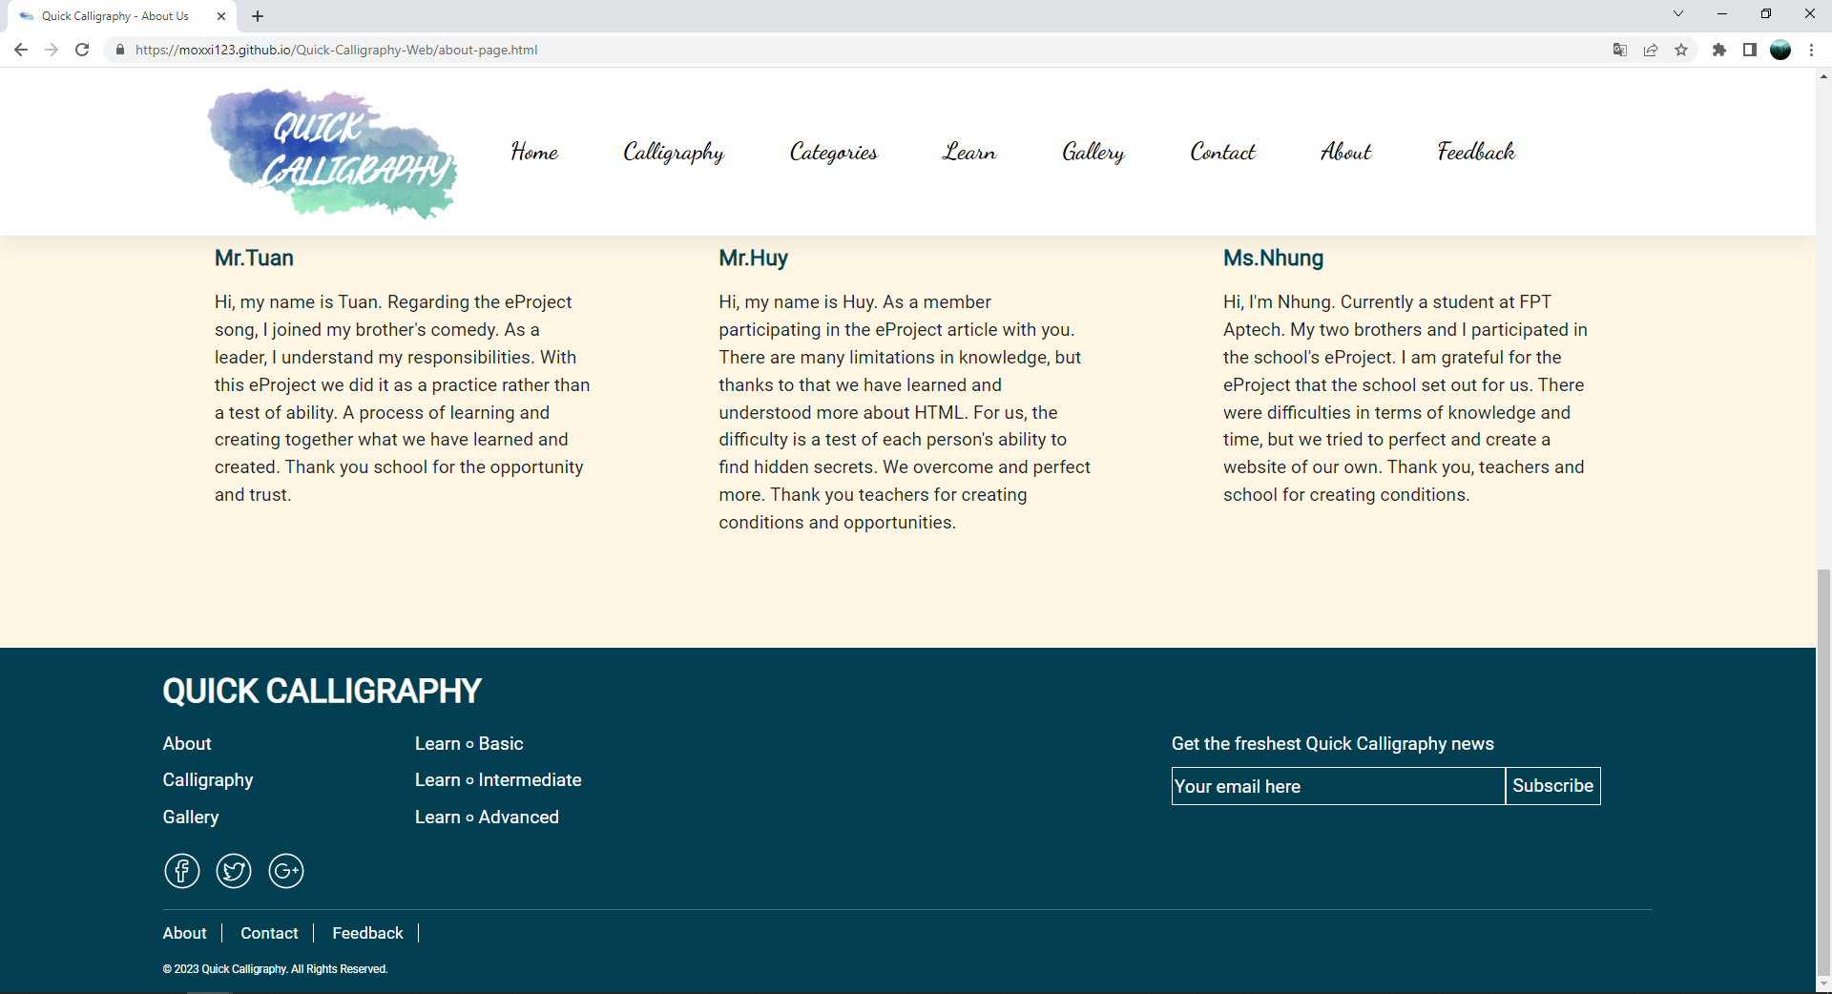

**Figure 99: About – part 3**

1. **Feedback page**
2. Description

This Feedback page displays following information:

- Display a quick feedback form with rate scale for viewers.

1. Screen shot

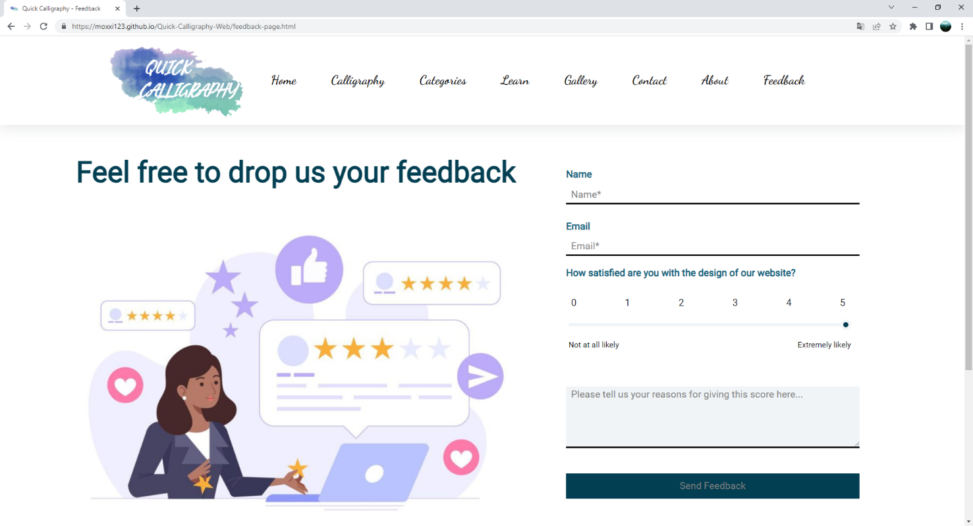

**Figure 100: Feedback – part 1**

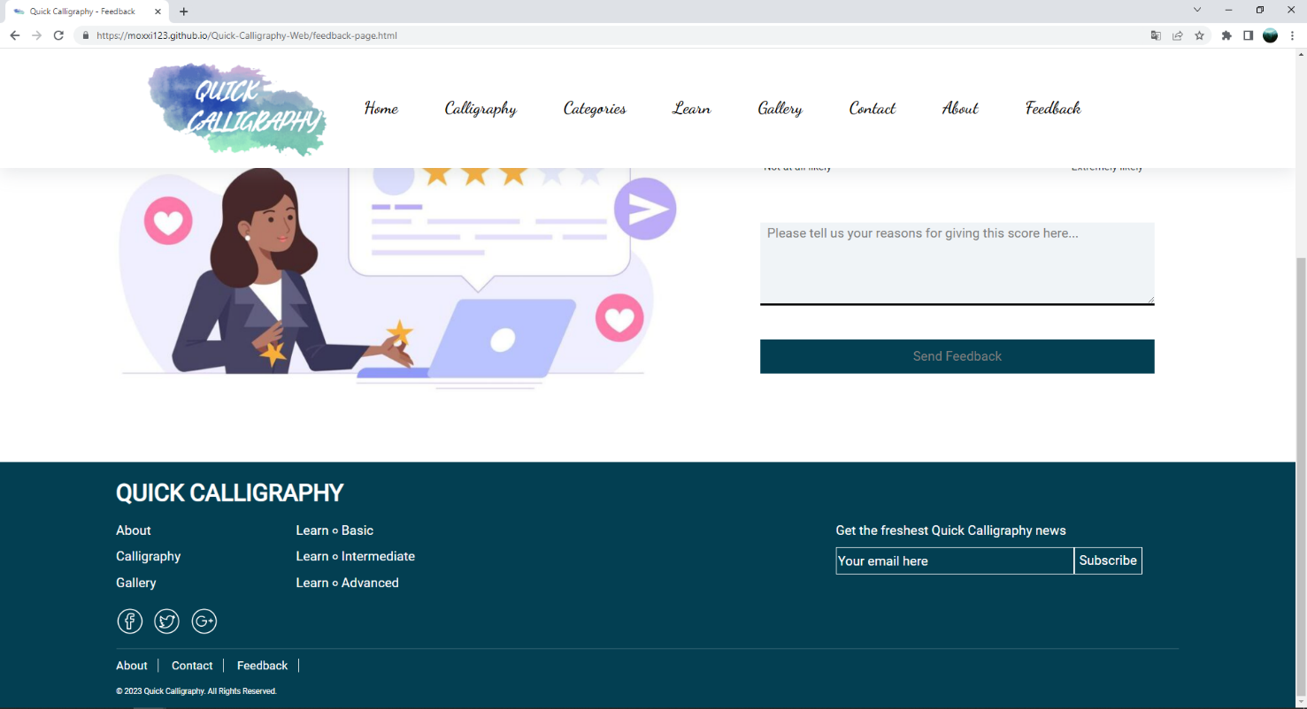

**Figure 101: Feedback – part 2**

# RESPONSIVE

The page has a responsive feature for small screen devices with a minimum width at 992px.

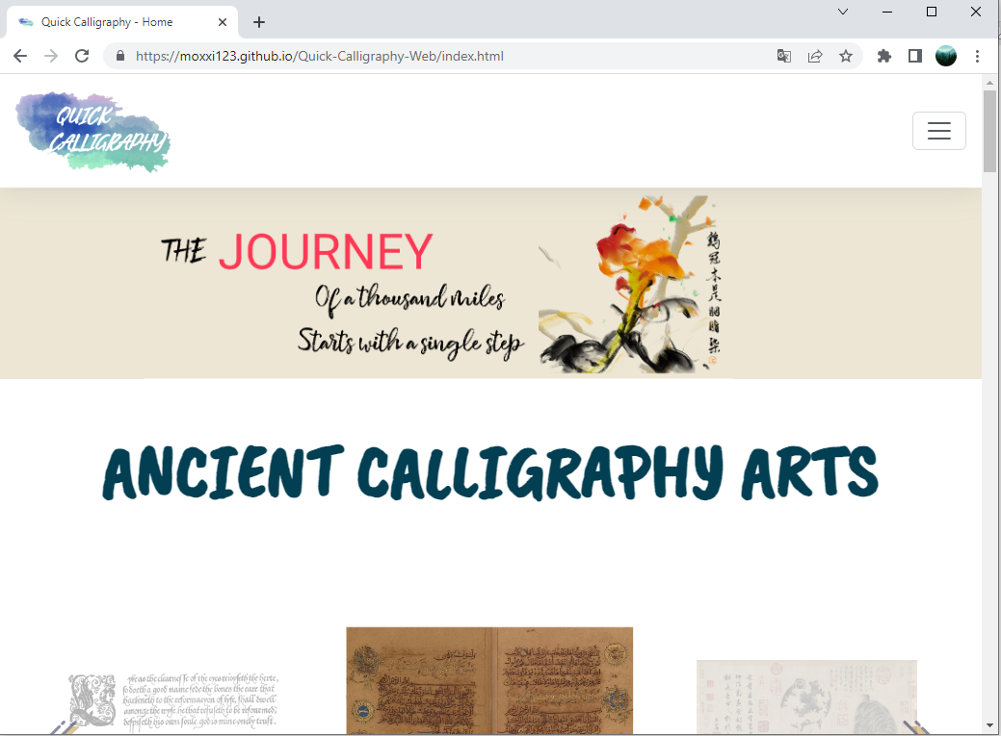

**Figure 102: Quick Calligraphy responsive – part 1**

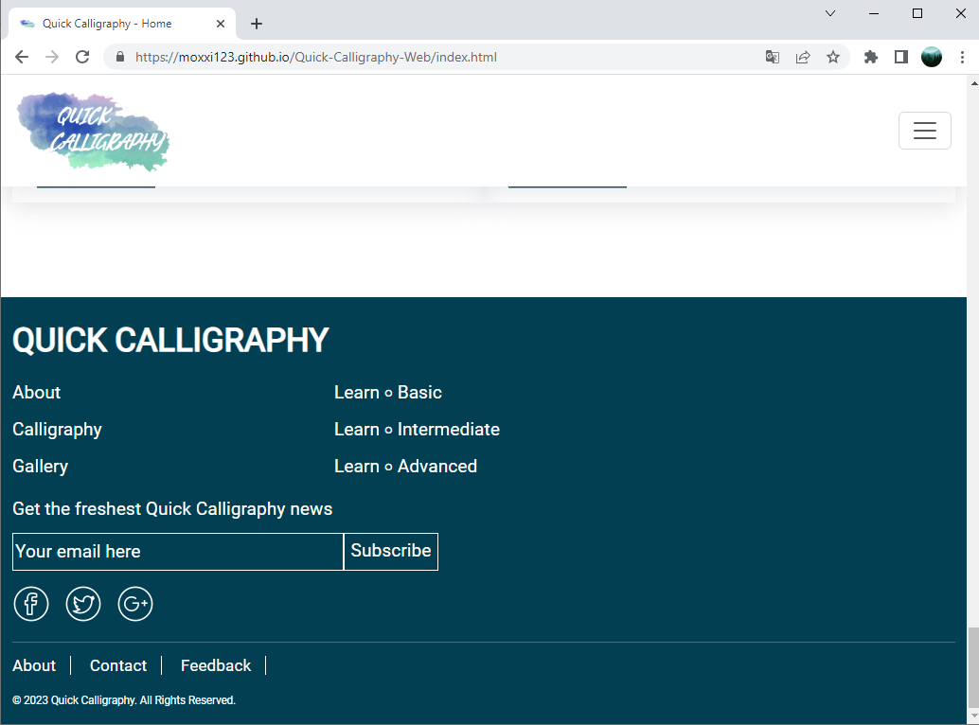

**Figure 103: Quick Calligraphy responsive – part 2**

# JAVASCRIPT DESCRIPTION

1. **Owl Carousel slider**
2. Description

* This script used a slick package (carousel) to display the image slider on the website.

1. Screen shot

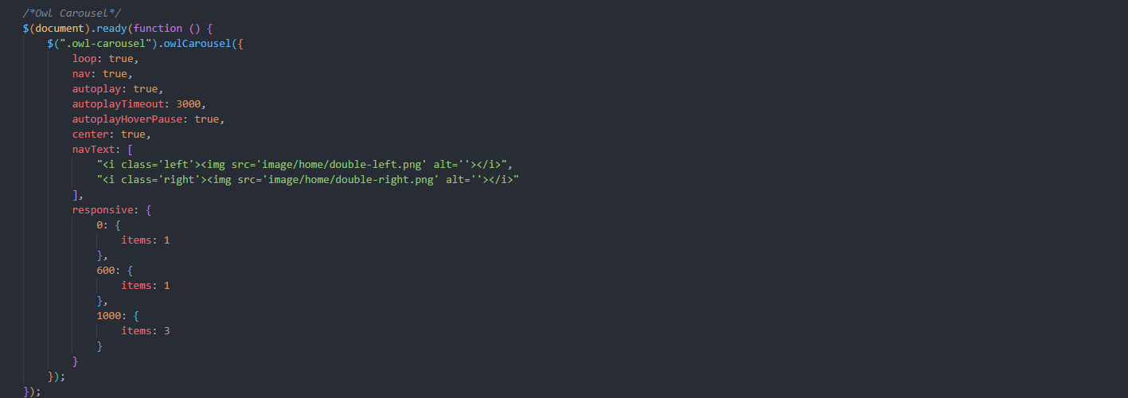

**Figure 104:** **Image slider – Index page**

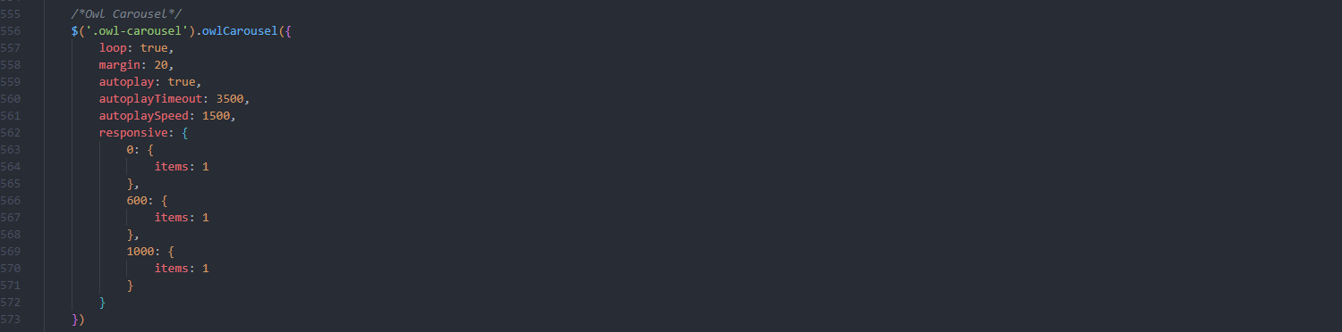

**Figure 105: Image slider –Learn Intermediate page**

1. **Angular JS data validation**
2. Description

- This script used a toolset (Angular JS) and its module (Angular-messages) to display the data validation messages on the website.

1. Screen shot

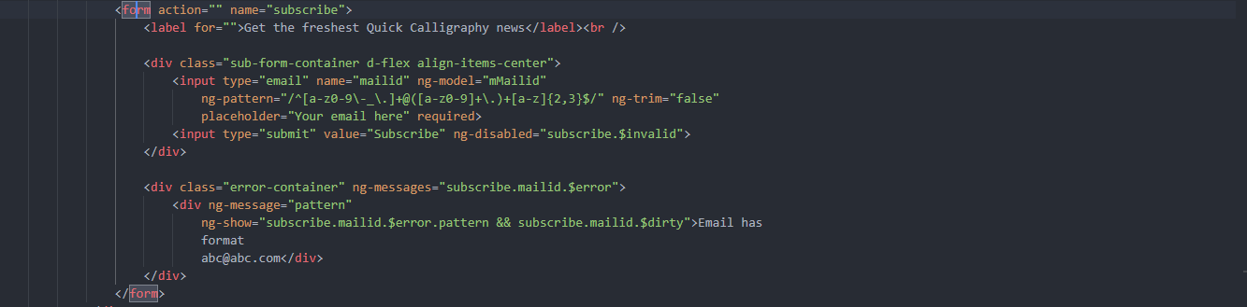



**Figure 106: Data validation – footer**

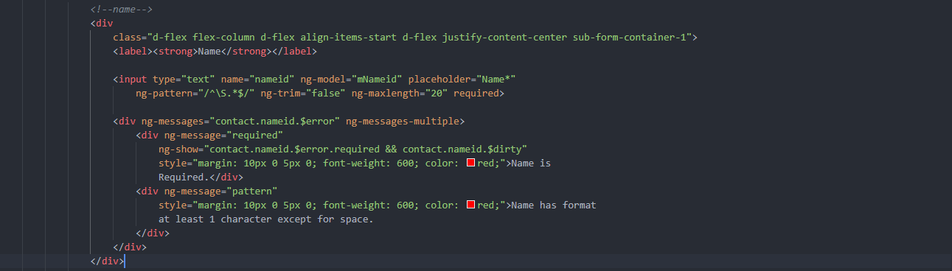

**Figure 107:** **Data validation – name input**

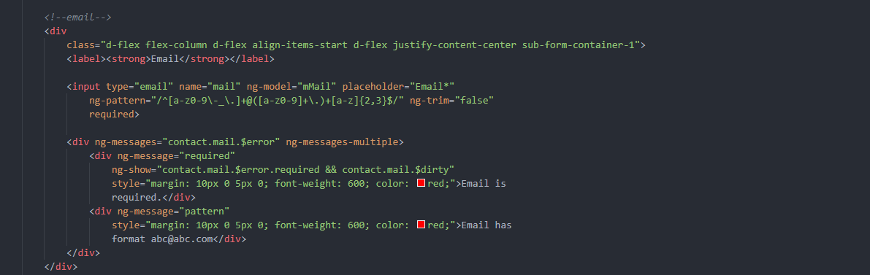

**Figure 108: Data validation – mail input**

1. **Sort by categories Javascript**
2. Description

- This script is used to sort the image by categories (Arab, East Asian, Indian, and Western) in the gallery. It hides the image that does not match the category sort.

1. Screen shot

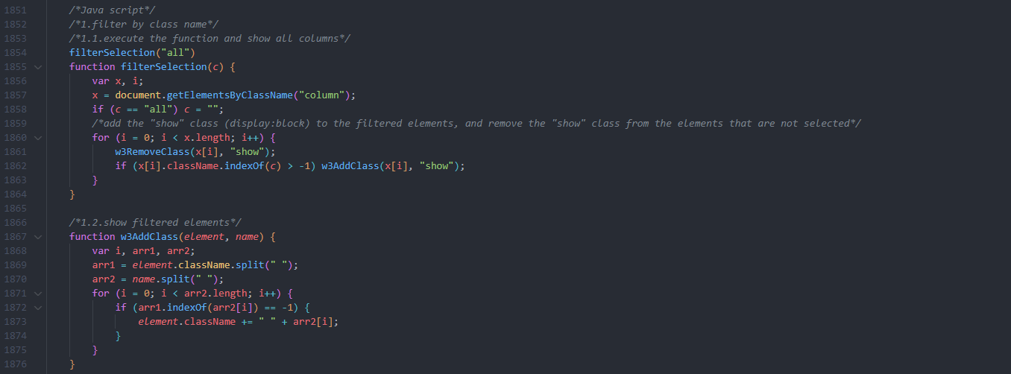

**Figure 109: Image sort – part 1**

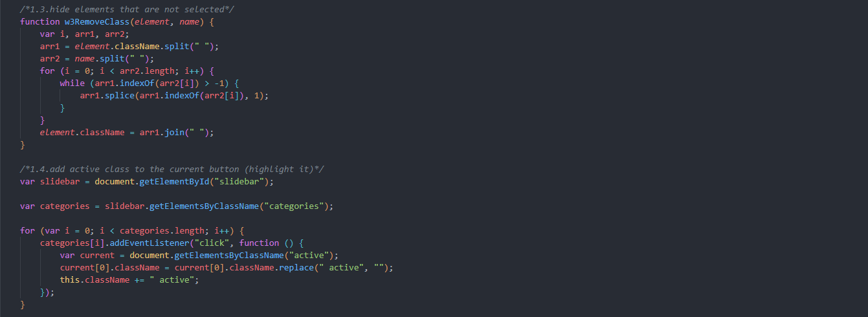

**Figure 110: Image sort – part 2**

1. **Search by categories Javascript**
2. Description

- This script is used to search the image by categories (Arab, East Asian, Indian, and Western) in the gallery.

1. Screen shot

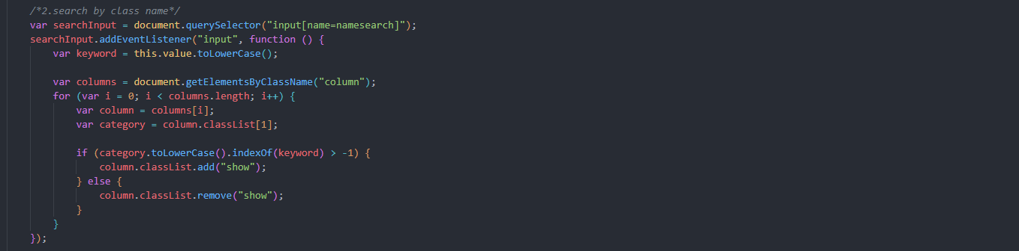

**Figure 111: Image search**

1. **All category active when loading page Javascript**
2. Description

- This script is used to set the default “All category” when loading the Gallery page.

1. Screen shot



**Figure 112: All category active by default**

1. **View count when clicking on the image Javascript**
2. Description

- This script is used to count the number of clicks on a particular image with an index number and store the count in localStorage.

1. Screen shot

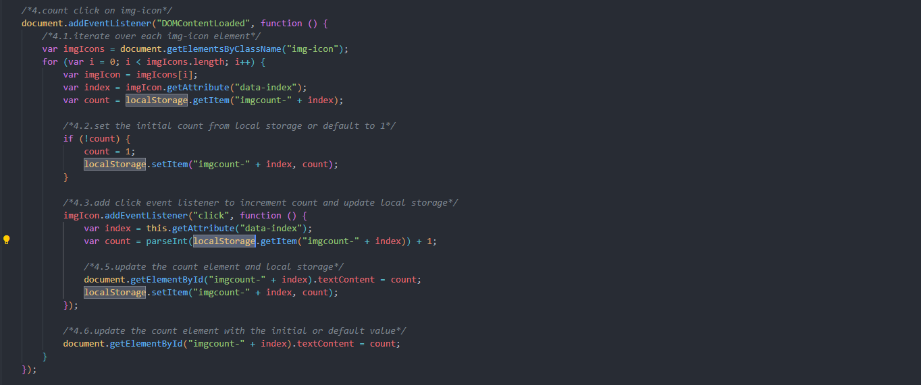

**Figure 113: View count when clicking on the image**

1. **Like count when clicking on the love button Javascript**
2. Description

- This script is used to count the number of clicks on a particular love button with an index number and store the count in localStorage.

1. Screen shot

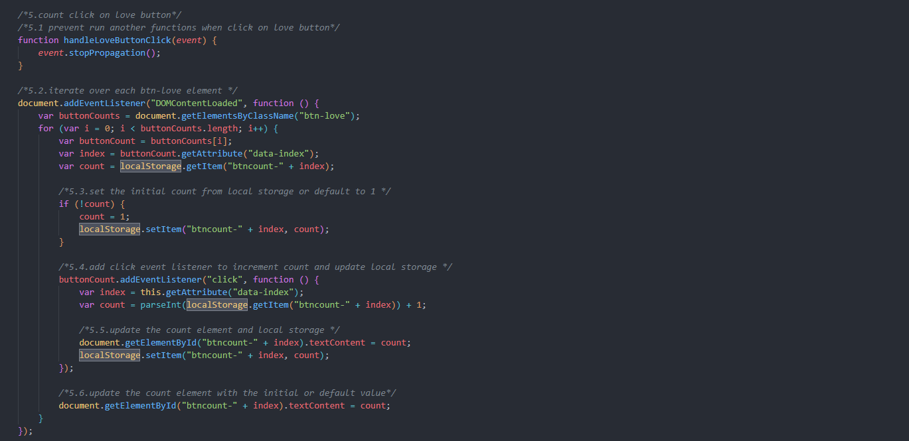

**Figure 114: Like count when clicking on the love button**

1. **Custom image slider modal Javascript**
2. Description

- This script is used to display the image slider match with the current selection image.

1. Screen shot

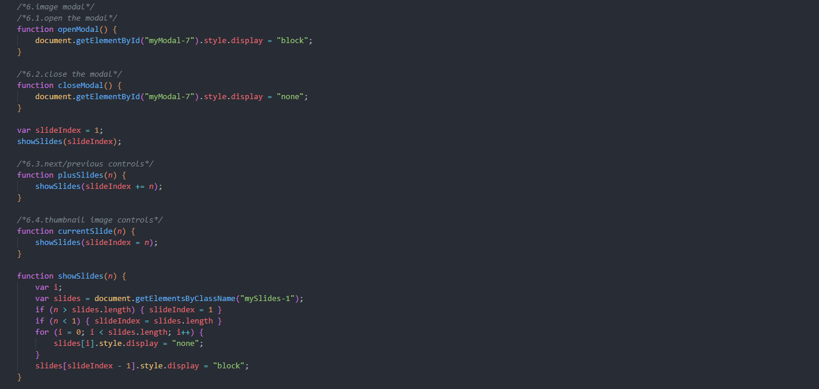

**Figure 115: Custom image slider modal**

# TASK SHEET REVIEW 3

|  |  |  |  |  |  |  |  |
| --- | --- | --- | --- | --- | --- | --- | --- |
| **Project Ref. No.:**  **eP/Advertisement Portal Management**  **System/01** | | **Project Title:** | **Activity Plan Prepared By:** | **Date of Preparation of Activity Plan:** | | | |
| **Sr.**  **No.** | **Task** | **Actual**  **Start**  **Date** | **Actual Days** | **Team**  **Mate Names** | **Status** |
| 1 | Home | Quick Calligraphy | Tuan | 28-June-23 | 1 | Huy | Completed |
| 2 | Calligraphy | 28-June-23 | 1 | Tuan | Completed |
| 3 | Arabic calligraphy | 28-June-23 | 1 | Nhung | Completed |
| 4 | East Asian calligraphy | 29-June-23 | 1 | Nhung | Completed |
| 5 | Greek calligraphy | 30-June-23 | 1 | Nhung | Completed |
| 6 | Indic calligraphy | 1-July-23 | 1 | Nhung | Completed |
| 7 | Western calligraphy | 2-July-23 | 1 | Nhung | Completed |
| 8 | Learn basic | 3-July-23 | 1 | Nhung | Completed |
| 9 | Learn intermediate | 4-July-23 | 1 | Nhung | Completed |
| 10 | Learn Advanced | 5-July-23 | 1 | Nhung | Completed |
| 11 | Gallery | 29-June-23 | 1 | Tuan | Completed |
| 12 | About Us | 29-June-23 | 1 | Huy | Completed |
| 13 | Contact Us | 3-July-23 | 1 | Tuan | Completed |
| 14 | Feedback | 4-July-23 | 1 | Tuan | Completed |
| 15 | Java Script | 30-June-23 | 3 | Tuan | Completed |
| 16 | Responsive | 30-July-21 | 21 | Tuan | Completed |

|  |  |
| --- | --- |
| **Date:** | |
| Signature of Instructor:  **Ms. Le Mong Thuy** | Signature of Team Leader:  **Vu Minh Tuan** |